Created a simple App, where I kept button and a text control.

In Button action: I am calling process

In text action: I passed out_arg to display value

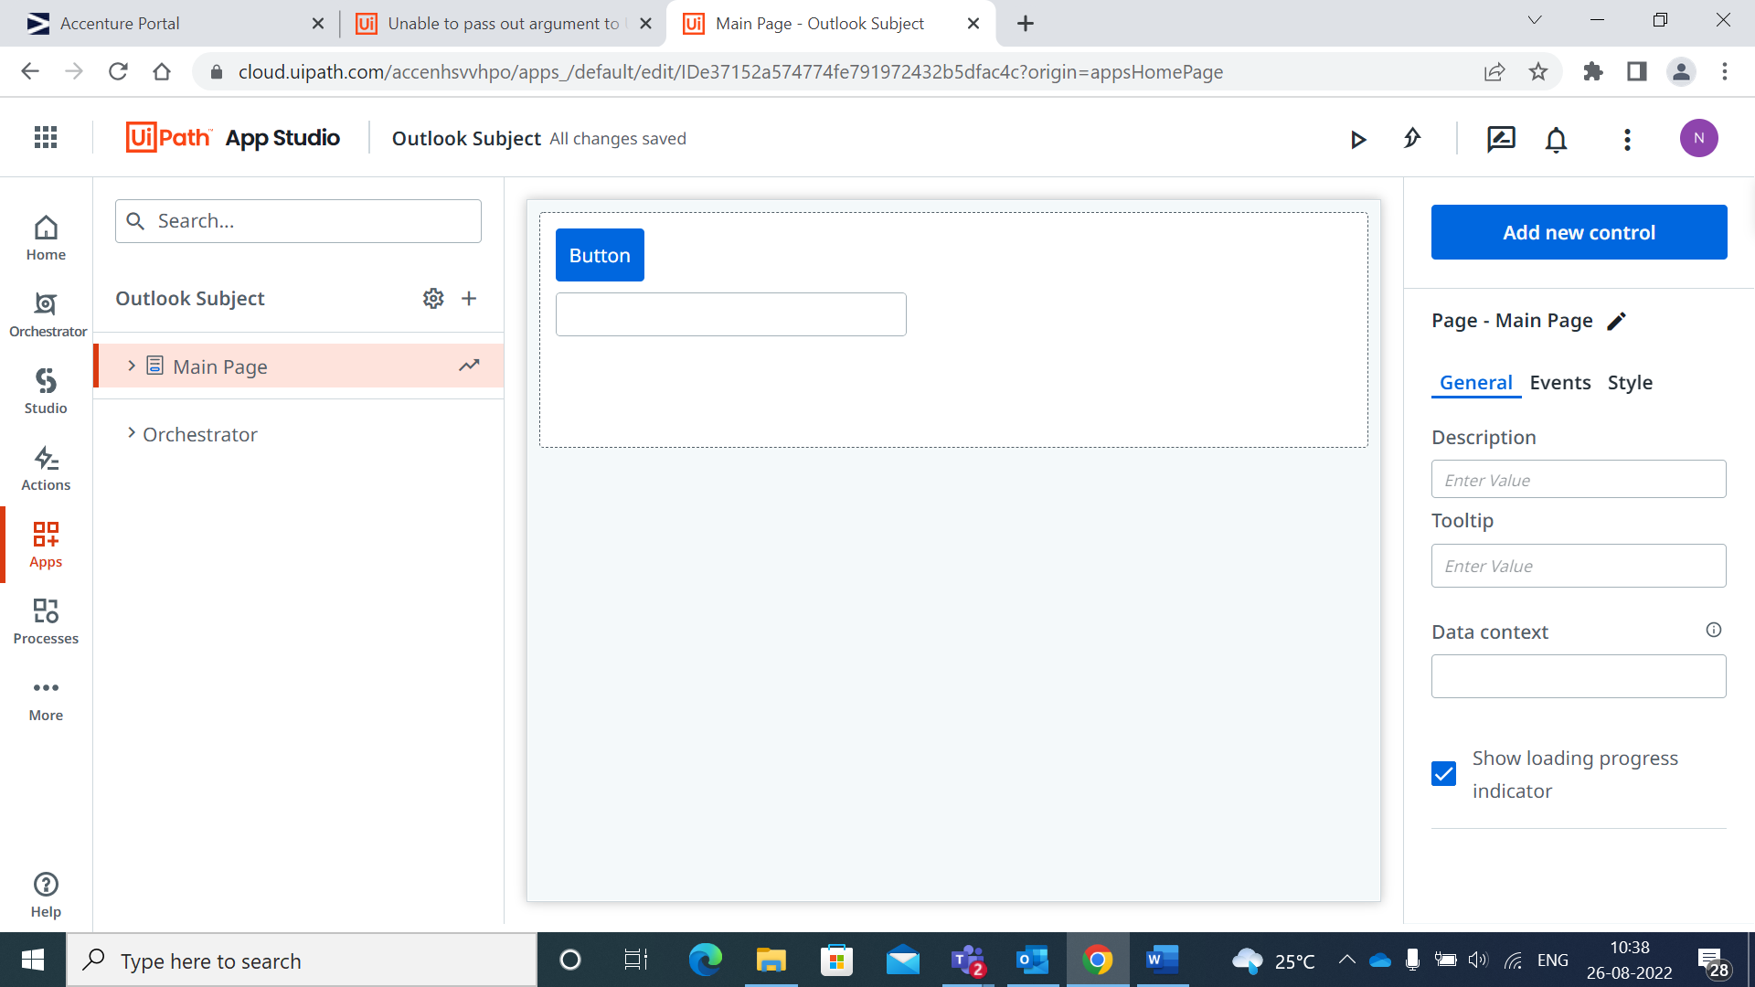

Button Action:

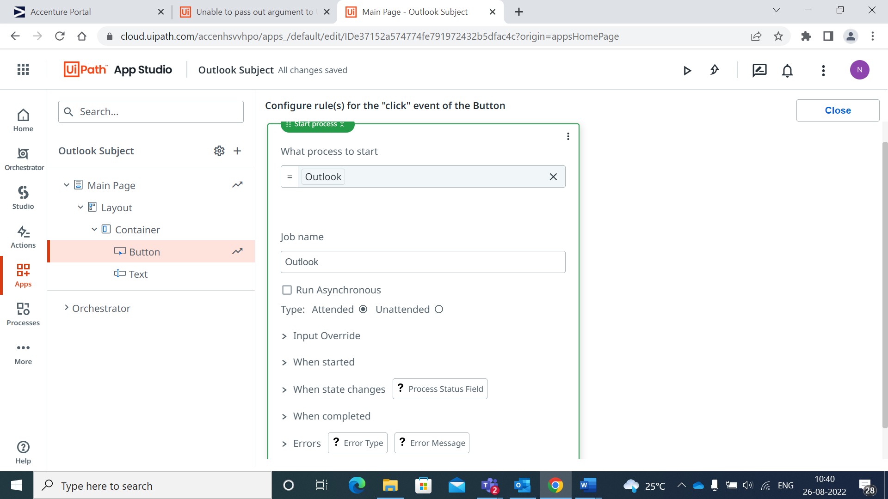

Text Action:

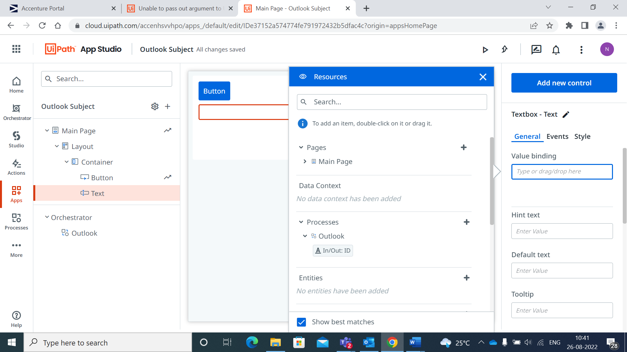

My Workflow

