Move PDF files into the correct folders that contains the filename

I was able to build a robot that move the pdf files into the correct foldername using a for each item in arrayfolder (if item.contains(filename) ) then move the file into the correct folder and if not stay in the original location.
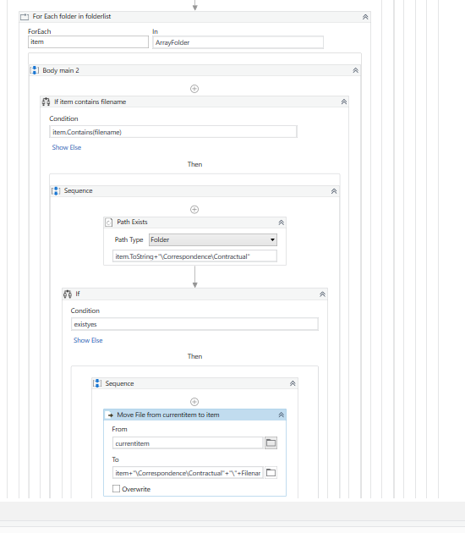

It works pretty good except the following behaviour (hope you can help :) )
When using PDF file name like 824.pdf 24.pdf 2024.pdf 2124.pdf (so the 24 is repeating each time in the file name), then when running the robot => the PDF’s all goes to the correct folder except the number 824.pdf where I obtain the below error message. Do you know what to do to ignore this error or how to build a part of the robot differently to avoid such behaviour?

PS: Noted that when I got this error then I just need to restart the robot and the file can be moved into the correct folder.

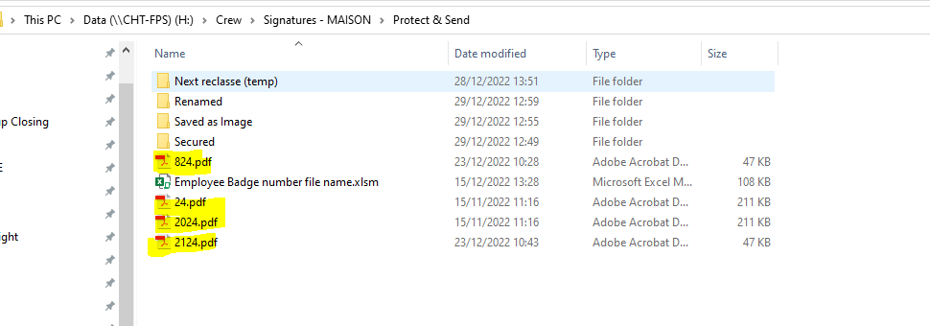

Into

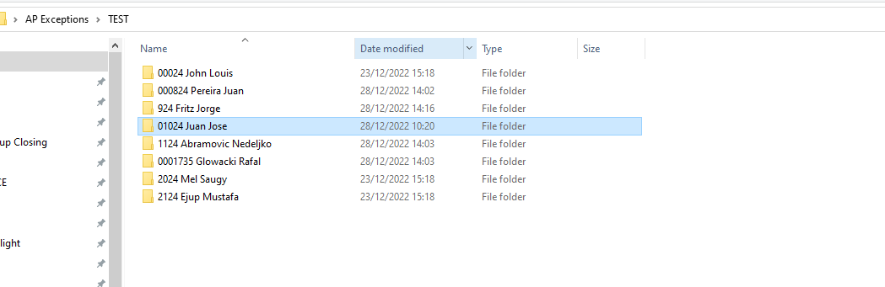

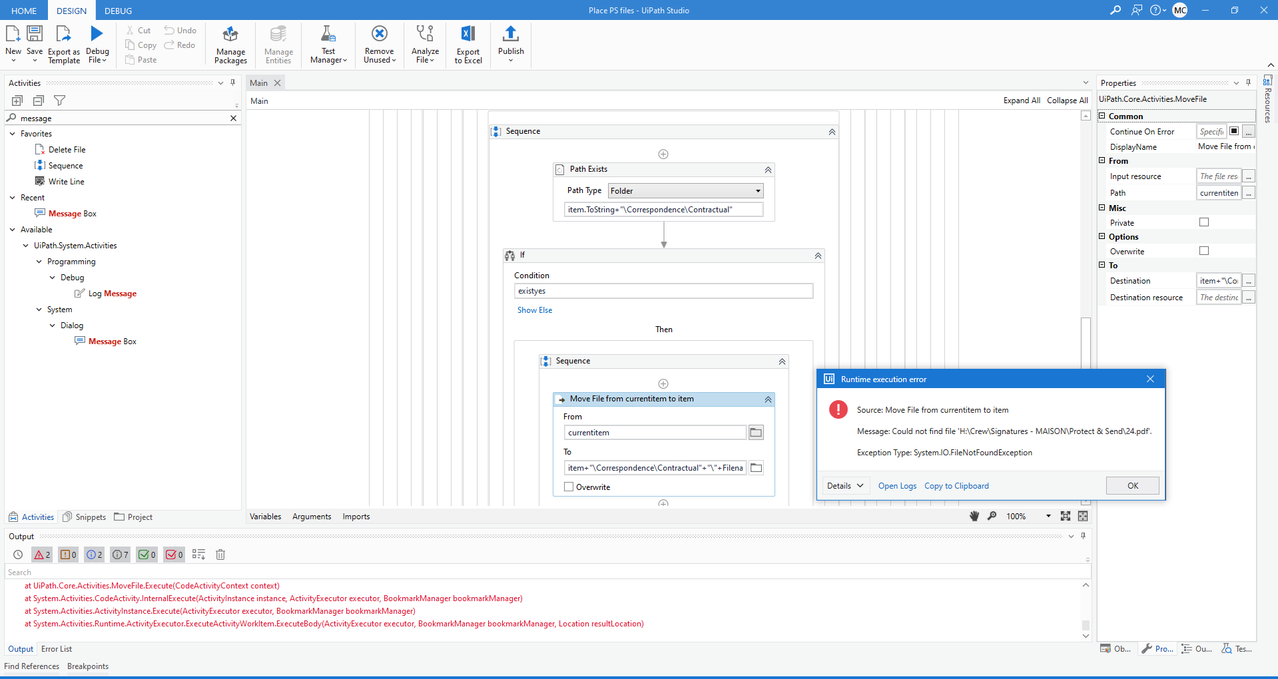

Only 824.pdf stay in the location

