Senario1:
InputXSD:Provide input XSD file folder path
InputXML:Provide input XML file folder path
Namespace: Provide target Namespace if you have. Otherwise it should be blank.
Message: Provide string it will return sucess or error message.
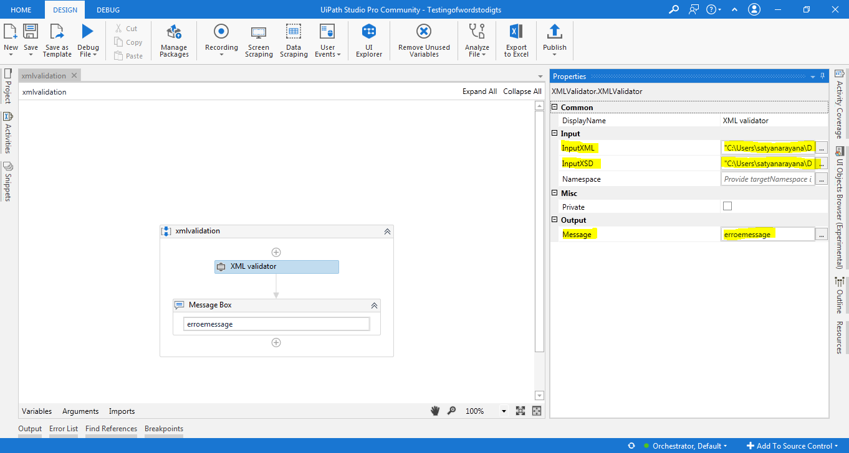
Here is my input xml folder path I am taking 3 xml files

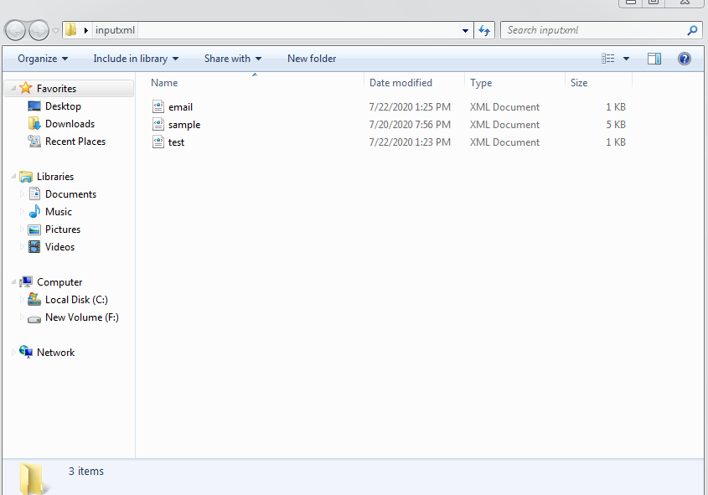

Here is my input xsd folder path I am taking 3 xsd files
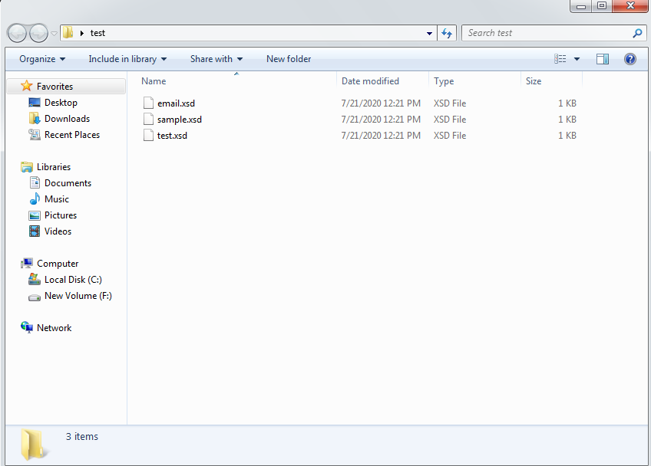
Note: Both xml and xsd file names should be same
Here is the final output return string message
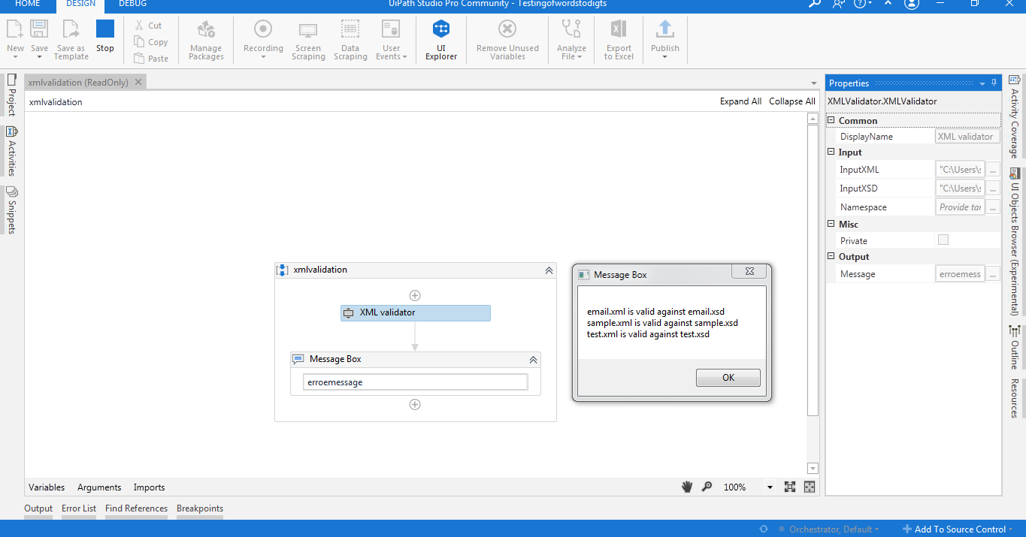

Scenario2:
Here I am taking input xml file and passing name space
<?xml version="1.0" encoding="UTF-8"?>
<bookstore xmlns="http://www.books.org">
<book category="children">
<title>Harry Potter</title>
<author>J K. Rowling</author>
<year>2005</year>
<price>29.99</price>
</book>
<book category="web">
<title>Learning XML</title>
<author>Erik T. Ray</author>
<year>2003</year>
<price>39.95</price>
</book>
</bookstore>
Here is I am taking input xsd file with targetnamespace
<?xml version="1.0" encoding="utf-8"?><xs:schema attributeFormDefault="unqualified" elementFormDefault="qualified" targetNamespace="http://www.books.org" xmlns:xs="http://www.w3.org/2001/XMLSchema"><xs:element name="bookstore"><xs:complexType><xs:sequence><xs:element maxOccurs="unbounded" name="book"><xs:complexType><xs:sequence><xs:element name="title" type="xs:string" /><xs:element name="author" type="xs:string" /><xs:element name="year" type="xs:unsignedShort" /><xs:element name="price" type="xs:decimal" /></xs:sequence><xs:attribute name="category" type="xs:string" use="required" /></xs:complexType></xs:element></xs:sequence></xs:complexType></xs:element></xs:schema>

Here is the result
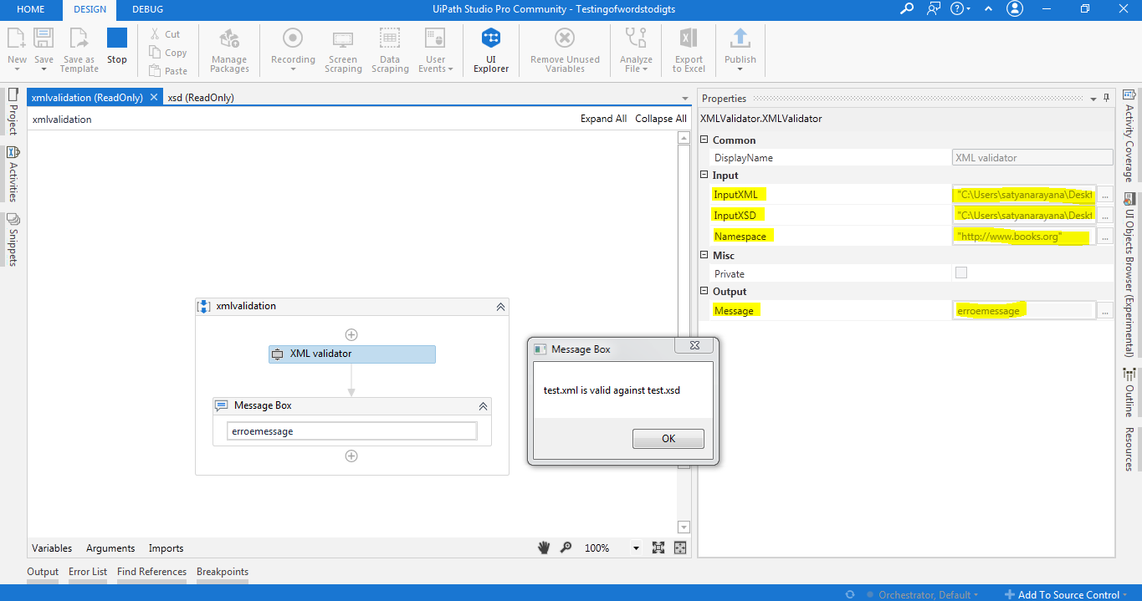
Senario3:
Here I am taking input xml file with tags are shuffle
<?xml version="1.0" encoding="UTF-8"?>
<bookstore>
<book category="children">
<author>J K. Rowling</author>
<year>2005</year>
<price>29.99</price>
<title>Harry Potter</title>
</book>
<book category="web">
<title>Learning XML</title>
<author>Erik T. Ray</author>
<year>2003</year>
<price>39.95</price>
</book>
</bookstore>

Here is my xsd file without tags shuffle
<?xml version="1.0" encoding="utf-8"?><xs:schema attributeFormDefault="unqualified" elementFormDefault="qualified" xmlns:xs="http://www.w3.org/2001/XMLSchema"><xs:element name="bookstore"><xs:complexType><xs:sequence><xs:element maxOccurs="unbounded" name="book"><xs:complexType><xs:sequence><xs:element name="title" type="xs:string" /><xs:element name="author" type="xs:string" /><xs:element name="year" type="xs:unsignedShort" /><xs:element name="price" type="xs:decimal" /></xs:sequence><xs:attribute name="category" type="xs:string" use="required" /></xs:complexType></xs:element></xs:sequence></xs:complexType></xs:element></xs:schema>

The message wii return with error message
"message": "test.xml is invalid against test.xsd The element 'book' has invalid child element 'author'. List of possible elements expected: 'title'.
