- Press Tools > Excel AddIn

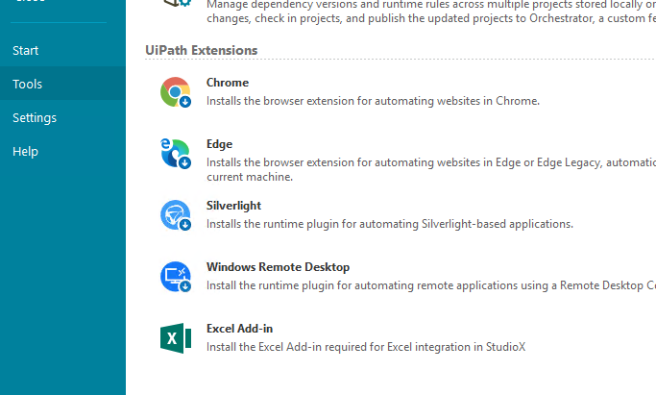

- This following message pops-up - before pressing OK, please make sure you save all open Excel Worbooks and close them manually.
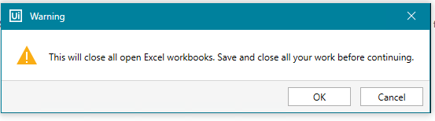

- If you have received this message. You are ready to GO.
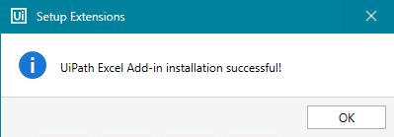

- You can Go to a new StudioX project and try “Indicate in Excel”
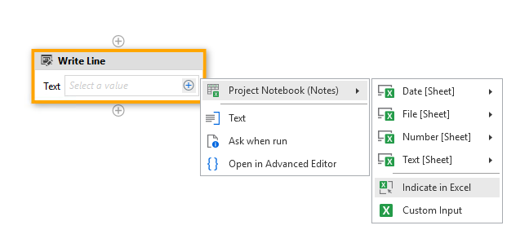
- This should open up Excel, with the “Selection Ribbon” on top of the document.

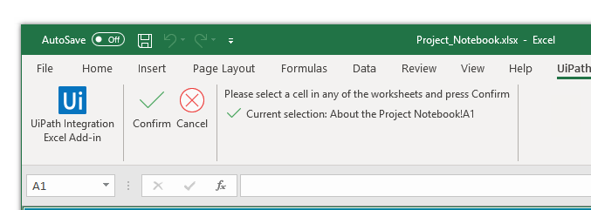

If you get an error message during Installation or when pressing “Indicate in Excel”, please perform the following checks:

- Microsoft Excel (Office 2010+) must be installed on your machine, and you should have a valid license. Some Excel installations are corrupt, and a re-install might be necessary (An error message indicates when a re-install is necessary)
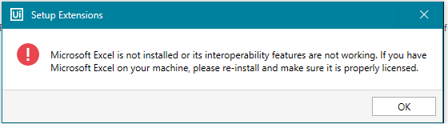
- Close all Excel instance manually and verify with Task Manager that you don’t have any blocked instances. If you do, click End Task.
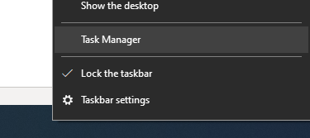

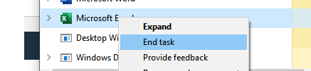

After this, try again to press “Install AddIn” and/or “Indicate in Excel”.

- Go to Microsoft Excel > File > Options:
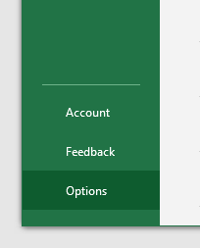

- Choose Add-ins
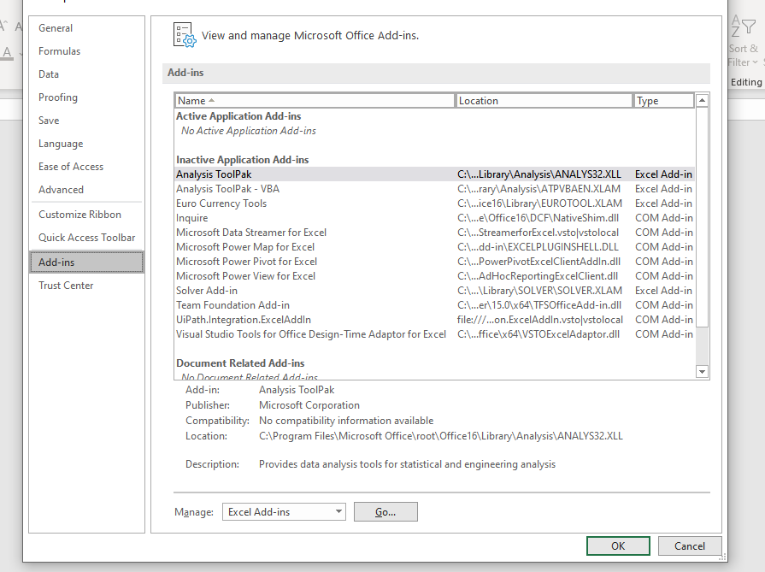

If UiPath.Integration.ExcelAddin appears In-Active or Disabled, try to enable it manually

- If the AddIn Appears as Disabled, select Disabled Items from the Manage dropdown and press GO:

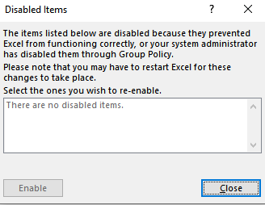

- In the above window, select the UiPath AddIn from the list and press Enable.

- If the AddIn Appears as Inactive, select COM Add-ins from the Manage dropdown and press GO:
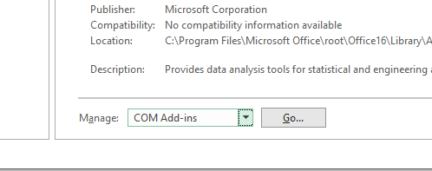

- Check the UiPath.Integration.ExcelAddIn and press OK:
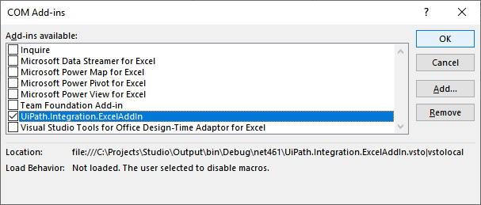
Please check the LoadBehavior message to see if there are any indication about why it was not loaded. In this case, Microsoft Excel user configuration is preventing the Add-in to be loaded.

- Go to Microsoft Excel > File > Options > Trust Center > Trust Center Settings

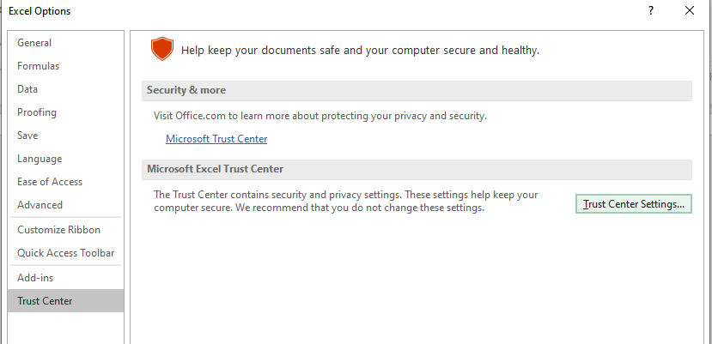

- Check if the UiPath certificate is in the Trusted Publisher list. 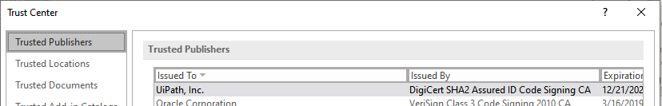

Make sure you have enough right to add a Certificate as trusted. Talk with your Domain Administrator about this if you are in a Company Network.

- If not, try to install the AddIn by double clicking the VSTO file at the following location:
For MSI Setup -- [UIPathInstallationFolder] / UiPath.Integration.ExcelAddIn.vsto
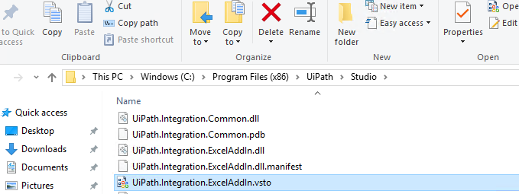
For community edition -- C:\Users\<your_username>\AppData\Local\UiPath\<app_version>\

- Double click should show the following message:
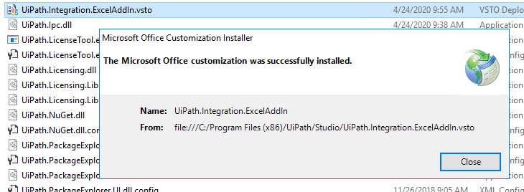

- If it still doesn’t work, check the Add-Ins section under Trust Settings. Make sure you haven’t disabled all AddIns:
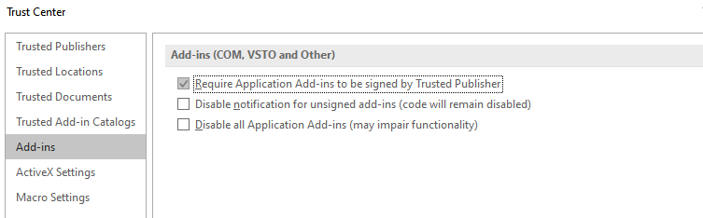

- If the Tools > Install ExcelAddIn link doesn’t’ work at all. It might be one of the following two causes:
- An Antivirus is preventing the installation script to be executed. Do it manually, using step 8 and 9

