- Web page visibility -
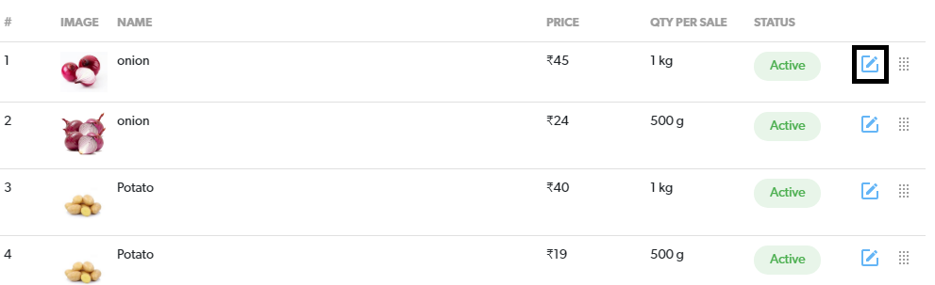
- Onclick of the above button, the following page displays –
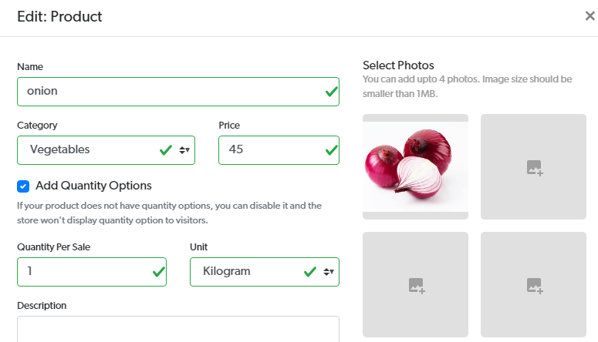
Problem: In the first step, not able to select and click on the icon (highlighted here on black).
In the second step, not able to update price.
Observations: In the first step, if I click on any product, it is not opening as a new page or URL, just opens up as a sub window.

