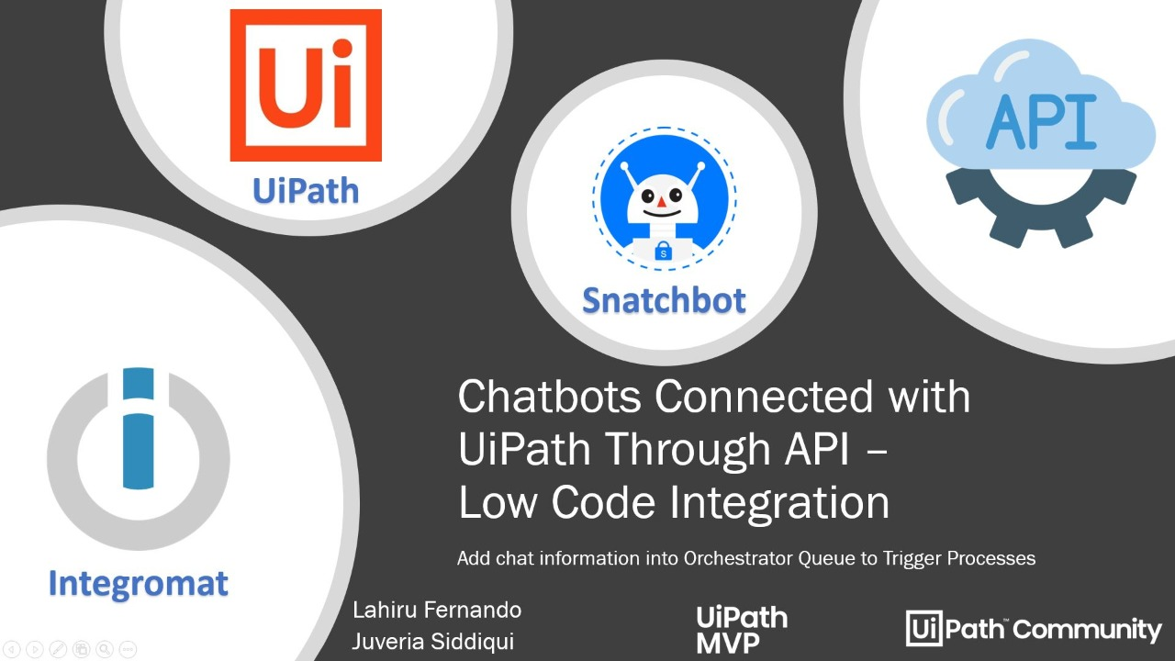

Table of Contents
Introduction 2
What will you need to get started? 2
About UiPath Orchestrator: 3
About Integromat: 3
About Snatchbot: 3
What are we trying to achieve using this chatbot? 4
Creating chatbot framework on Snatchbot platform 5
Steps to create Banker Bot 6
Information from UiPath Orchestrator. 17
Tenant Information 17
Orchestrator API Request to get Access Token 20
Orchestrator API Request to Create Queue Items. 21
Integromat: API Integration 23
Steps to create last interaction in Snatchbot: 30
Integromat Configuration steps: 32
Let’s run a final version. 41

Introduction
This document is a step by step guide to integrate UiPath, Snatchbot platform, and Integromat to create a chatbot.
This chatbot is called as ‘Banker’ and it takes up request from the applicant who wants to add a bank account to ACME system.
An applicant needs to provide all details as requested by the Banker Bot. Banker bot is connected to UiPath Orchestrator using Integromat platform for API integration. A queue item is created with all the applicant’s details. The Queue in the UiPath orchestrator has Queue trigger enabled, so as soon as the details are added to the queue, UiPath Robot takes over the work to add a bank account in the ACME system.
The integration is simple and interesting. Let’s meet Banker Bot.
If you are wondering, what else can we do with UiPath, Snatchbot and Integromat integration? This document will help you explore all the three platforms and will help you create your own chatbot.

What will you need to get started?
- An account on UiPath Orchestrator. For the documentation purpose, I have the account created on cloud UiPath orchestrator (https://cloud.uipath.com/).
- An account on Snatchbot platform (https://snatchbot.me/)
- An account on Integromat platform (https://www.integromat.com/)

About UiPath Orchestrator:
UiPath orchestrator is the core of managing all your automation. It gives you the power to provision, deploy, trigger, monitor, measure, track, and ensure the security of every robot in your organization. So now you can manage everything from your browser—or your mobile device.

About Integromat:
Integromat is a powerful integration platform that allows you to visualize, design and automate your work. We are using Integromat for UiPath Orchestrator API integration with Snatchbot platform.

About Snatchbot:
Snatchbot eliminates complexity and helps you to build the best chatbot experience for your customers. It provides robust administrative features and enterprise-grade security to comply with regulatory mandates.
Now that we know what needs to be done, let’s get started!!
Let’s see the UiPath workflow in the studio and ACME system first.

What are we trying to achieve using this chatbot?
This chatbot is called as ‘Banker’ and it takes up request from the applicant who wants to add a bank account to ACME system.
An applicant needs to provide all details as requested by the Banker Bot. Banker bot is connected to UiPath Orchestrator using Integromat platform for API integration. A queue item is created with all the applicant’s details. The Queue in the UiPath orchestrator has Queue trigger enabled, so as soon as the details are added to the queue, UiPath Robot takes over the work to add a bank account in the ACME system.
The details that the Banker bot needs are:
- First Name
- Last Name
- City
- Email ID
- Phone Number
- Age
- Number of Dependents
Once these details are given to Banker bot, in the chat, the chatbot then triggers the API call, and creates a queue item.
Our queue is on UiPath orchestrator and has Queue trigger enabled, such that, as soon as a new item is added, UiPath robot is triggered.
Once the UiPath robot is triggered, it will open the ACME system, and add a bank account for the applicant.
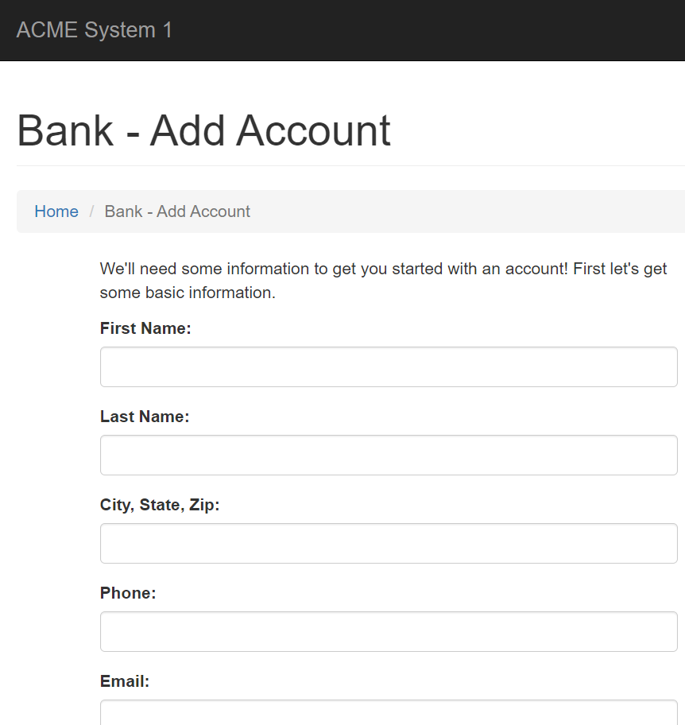

I have attached the UiPath Studio workflow for your perusal.

Creating chatbot framework on Snatchbot platform
First things first, let’s start by creating a chatbot on Snatchbot platform that will welcome an applicant and will request for following details:
- First Name
- Last Name
- City
- Email ID
- Phone Number
- Age
- Number of Dependents
The bot works by adding new interaction/plugin, and you have multiple options to select from.

Steps to create Banker Bot
- Once you have created your account/logged into your account on the platform click on My Bots and then click on Create Bot.

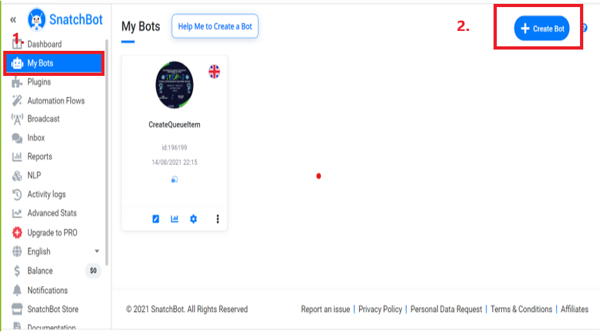
- Select a Blank bot template to start with the bot creation.

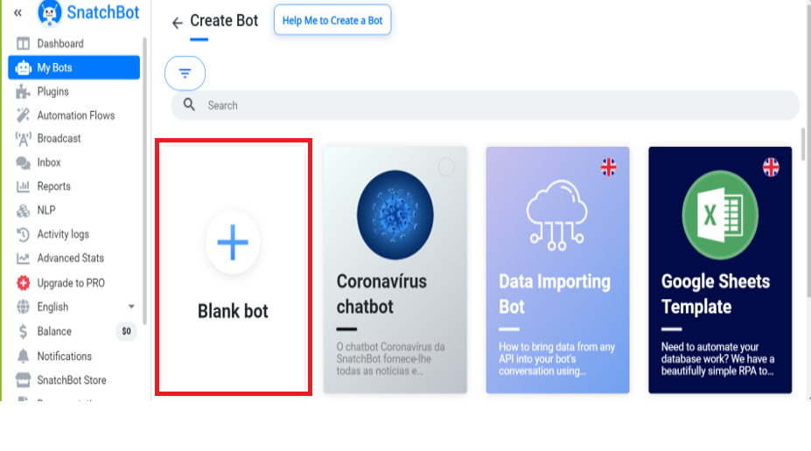

- Upload an image for your bot, this image will serve as the look for your chatbot. Provide a name of your choice and a meaningful description.

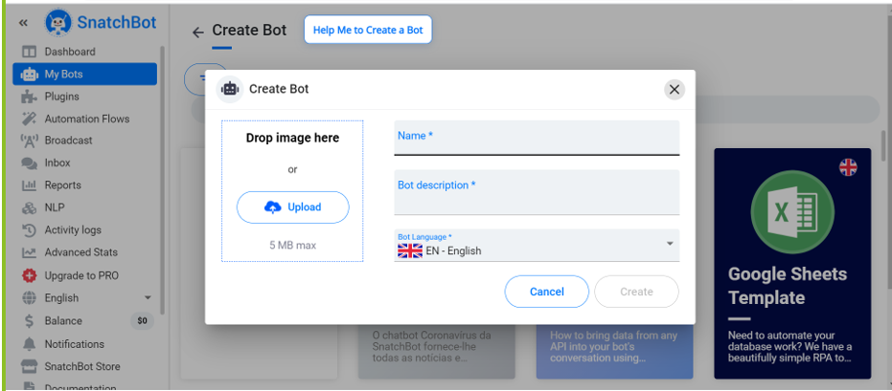

- Once done click on create, this will lead you to below page where you can start creating interactions for the bot. Click OK.

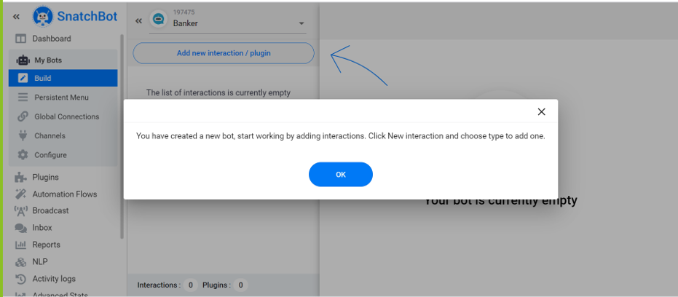

- Click on Add new interaction and select Bot Statement and give a name to your interaction. We will start by giving it a name as ‘Welcome’

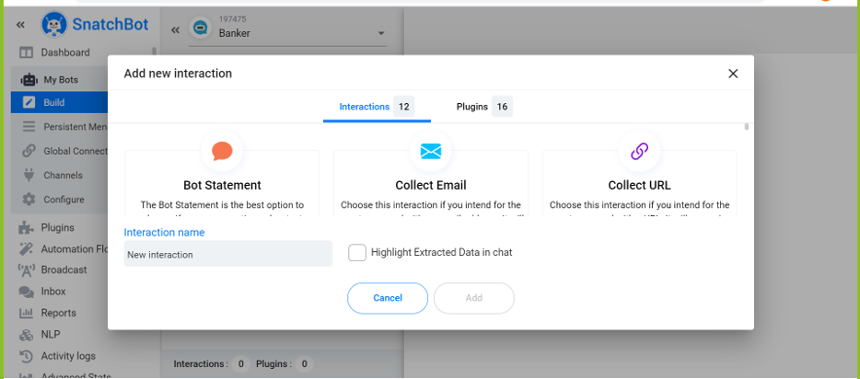
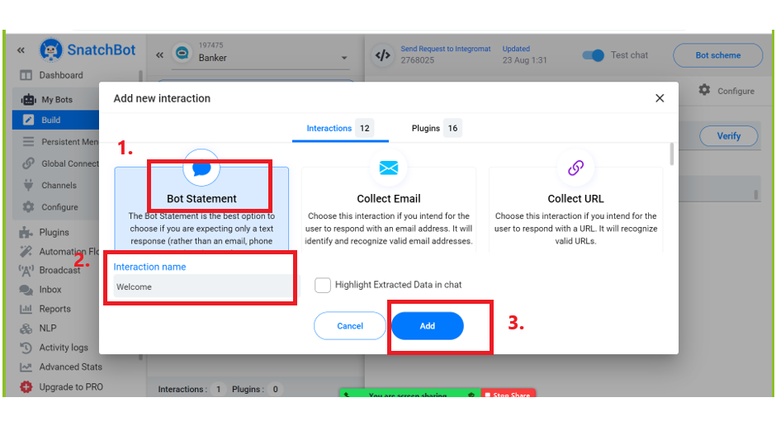

- We will be working on 3 parts of the interaction we create.
- Bot Message
- Configure (Attributes)
- Previous Reply (this will help us capture applicant’s input to previous interaction)
- Connection (this will connect one interaction to other)

- A new interaction will look like this, for Welcome interaction let’s start by providing the bot message as shown below and then clicking on connection:

Bot Message: Hi, I am a Banker Bot. How can I help you today?

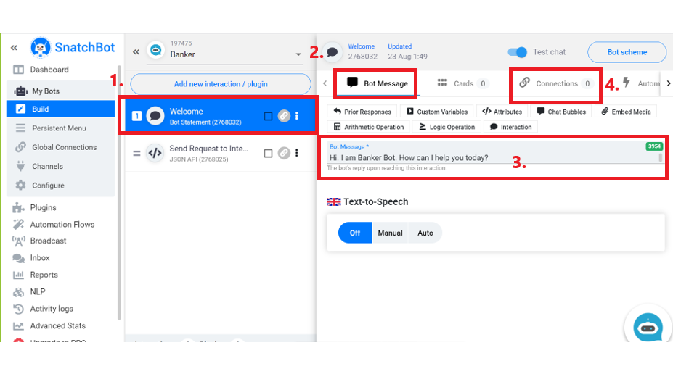

- Under connections, we are going to use Quick Replies for Welcome Interaction.

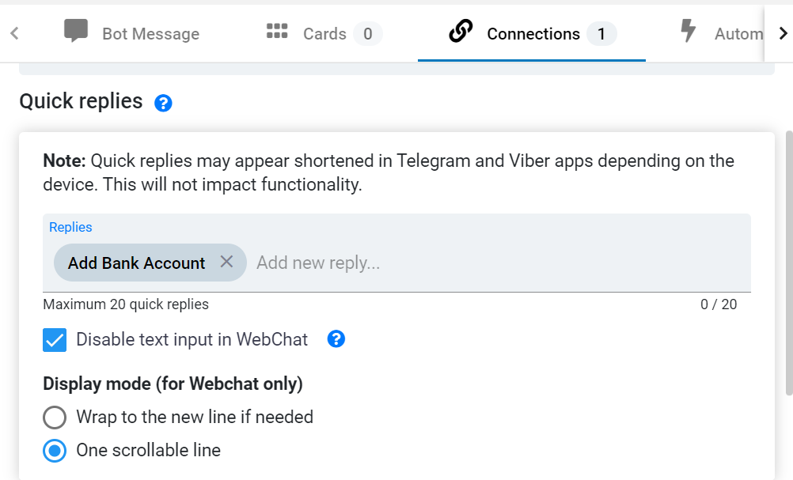

- Click on Add new reply or simply start by typing Add Bank Account and then press Enter, an example is shown below. Proceed by clicking Yes

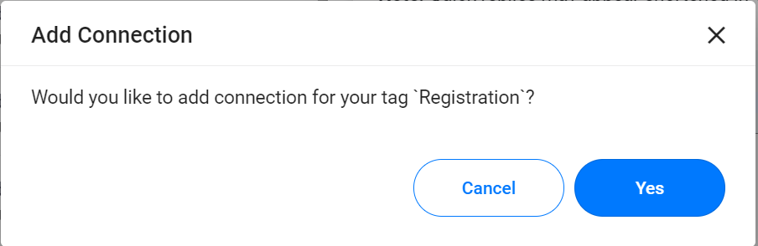

- Proceed by providing following information. In our case we can keep Interaction field in the pop-up as blank for now and we will populate it later with our next interaction. Click on Add Quick Reply. We will re-visit this step, after creating our next interaction.

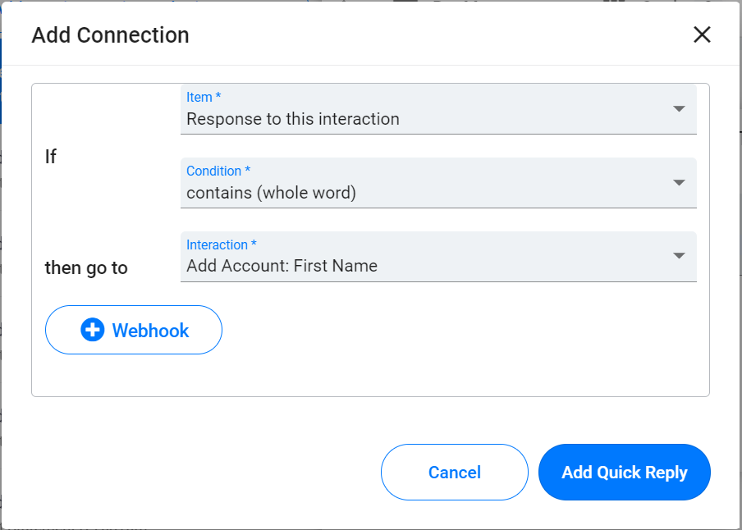

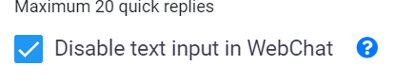
- Follow step 5 to create a new interaction. Name this interaction as Add Account: First Name.
- Bot Message: Please give your First name
- Re do Step 10.
- Pay close attention to below highlighted detail as it will be used further. This is the ID for each interaction and we are going to use it to capture previous reply.

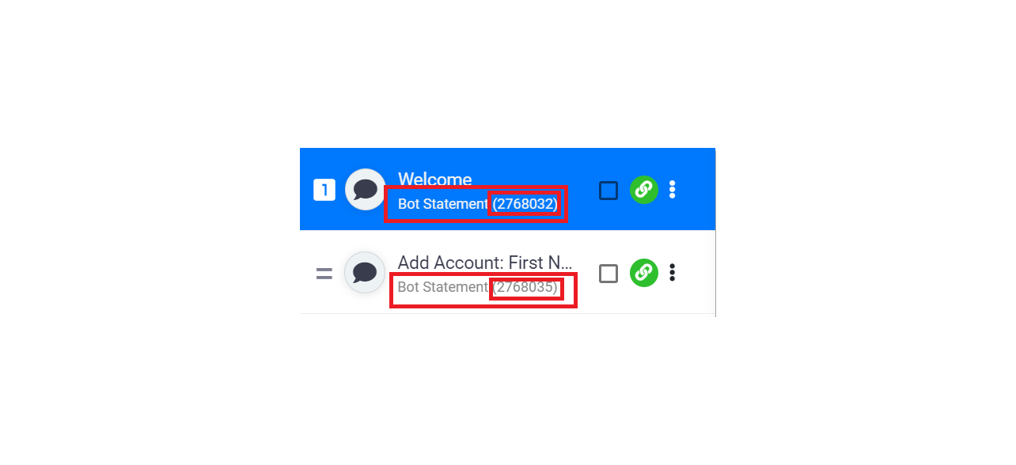

- Before moving forward let’s build on concept. To capture the details which the applicant will provide us in the chat, we will use Attribute.
- So imagine we have two interaction called A and B. The response from A will be captured in B using Previous Reply option found in Bot Message tab as shown below.

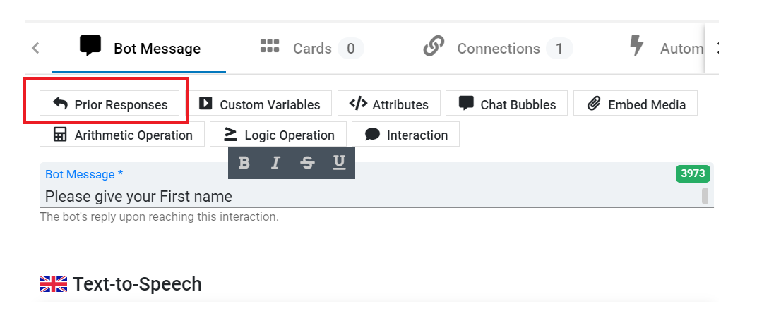

- Let’s click on Prior Response and select below highlighted option. This will generate a text:
[responseTo interaction=ID fallback=TEXT].
This text serves as the value of attribute as discussed in Step 13. Replace the value of ID as explained in step 12.
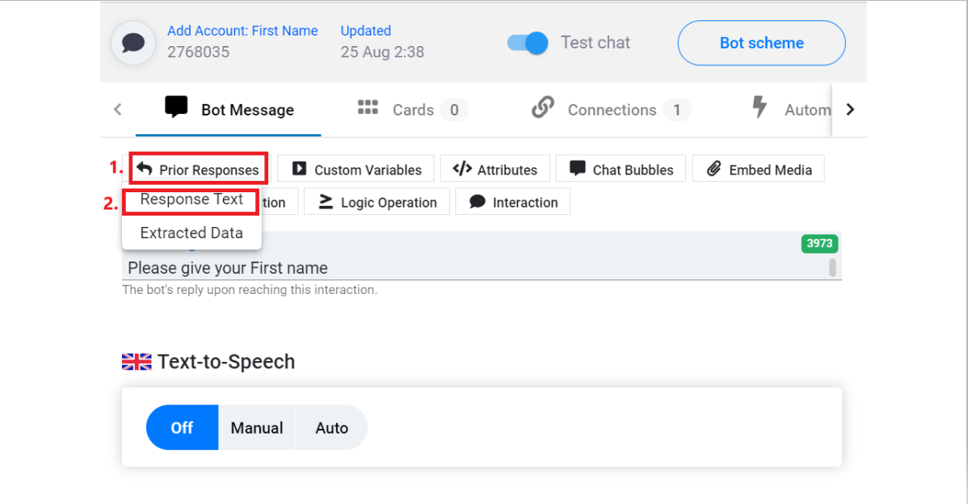

- Let’s learn how to configure attribute by creating a new interaction with name Add Account: Last Name
- Bot Message: Please give your Last name
- Now we will use Add Account: Last Name interaction to capture response from interaction Add Account: First Name
- To do that click Configure tab on Add Account: Last Name interaction and under Custom Attributes, provide attribute name firstName in Attribute Key and in Attribute Value, copy text from Step 17 and provide the ID (explained in Step 14) of the interaction Add Account: First Name
Attribute Value in this case as per below image: [responseTo interaction=2768035 fallback=TEXT]
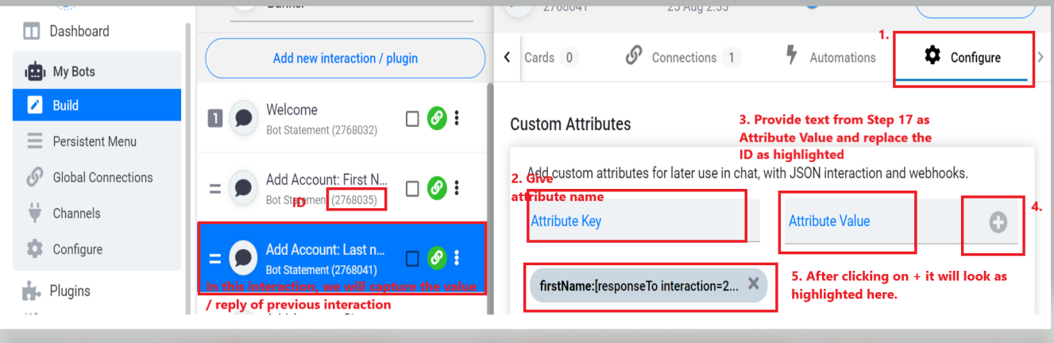
- Now we need to connect the two interaction that we have created in such a manner that after Welcome interaction we go to Add Account: First Name then we go to Add Account: Last Name
- In order to do this, lets click on Connections tab in the interaction Add Account: First Name.
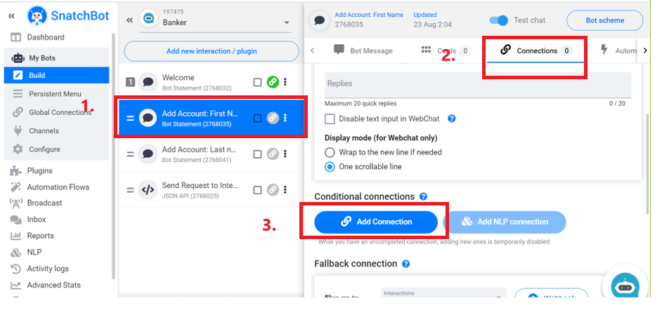
- Provide exact information as highlighted in below image.
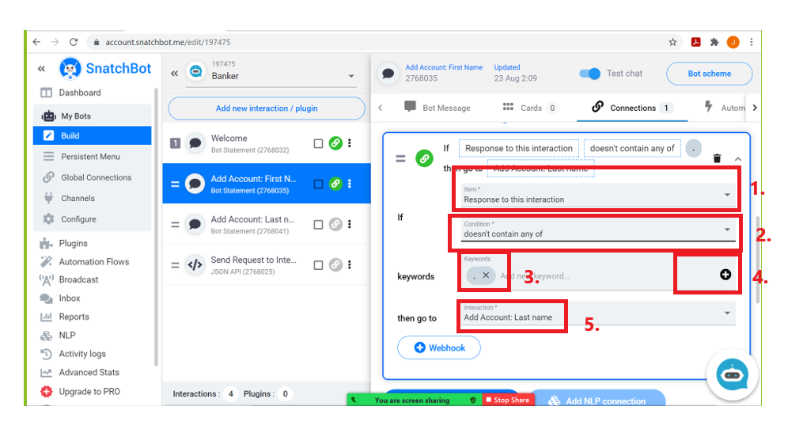

- Create other interaction in similar way to capture other information like City, Age, Number of Dependents, Phone Number and Email.
- Create an Interaction with name Proceed and create below connection:
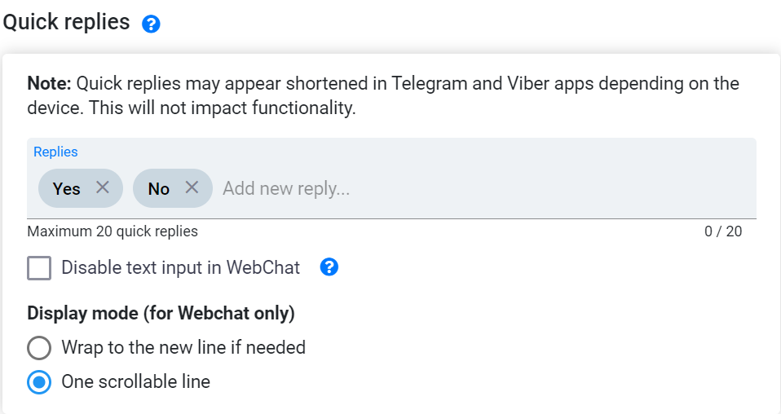

- Our last interaction will be used to connect to UiPath orchestrator. But before discussing that, let’s learn a few things that we need from UiPath Orchestrator and Integromat.

Information from UiPath Orchestrator.
We will be using UiPath Orchestrator API. Let’s learn about following topics:
- Tenant Information
- Orchestrator API Request to get Access Token
- Orchestrator API Request to Create Queue Items.

Tenant Information
Follow below highlighted steps to gather tenant information from UiPath orchestrator.
- Login to UiPath Orchestrator.
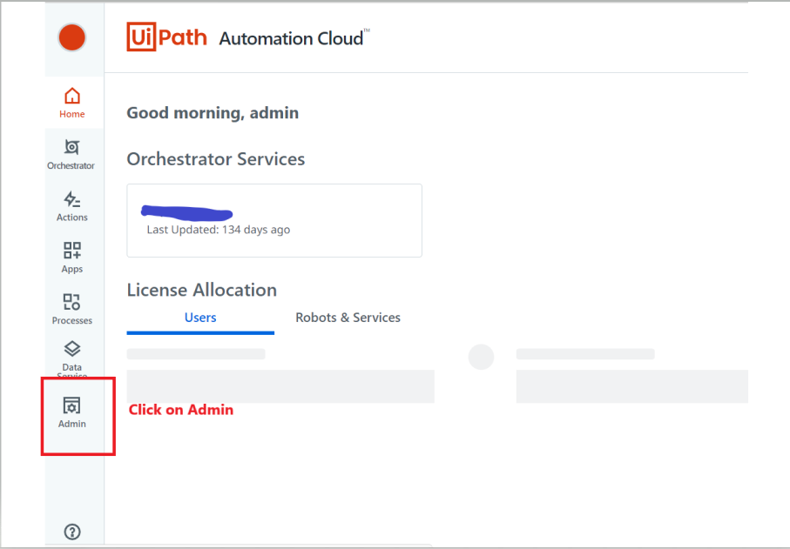
- Click On Tenant and then expand to see your orchestrator. Click on highlighted areas.

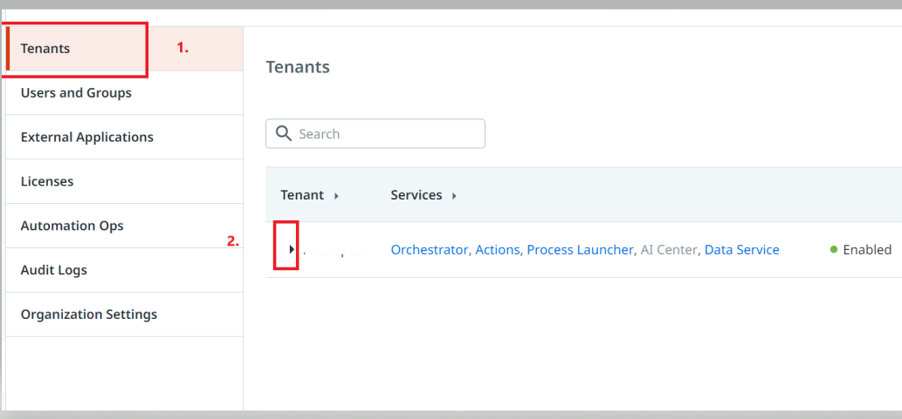

- Alongside Orchestrator, click on 3 dots to gather information.
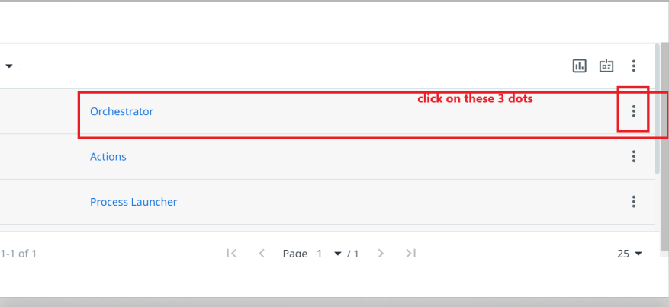

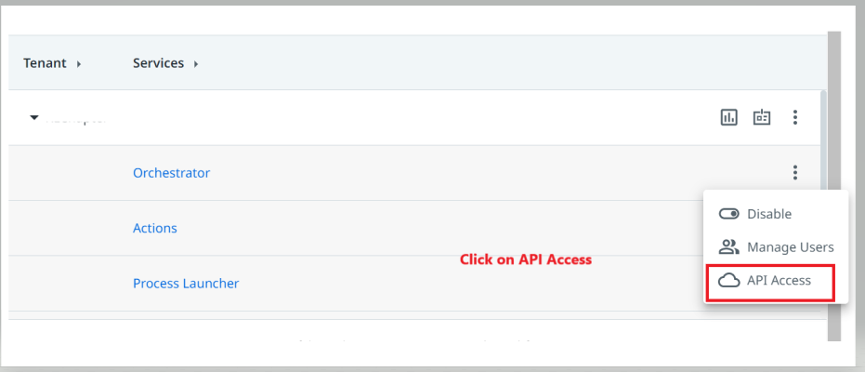

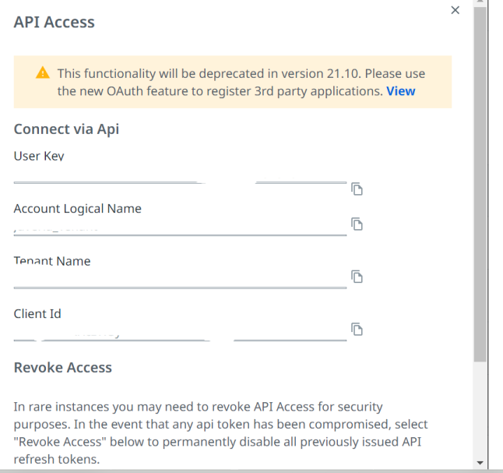

User Key will be used as Refresh token

- Click on Orchestrator and check the URL for fid which serves as Organization ID.
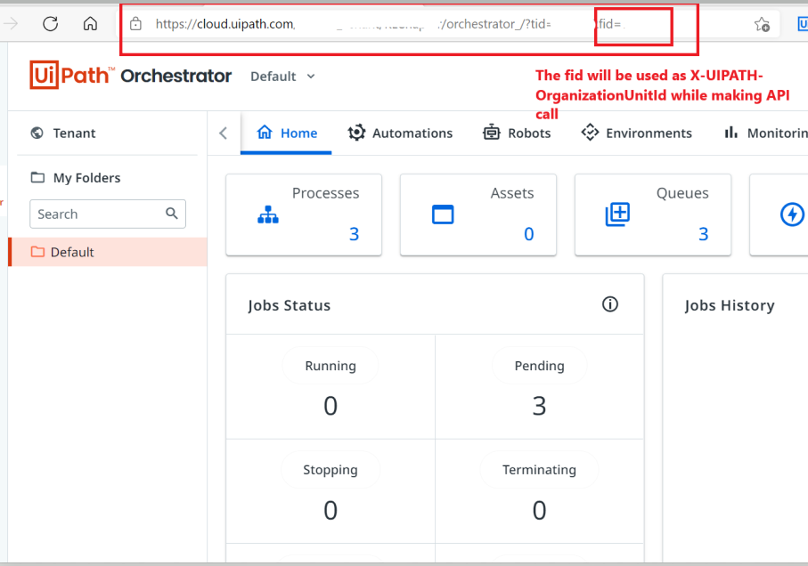

All the above information will be used to make API calls.

Orchestrator API Request to get Access Token
Type: POST
URL: https://account.uipath.com/oauth/token
Header:
- X-UIPATH-TenantName = gathered from above steps
- Content-Type = application/json
Request Body: Raw and Format JSON. Get details for client_id and refresh_token from above step.
{
"grant_type": "refresh_token",
"client_id": “”,
"refresh_token": ""
}
Response Body:
From the Response body we will use access token.
{
"access_token": "",
"id_token": "",
"scope": "openid profile email offline_access",
"expires_in": 86400,
"token_type": "Bearer"
}

Orchestrator API Request to Create Queue Items.
Type: POST
URL: https://platform.uipath.com/{Tenant Name}/{Account Logical name}/odata/Queues/UiPathODataSvc.AddQueueItem
Header:
- Authorization: - Bearer ‘access token’ from above API response
- Bearer suffix will be used before access token.
- X-UIPATH-TenantName: - From above steps
- Content-Type = application/json
- X-UIPATH-OrganizationUnitId: - From Above Steps
Request Body: Raw and type JSON
Use the same request body for our use case. Specific Content is nothing but the Queue items.

{
"itemData": {
"Name": "Queue name",
"Priority": "Normal",
"SpecificContent": {
"FirstName": "we will get this from chatbot response",
"FirstName@odata.type": "#String",
"LastName": "we will get this from chatbot response",
"LastName@odata.type": "#String",
"City": "we will get this from chatbot response",
"City@odata.type": "#String",
"Phone": "we will get this from chatbot response",
"Phone@odata.type": "#String",
"Email": "we will get this from chatbot response",
"Email@odata.type": "#String",
"Age": "we will get this from chatbot response",
" Age@odata.type": "#String",
"NOD": "we will get this from chatbot response",
" NOD odata.type": "#String",

}
}
}

Let’s proceed to Integromat and learn how to make these API calls using above information.

Integromat: API Integration
- Login to your Integromat account and follow below steps.
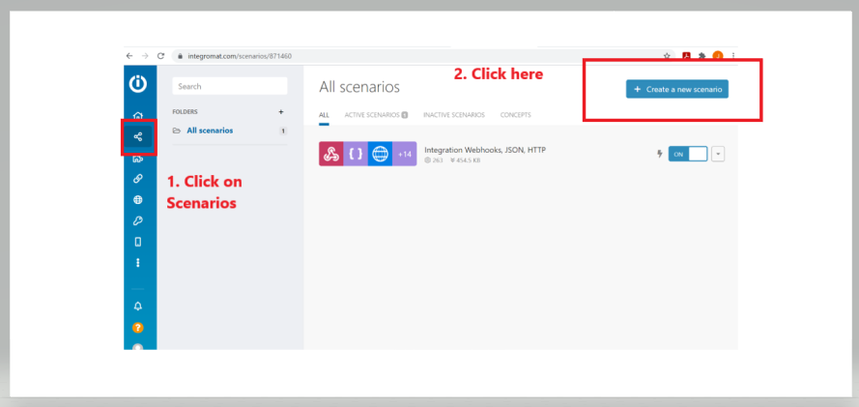

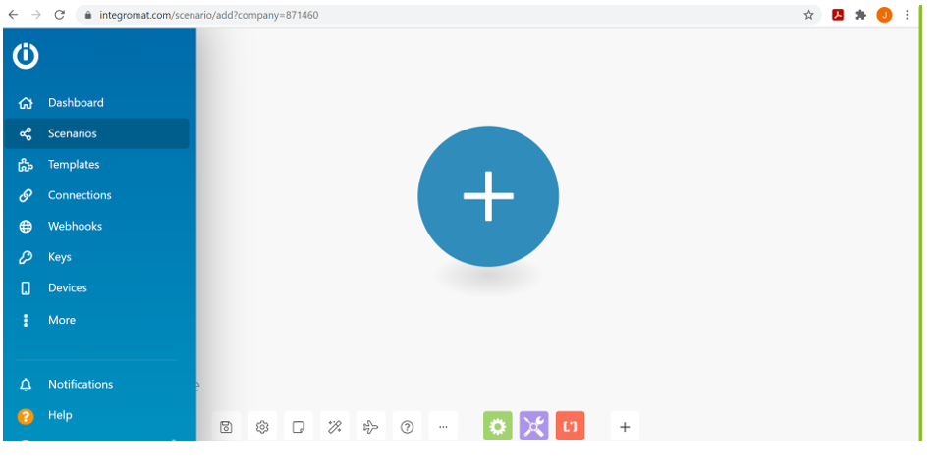

- Click on this plus sign and select ‘Webhooks’

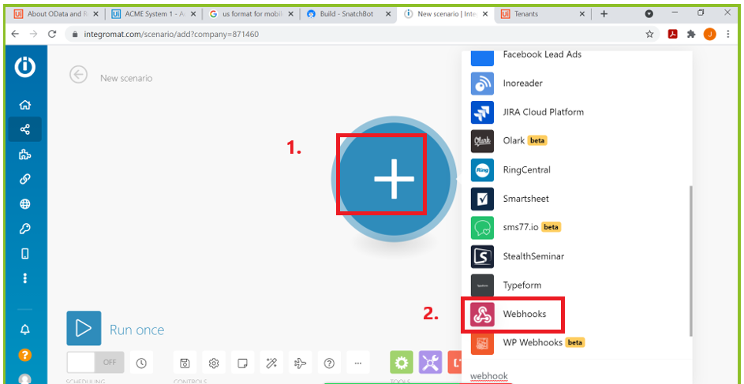

- Select Custom Webhook as shown below

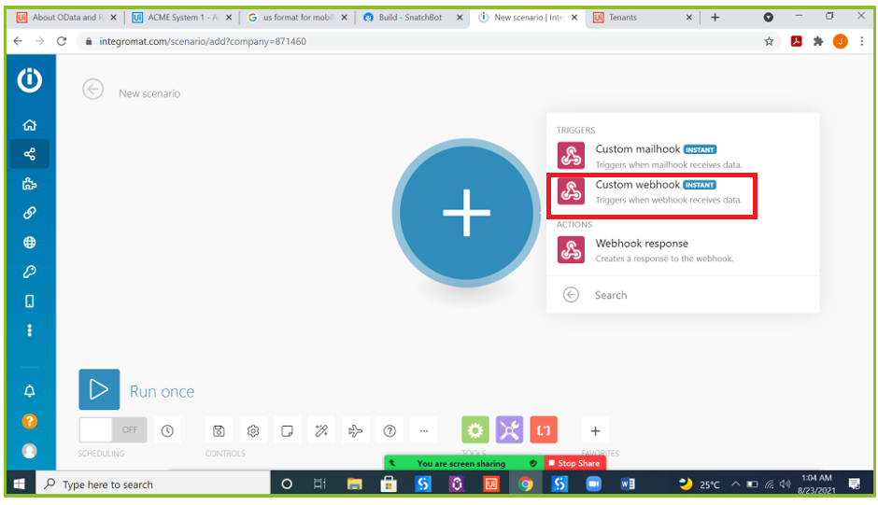

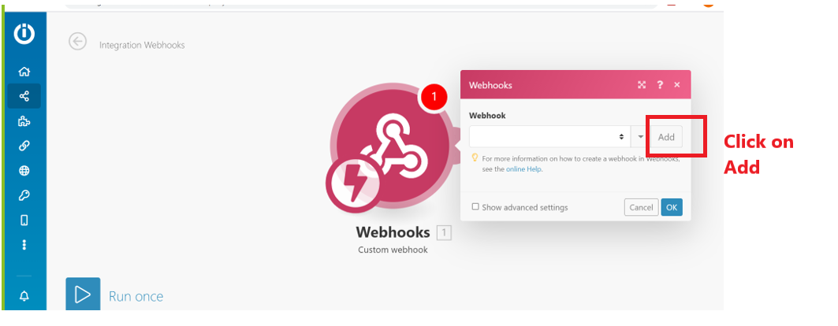

- Provide a Webhook name of your choice and save.

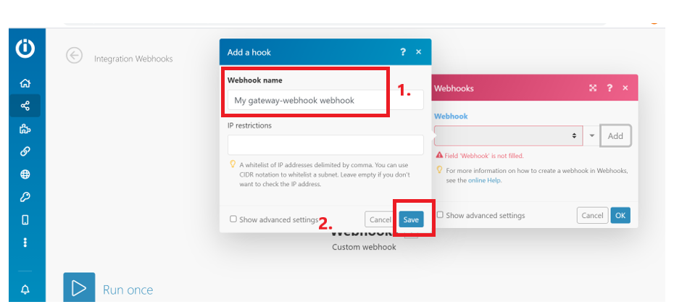

- Click on the Webhooks activity. You will see below information , copy the URL as this will be used in our last interaction in Snatchbot.

You can right click and select Rename. This will give meaningful name to each activity that we are going to use.

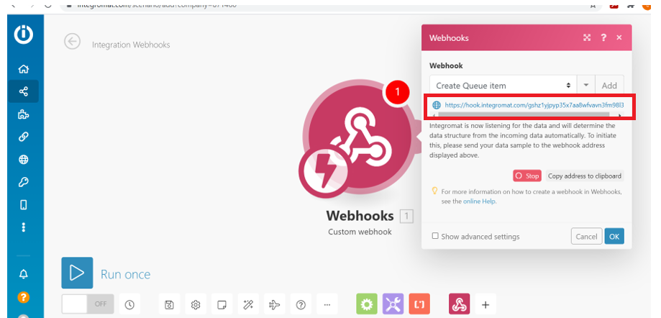

- Our first job in Integromat is make an API call to generate access token. The request body and its type has been explained above in the document. We will also need to create the same JSON request body in Integromat.

Let’s start by creating the request body for generating the access toke. Revisit API Call for this section.
- Click on Plus sign and follow the highlighted steps. We will use Create JSON activity to form our request body.

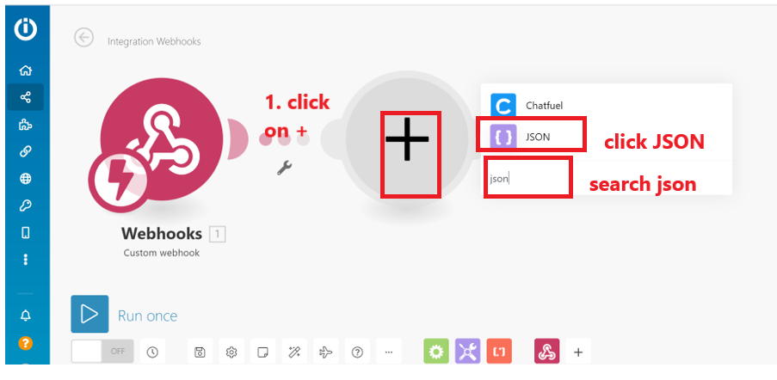

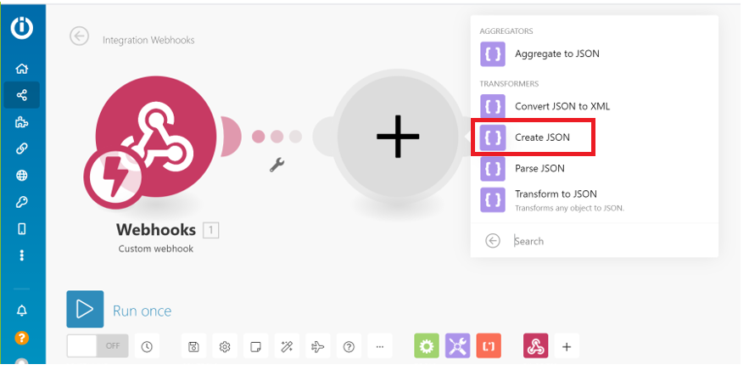

- 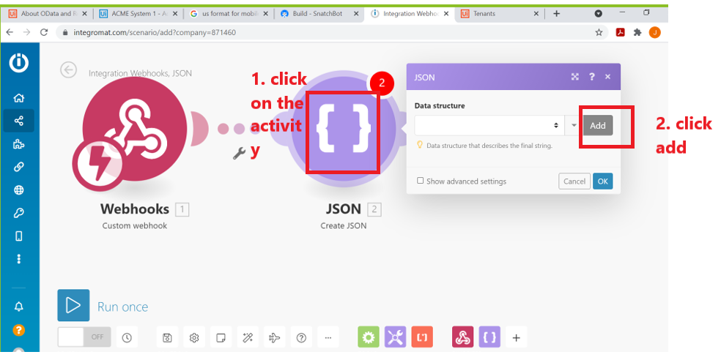

- 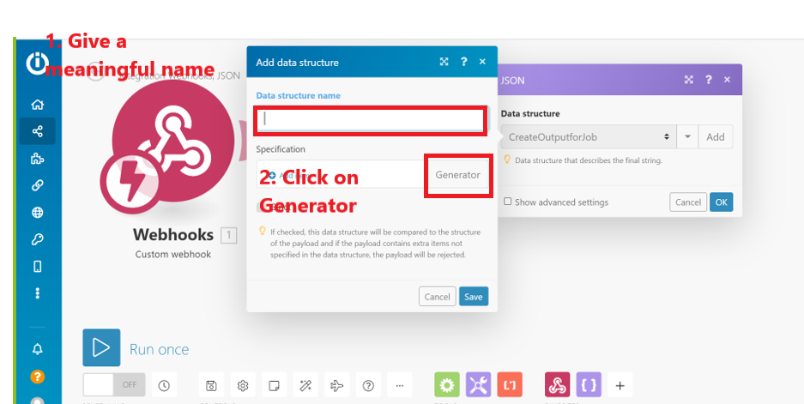

- Provide below information: Content type: JSON and request body in Sample data as shown below
For more details on below request and values for client_id and refresh_token, click here.
{
"grant_type": "refresh_token",
"client_id": "",
"refresh_token": ""
}

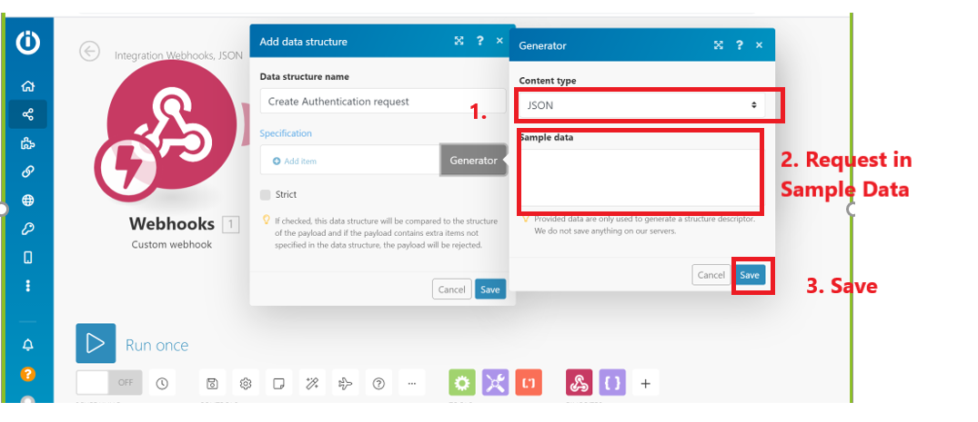

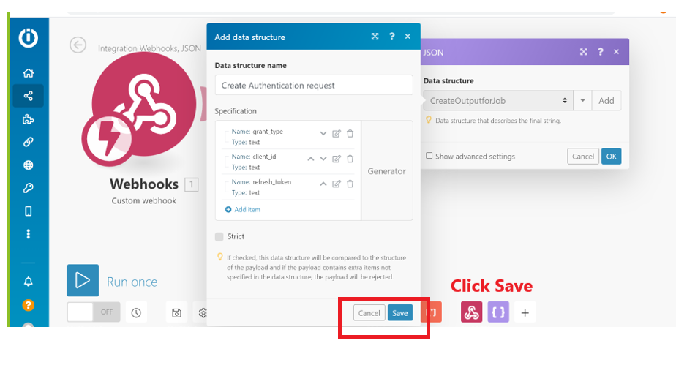

- Click on the activity Create JSON to open the dialog box and provide all the values and then click ok.
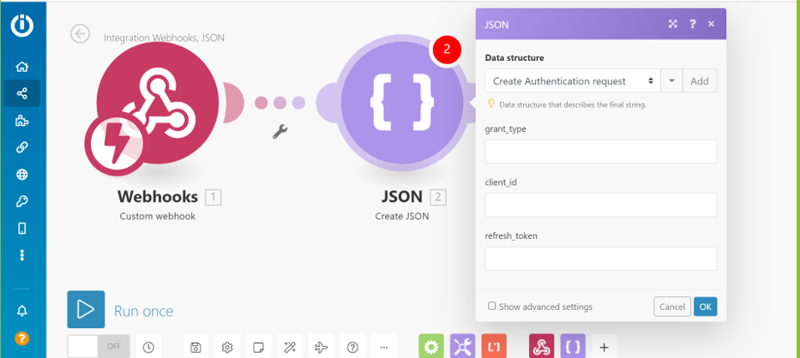

Before we move forward, let’s go back to Snatchbot and create our last interaction of type JSON.

Steps to create last interaction in Snatchbot:
This brings together all the three platforms. Let’s look at the steps. Why do I need to do this??
In order to test our API calls in Integromat we will need to create this last interaction in Snatchbot.
- Let’s start by clicking on Add new interaction in Snatchbot and selecting JSON as option. Let’s give this interaction a meaningful name highlighted below.
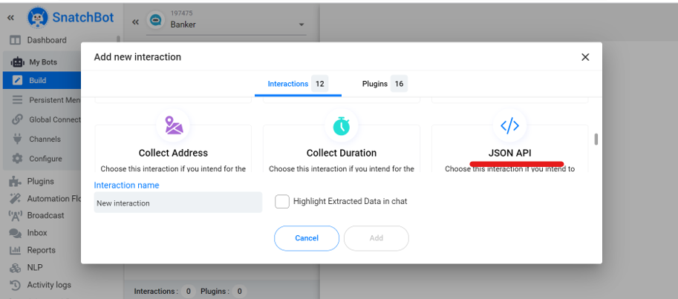

- 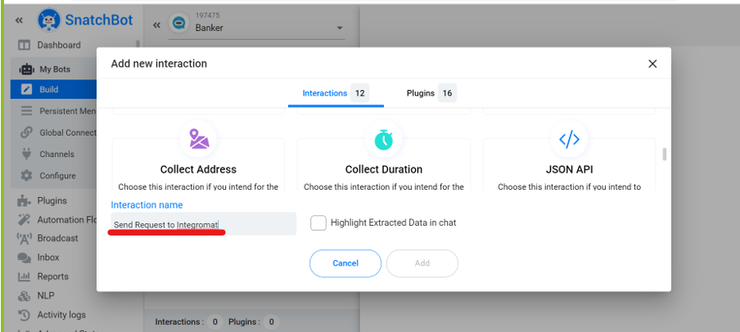

- 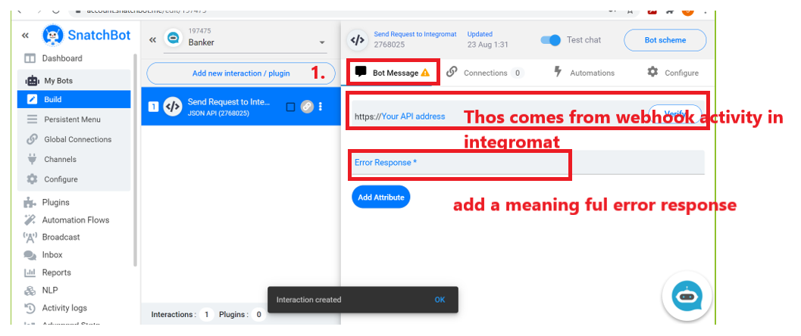

- Click on attribute and from the drop down select all the attribute that were created in our previous interactions.

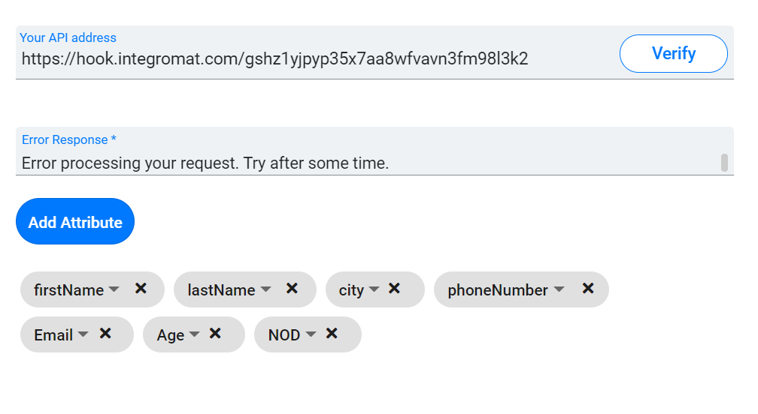

Now that we have successfully created all the interaction in the chatbot, let us now proceed with Integromat

Integromat Configuration steps:
- In previous steps we have learned how to create JSON request body, now we will learn how to make a POST request in Integromat.
- Click on plus sign and search for HTTP as shown below. Select ‘Make a Request’ option.

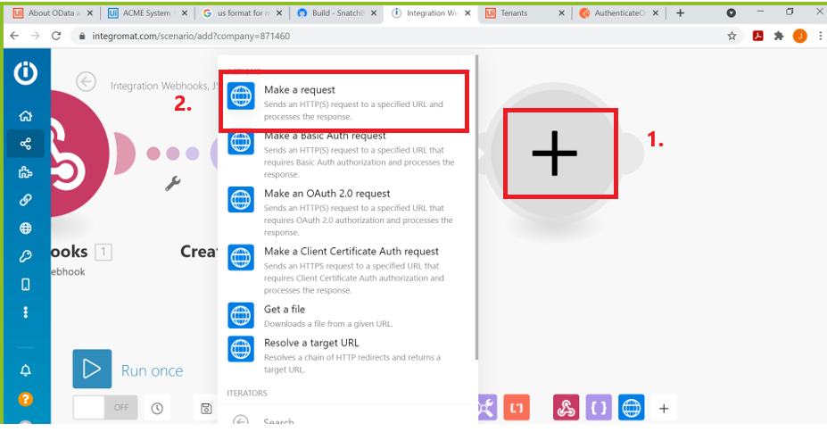

- Click on HTTP activity

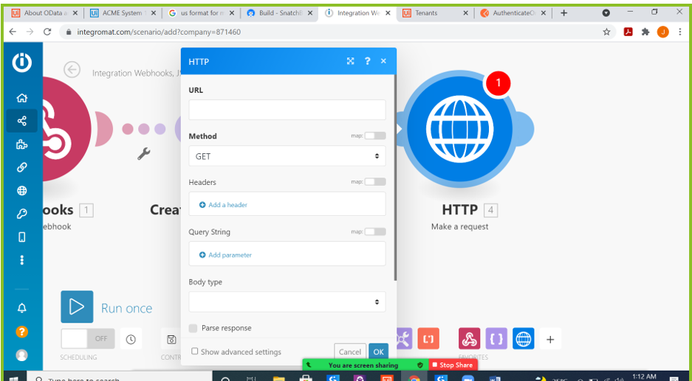

- Provide below information.URL and Header information can be found here. Body Type: Raw and Content type JSON.
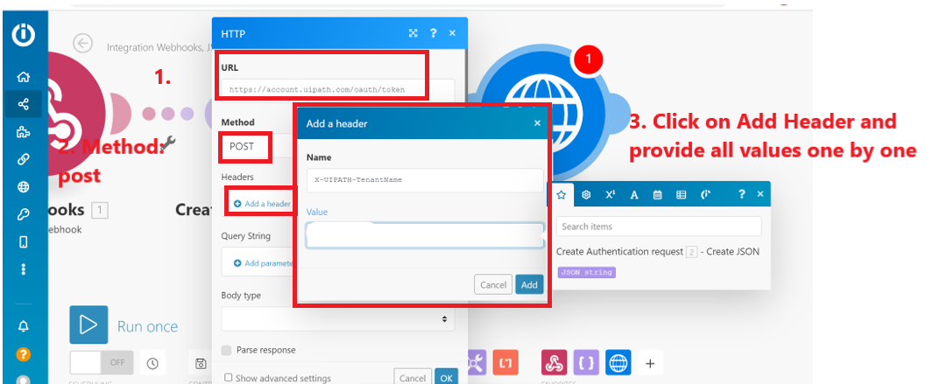

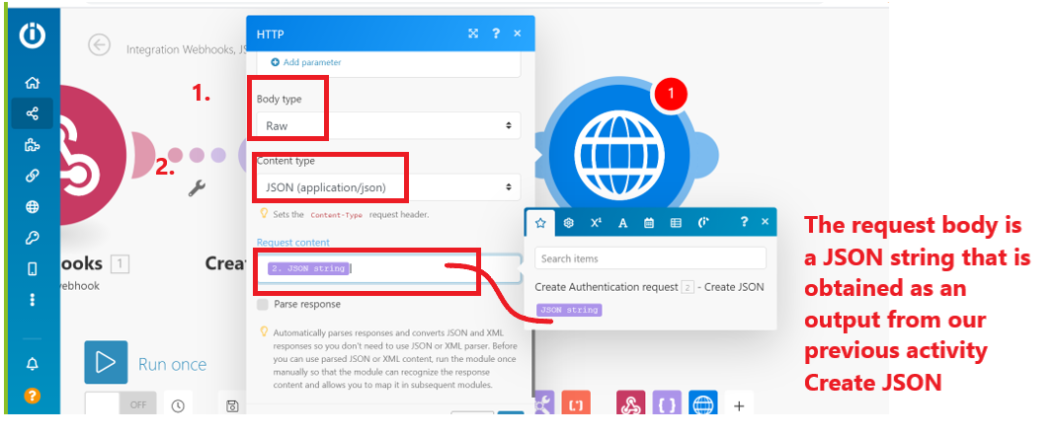

- The flow should like this. Run it once by clicking the Run Once option.

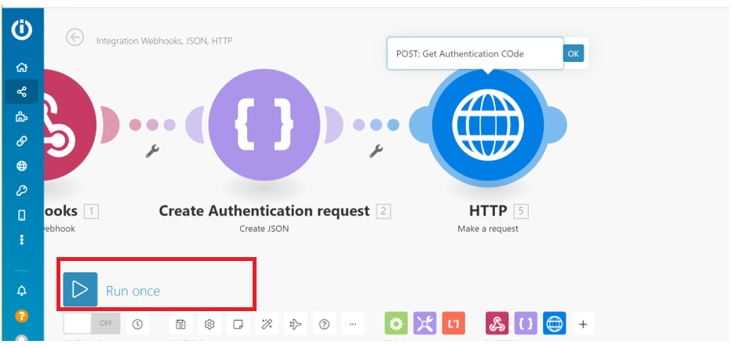

- Once you click on ‘Run Once’, go to your Snatchbot and launch your chatbot as shown below, and provide all information as requested by the chatbot. The reason of doing this is to get the output of the HTTP activity in Integromat.

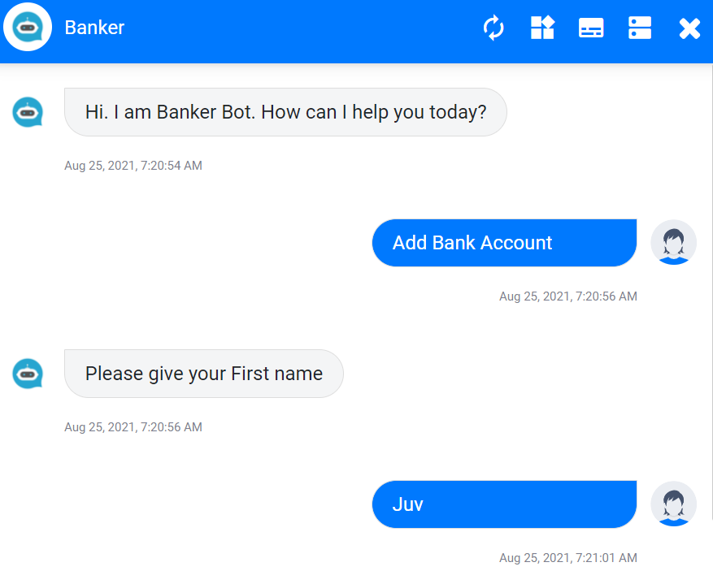

I know it’s getting interesting by each step now!!

- We will be testing our Integromat flow each time in this same way as described above.
- The output of the HTTP activity is basically a JSON string and from that string we need to extract access token. To do that, let’s click on plus sign and use Parse JSON activity. Once you select it, click on the activity.
- The output from HTTP activity will look like below:
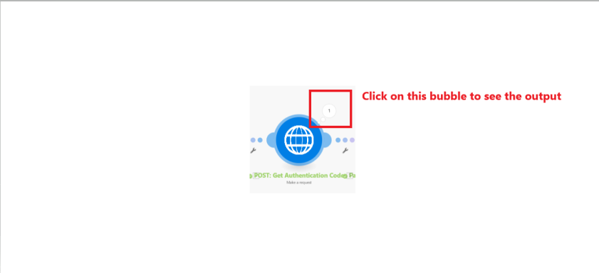
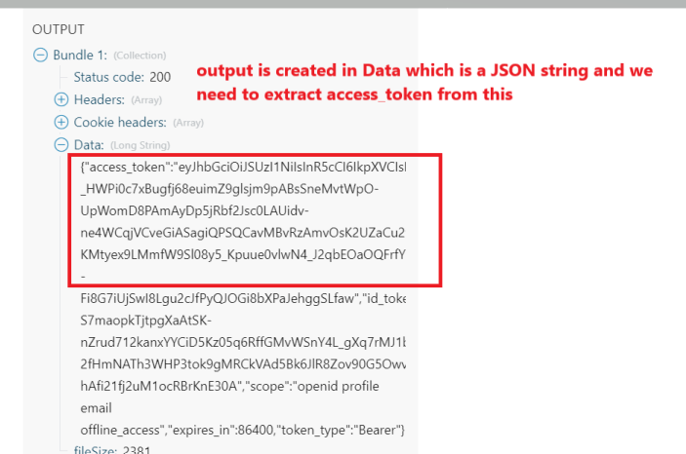

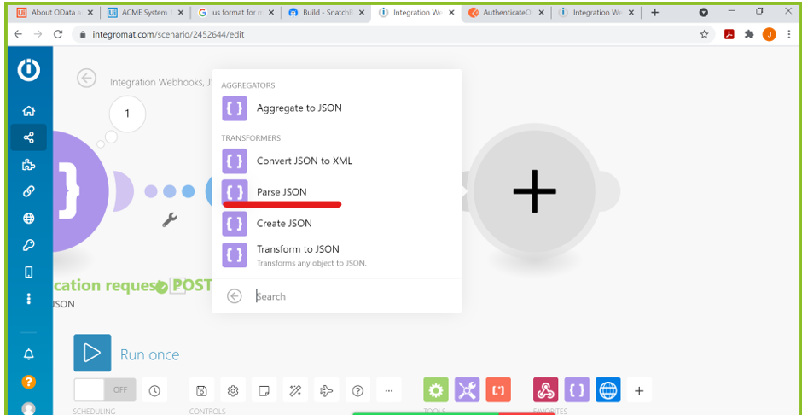

- 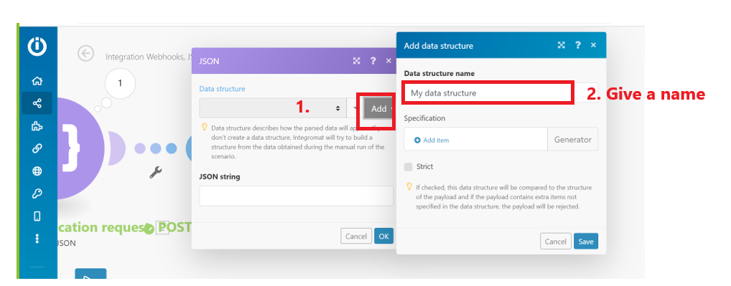
- 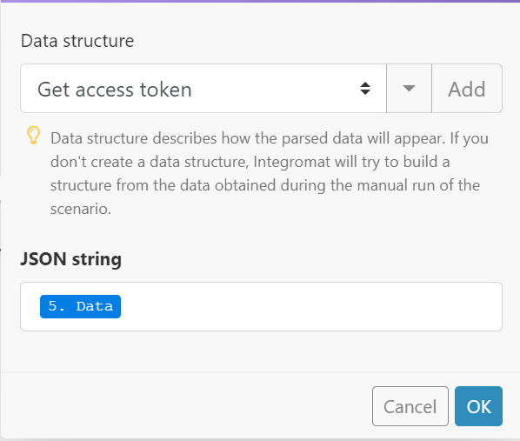

Let’s see the output for this parsed json string Data.
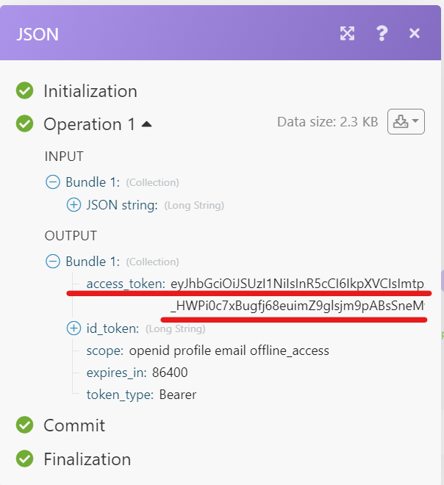

- Now let’s create a request body for API call to create queue item. Click here to find details.
- The steps to create and request body and make http request remains same as discussed above.

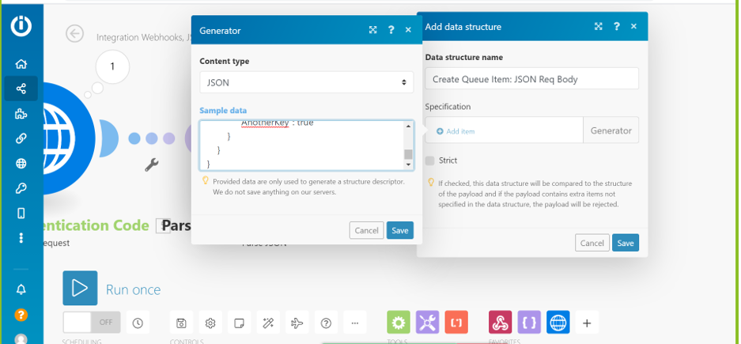

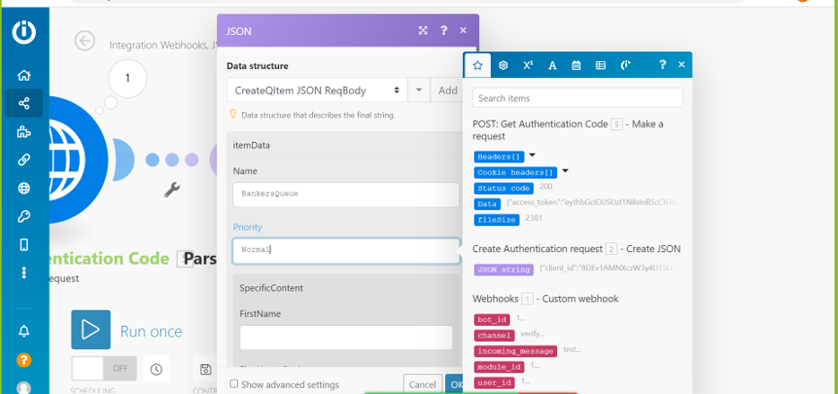

Carefully map the Specific content of the queue with attributes coming in from Snatchbot.
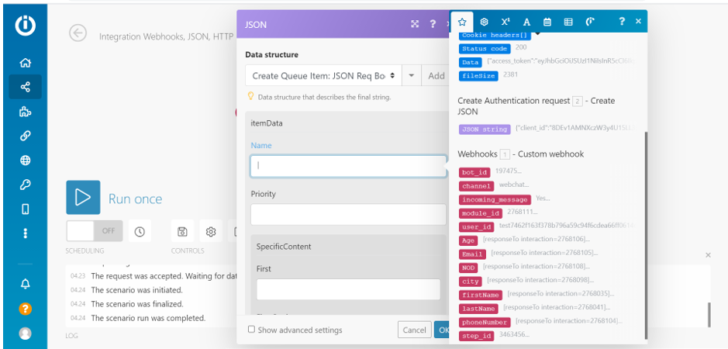
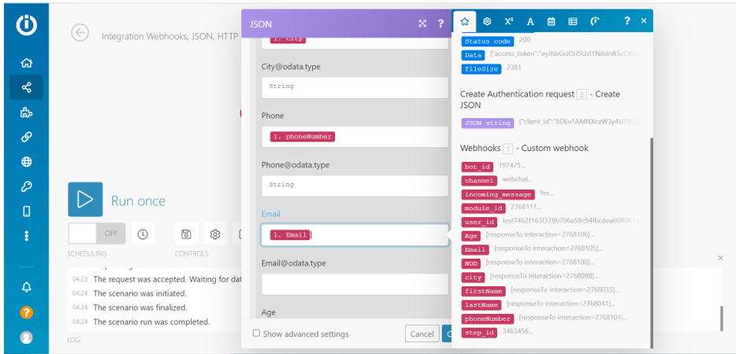

Once request body as JSON is created using Create JSON activity make a request for API call.
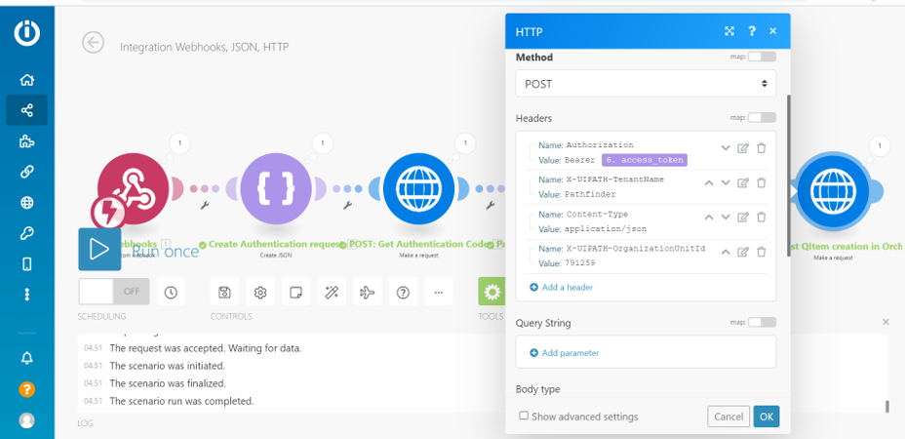
Lastly send response back to chatbot from API calla by Integromat, by using Webhooks response activity as sown below:

- Let’s start by creating a json string for our Webhook response
Add a new Data Structure name and instead of using Generator, add values one by one manually as shown below, following the same order.

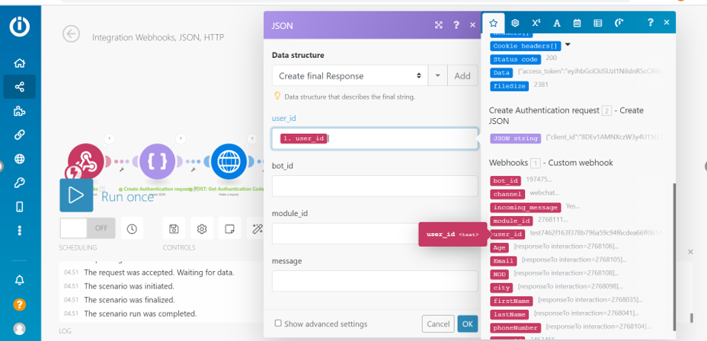

- Now use a Webhook response.
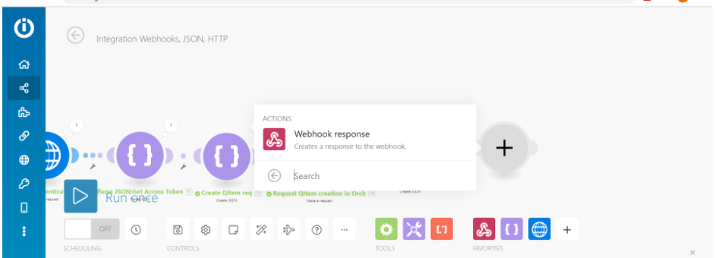

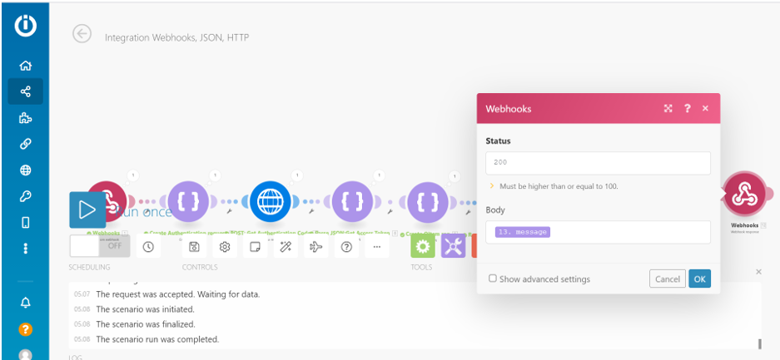

The final flow should look like below:

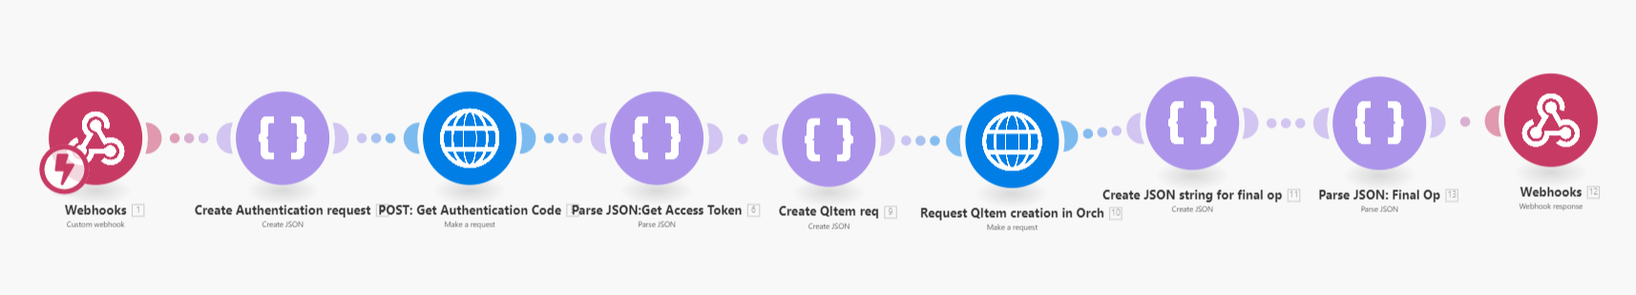

Let’s run a final version.

- On Integromat enable the following to On, so whenever the chatbot is used, it triggers the Integromat flow automatically.

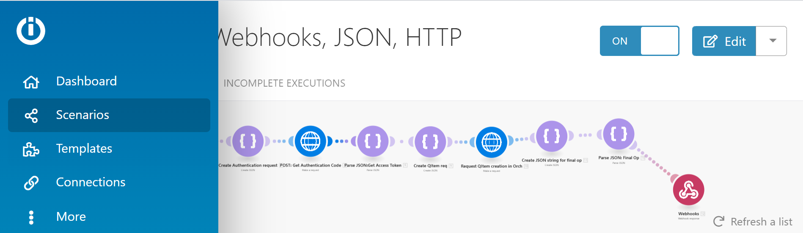

Wondering how to share your chatbot with the public??
- Click on channels on Snatch Bot platform and click on WebChat. Move to Get Embed Cod to get a URL for your chat bot.
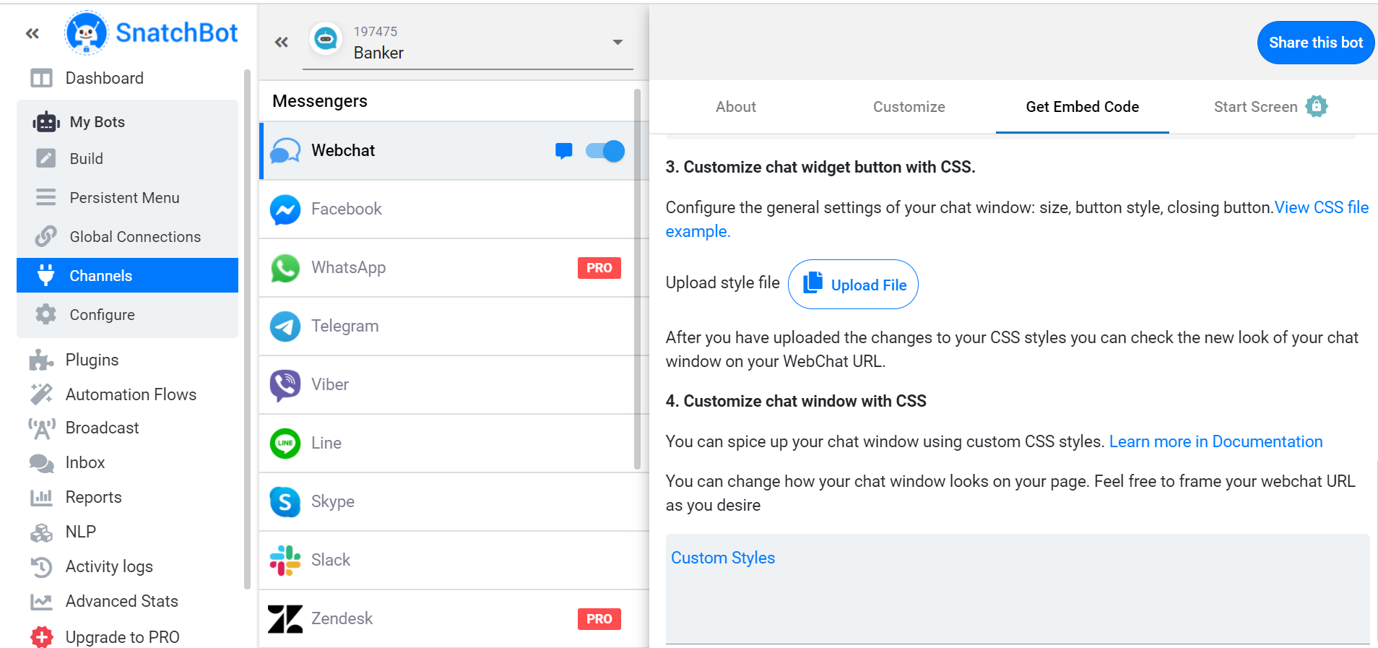

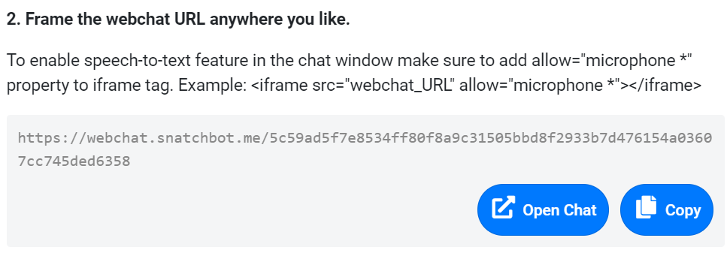

Congratulations!! You are all set to test your chatbot.
Happy Automation.

