BEGINNING BALANCE 991,628.29
01/04 CMS - CR PYMT MARS 529.10+ 992,157.39
ETIQA FAMILY TAKAFUL
ETIQA CLAIM
6626337
01/04 CMS - CR PYMT MARS 6,751.63+ 998,909.02
EFTB - FAMILY TAKAFU
ETIQA CLAIM
6633982
27/04 DEBIT RPP S/CHG .50- 288,469.39
01/04 CMS - CR PYMT MARS 242.00+ 999,151.02
ETIQA FAMILY TAKAFUL
ETIQA CLAIM
6556592
01/04 CMS - CR PYMT MARS 262.00+ 999,413.02
ETIQA FAMILY TAKAFUL
ETIQA CLAIM
6568745
01/04 CMS - CR PYMT MARS 492.00+ 999,905.02
ETIQA FAMILY TAKAFUL
ETIQA CLAIM
6613546
01/04 CMS - CR PYMT MARS 500.00- 999,905.02
ETIQA FAMILY TAKAFUL
ETIQA CLAIM
6613511
01/04 CMS - DR CORP CHG 78.00- 983,667.19
CMS - DRaa CORP CHG
01/04 CMS - CR PYMT MARS 5,336.65+ 989,003.84
TNBA
2200003135
01/04 CMS - CR PYMT MARS 5,000.00+ 989,003.84
TNBA
2200003122
PYT FR PERMODALAN NA
02/04 TRANSFER TO A/C 199.00+ 989,202.84
EJ BAYU *
PCR TEST
Pcr test
02/04 CMS - CR PYMT MARS 177.55+ 989,380.39
ELIB A/C-DATARAN (PA
ETIQA CLAIM
6618588
02/04 CMS - CR PYMT MARS 1,232.00+ 990,612.39
ELIB A/C-DATARAN (PA
ETIQA CLAIM
6566508
27/04 CLEARING CHQ DEP 2,029.09+ 85,048.73
02/04 CMS - CR PYMT MARS 757.00+ 991,369.39
ELIB A/C-DATARAN (PA
ETIQA CLAIM
6624097
02/04 TRANSFER TO A/C 136.00+ 991,505.39
TNBA
CLAIM
27/04 DEBIT RPP S/CHG .50- 188,468.89

Sample Format Output

Name | Number Of transaction | Total (postif) | Total (Negetif) | Date
ETIQA FAMILY TAKAFUL | 4 | 1,525.1 |  | April
ETIQA FAMILY TAKAFUL | 1 |  | 500.00
TNBA | 2 | 10,336.65 |  | April

My Existing process/Flow
1. Export PDF to text
2. Convert to excel (this part I believe cause the overall process to slow because i need to do if then else to populate the below field)

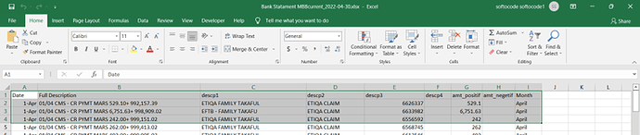

3. Do a query to populate the output (create datatable)
Need advice on how can I speed up the overall process.

