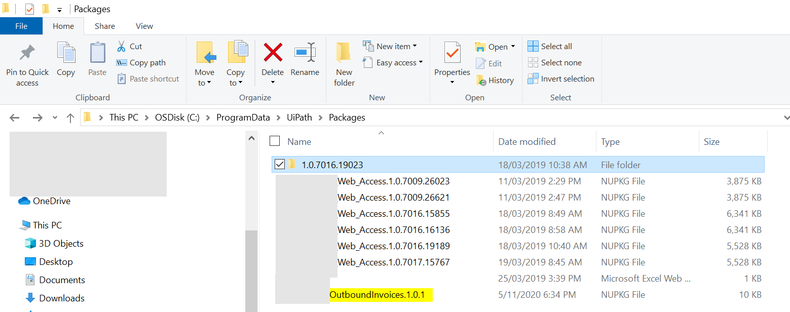
Published OutboundInvoices.1.0.1 project package to try and run it on Orchestrator
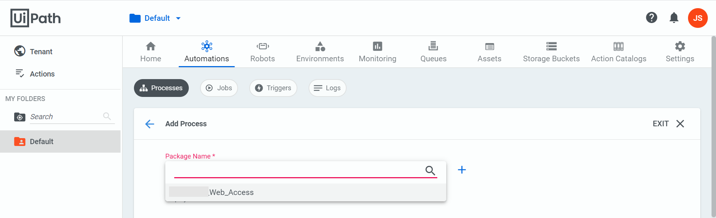
OutboundInvoices.1.0.1 project package is not shown in the dropdown.

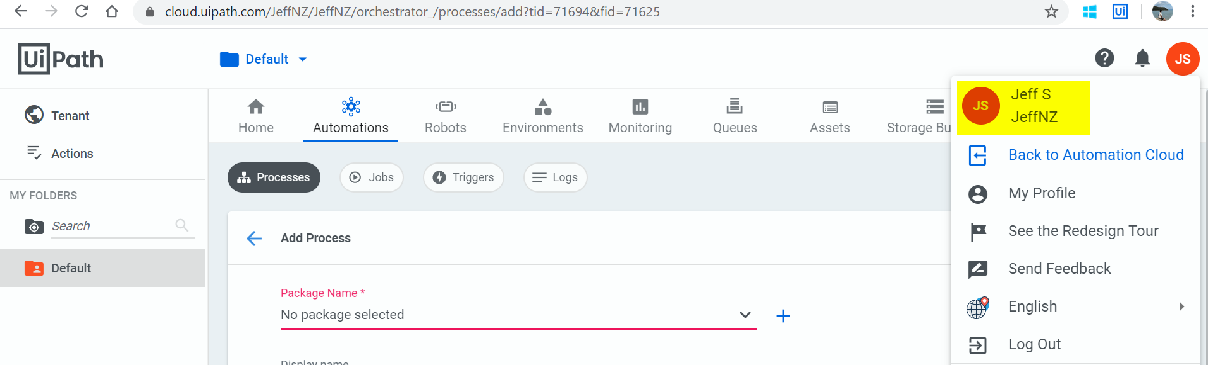
Are project packages tied to my profile? I think I might have more than one profile.

