https://forum.uipath.com/tag/question

https://forum.uipath.com/g/uipath/activity/posts

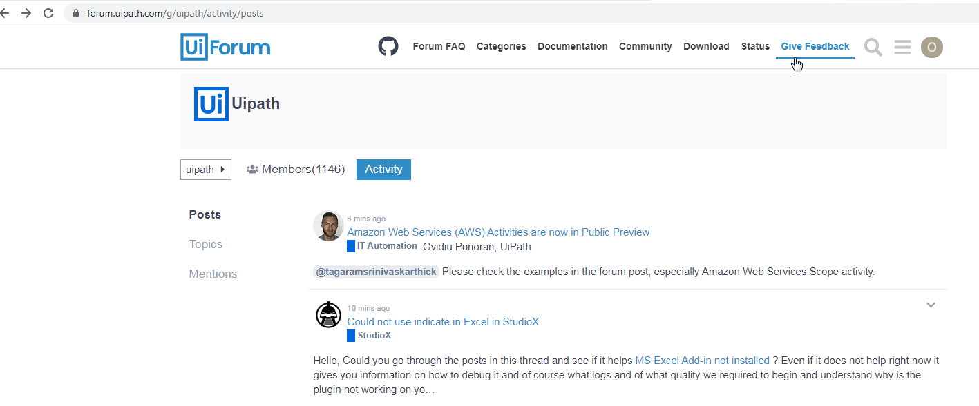
4 mins ago
8 mins ago
Could not use indicate in Excel in StudioX
StudioX
Hello, Could you go through the posts in this thread and see if it helps MS Excel Add-in not installed ? Even if it does not help right now it gives you information on how to debug it and of course what logs and of what quality we required to begin and understand why is the plugin not working on yo…

https://forum.uipath.com/t/ms-excel-add-in-not-installed/210557/41
dragos.sumaUiPath
2
dragos.suma
20h
So just to summarize what we discoverer in our investigation:
Excel installations that are based on the Microsoft Store will install Excel in the following path : C:\Program Files\WindowsApps – this would cause issues with the installation of the plugin.
The solution that worked is to reinstall Microsoft Office in the “traditional” location ( for example : C:\Program Files\Office) and then reinstall the Excel plug-in.
The alternative solution would be to try and regain control over the C:\Program Files\WindowsApps folder https://answers.microsoft.com/en-us/windows/forum/windows_rt-files/what-is-cprogram-fileswindows-apps-hidden-folder/783b5a18-c44d-46f7-b638-e98054b7c2a8 1 and then reinstall the plugin. I have to mention that this solution is not validated therefore I need a volunteer So please the next guy / gal which is encountering this would you be willing to try the alternative solution and then come back with the results
Regards,
Dragos.
In case this post gets flagged as the solution I would leave the debugging guide that we developed. Please note that it’s still rough around the edges so treat it as a final draft version, butt still draft UiPath Excel Addin Installation Troubleshooting v4.docx (388.6 KB)
Regarding logs, they are usually found in %localappdata%/UiPath/Logs and
- Studio.log – gives us information on how the Studio started or if it was able to load all the correct libs.
- Execution.log – gives us information on what happens after you click the run button
- UiPath.ExcelAddIn.log – gives us information on how the plugin interacted with Excel ( will not be present if the Add-In failed to install )
- ExcelAddIn_Install.log – gives us information on the issues encountered during the Excel plugin installation ( in this particular case it’s the most important )
Usually we would request that you delete the logs prior replicating the encountered defect. This is a best practice when reporting a defect since it would speed up the reading of the logs by the development team.

What I have done:
I have choosed the Profile Studio X:

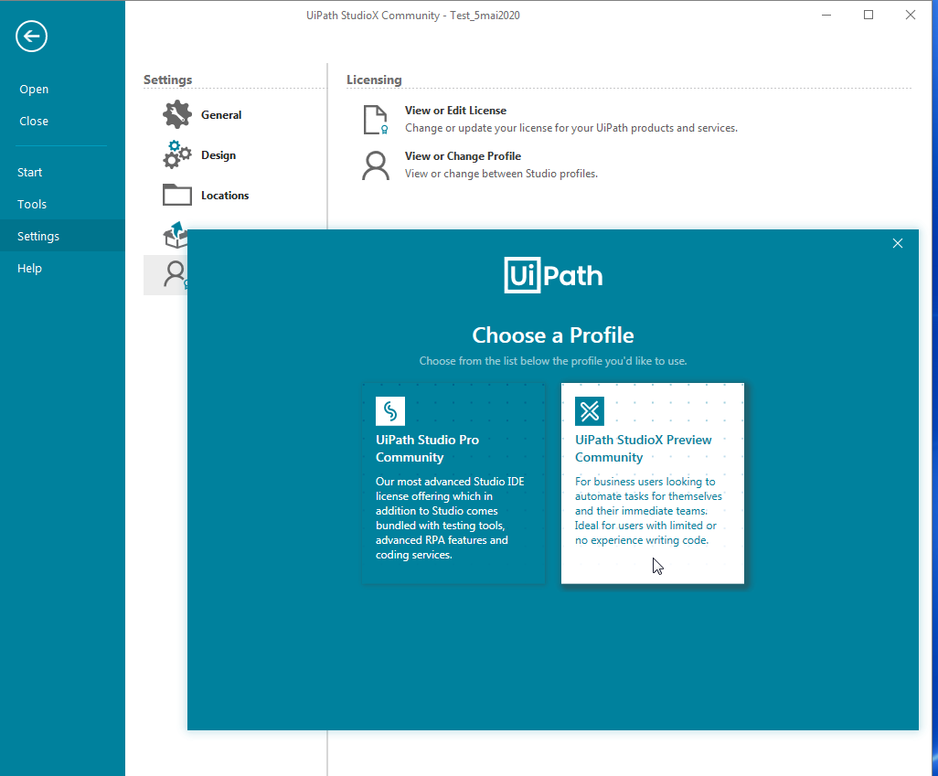

I have installed successfully Excel Add-In:
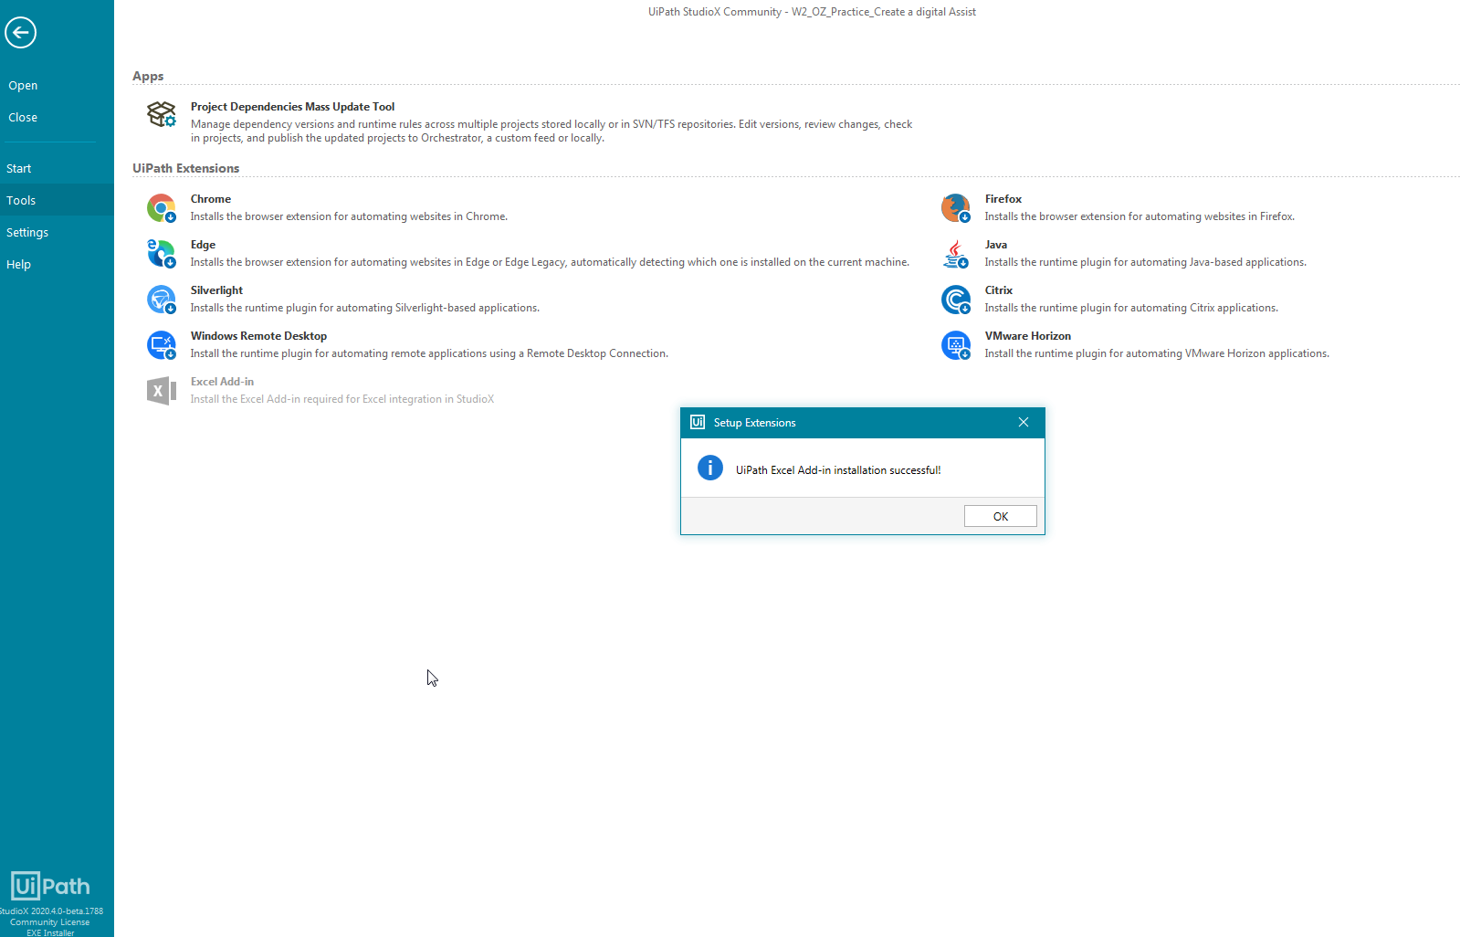

I have opened one project to test and tried to use the functionality <Indicate in Excel>, (see in the print screen, below).
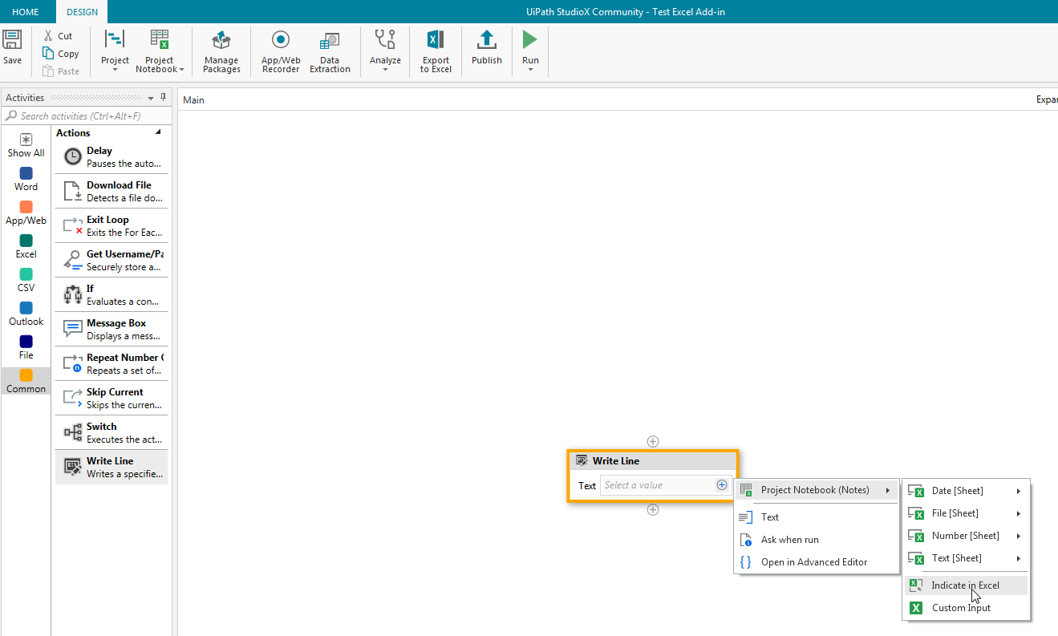
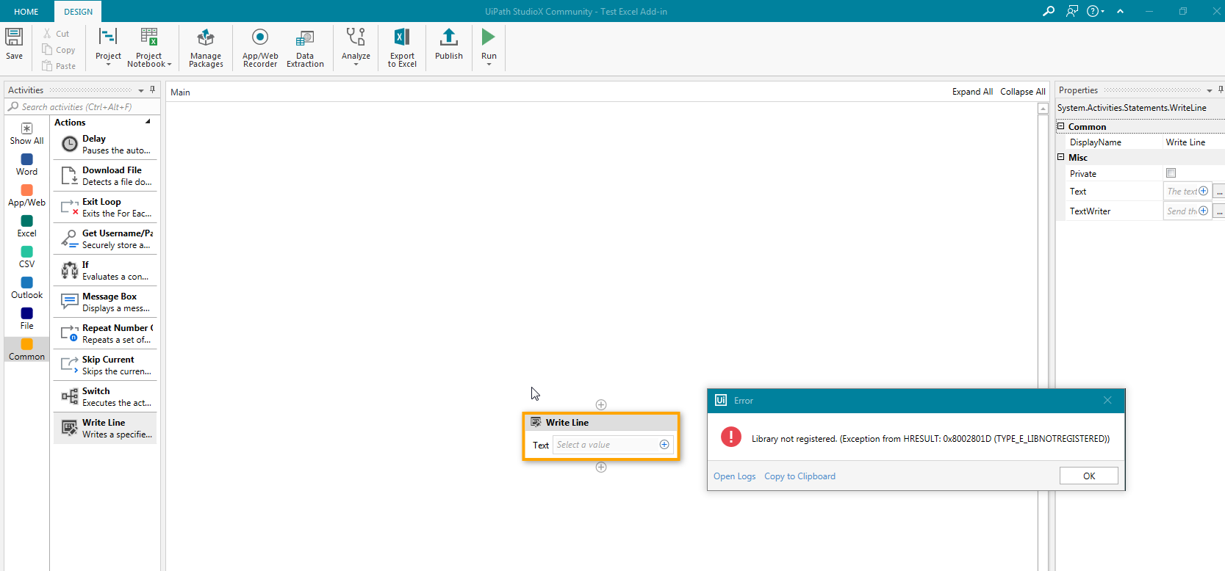

The result is that the system returns every time an error:
The error:
20.4.0-beta.1788
Library not registered. (Exception from HRESULT: 0x8002801D (TYPE_E_LIBNOTREGISTERED))

Then, I have followed indication given in the file:
UiPath Excel Addin Installation Troubleshooting v4.docx downloaded from the:
https://forum.uipath.com/t/ms-excel-add-in-not-installed/210557/41

I have followed the indication in the file <<UiPath Excel Addin Installation Troubleshooting v4 >>
Step 4 from the file <<UiPath Excel Addin Installation Troubleshooting v4 >>:

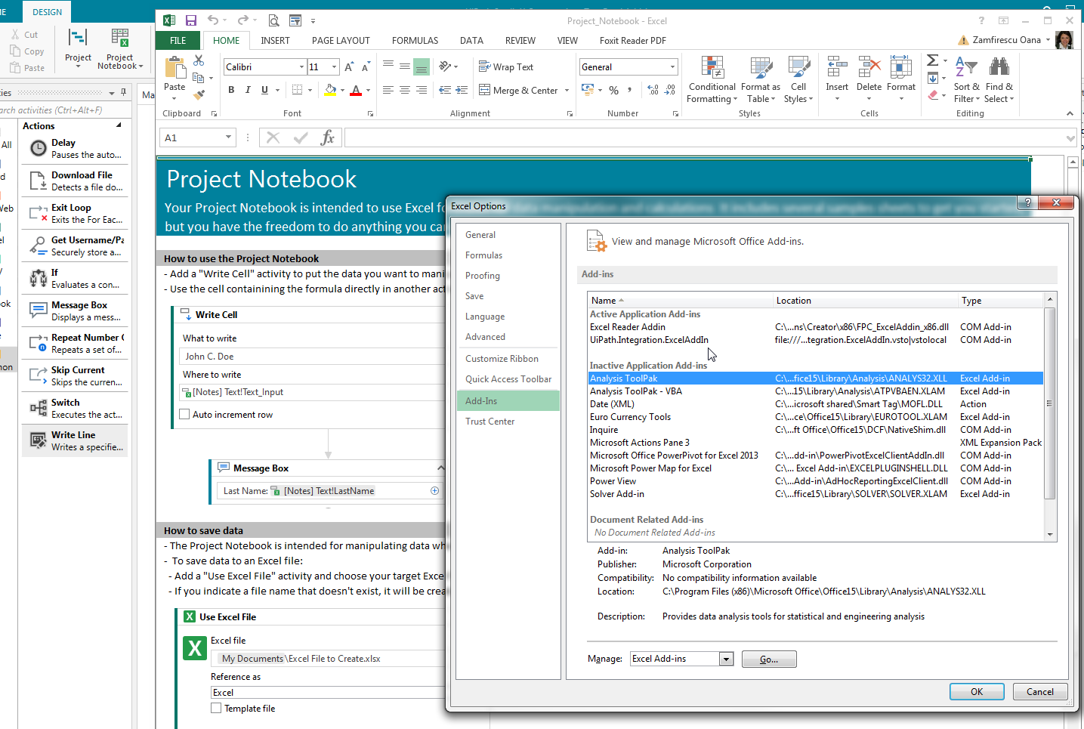

Steps: 5, 6

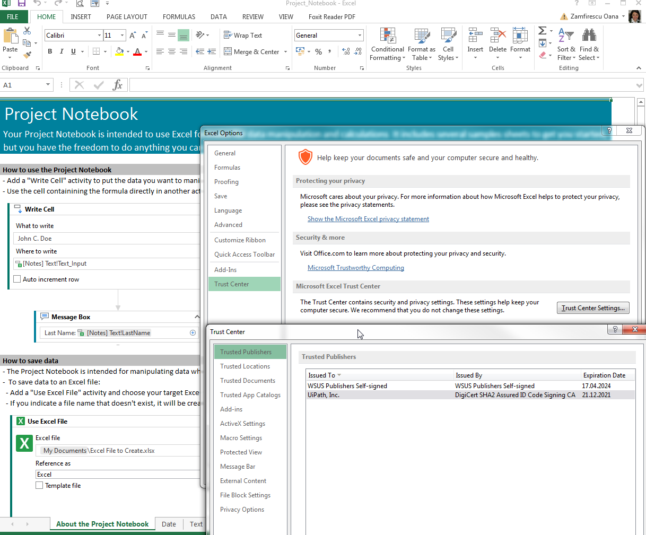

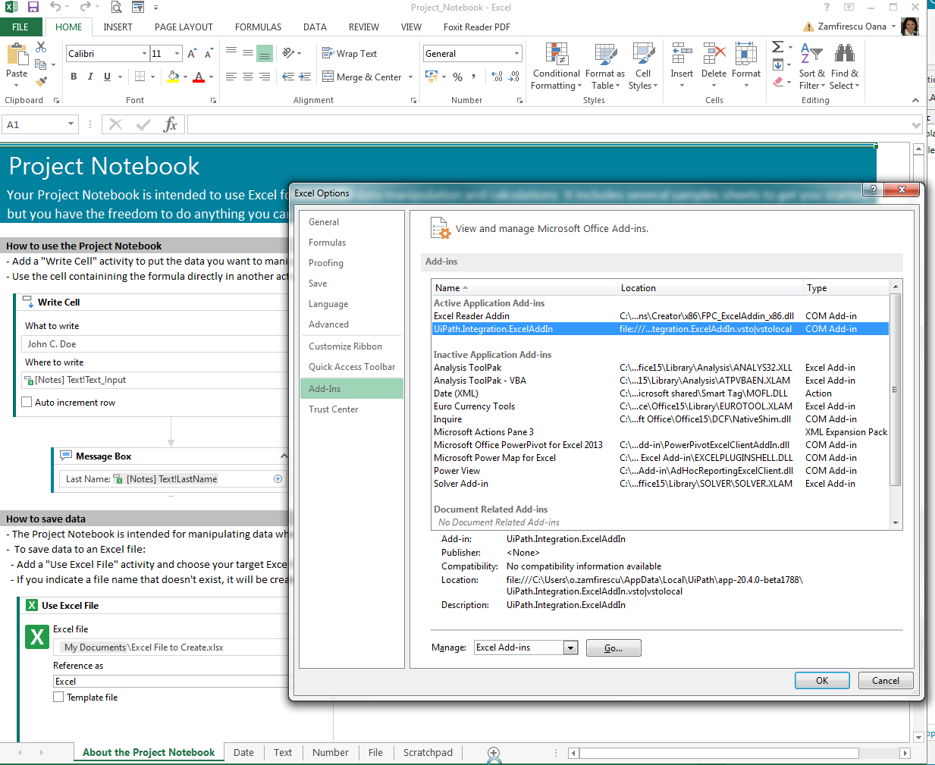

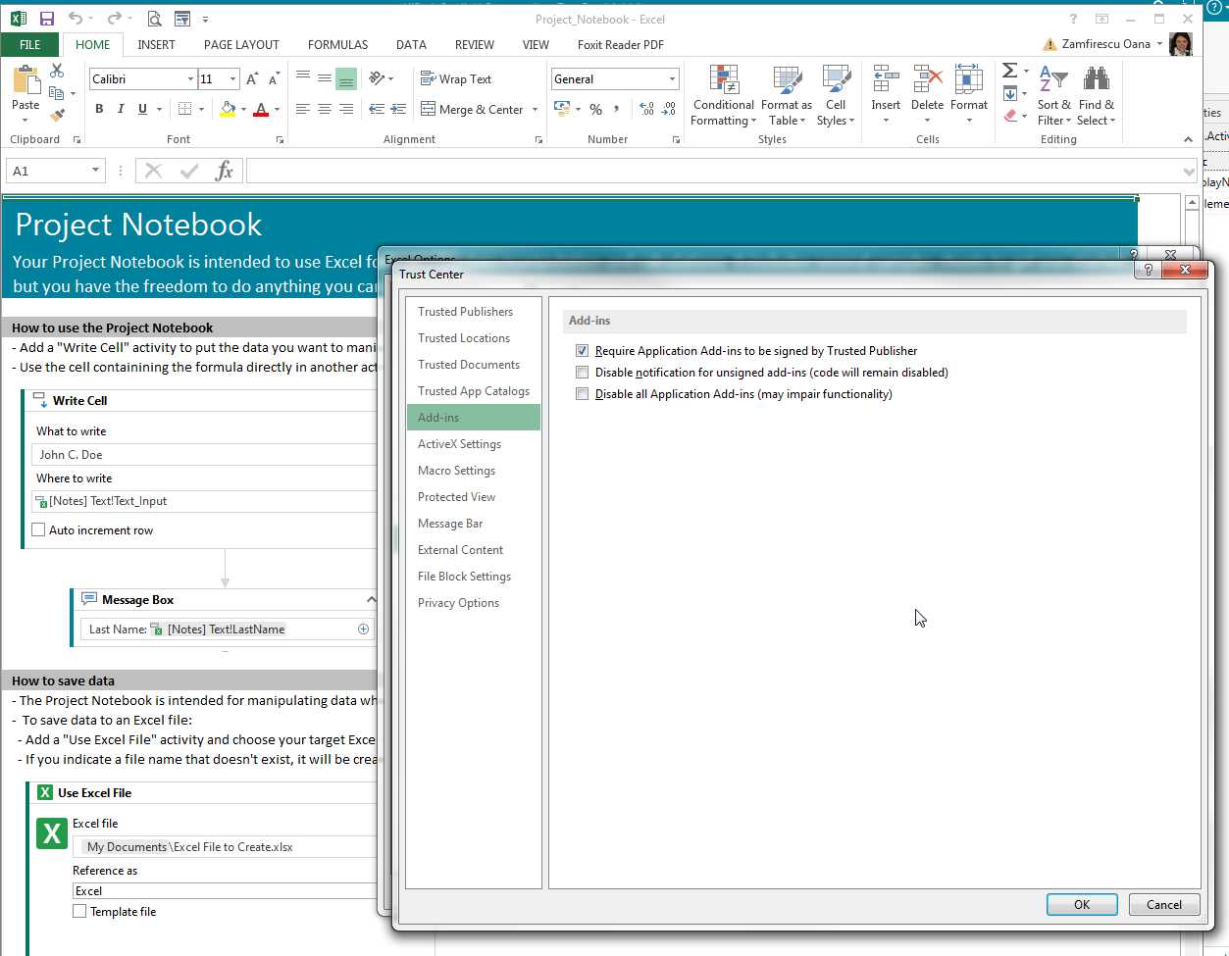

Every setting seems to be OK, but the test didn’t work.
So, I have reinstalled Excel Add-In, with all Excel files closed:

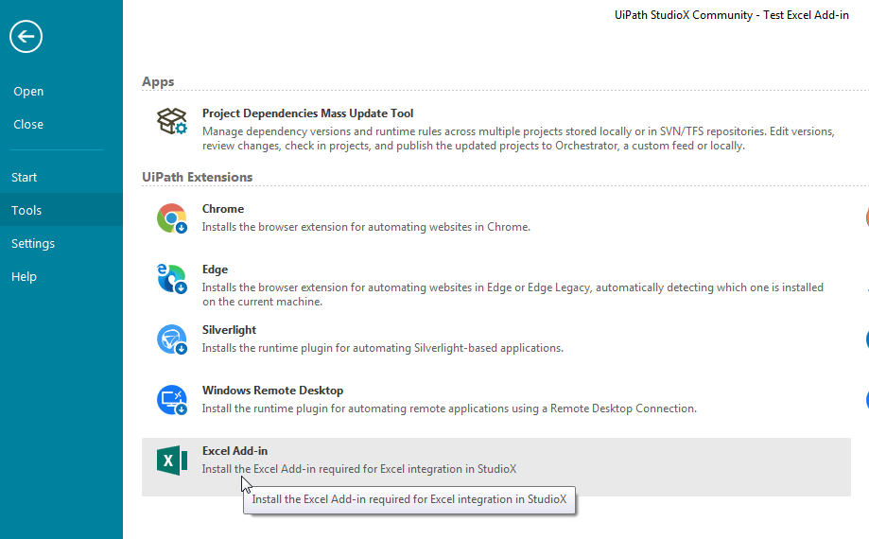

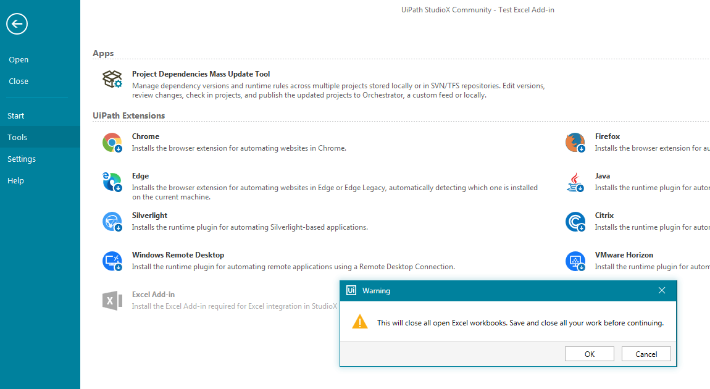
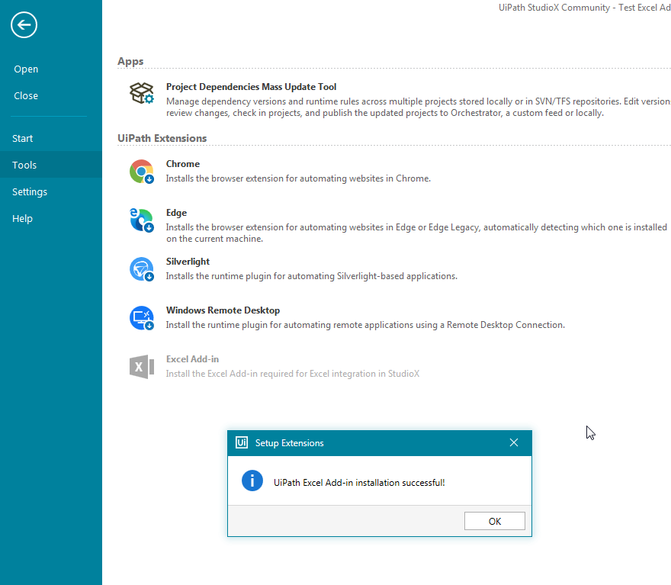

Redid the test, opening the Project:

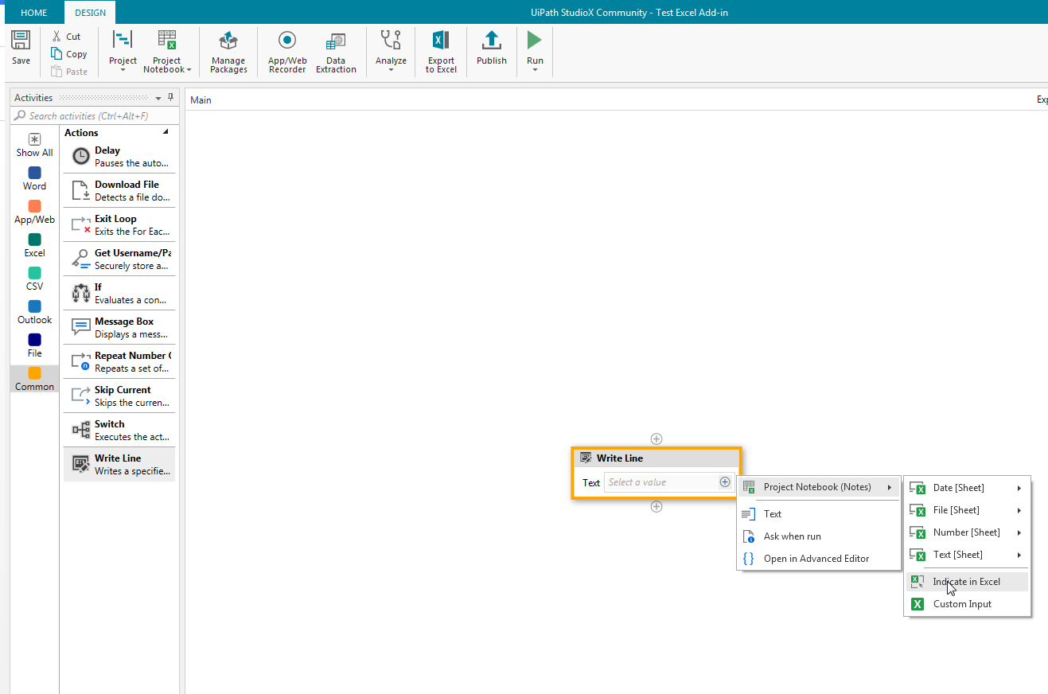

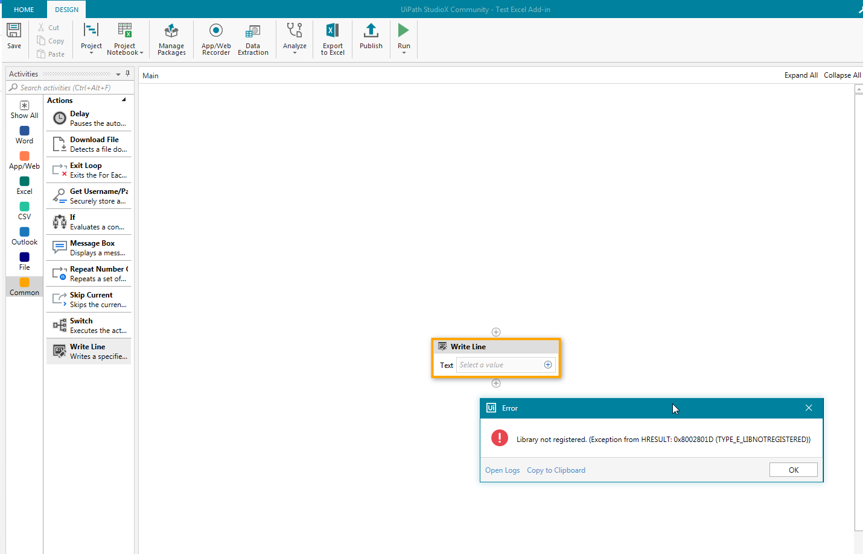

Open Logs:

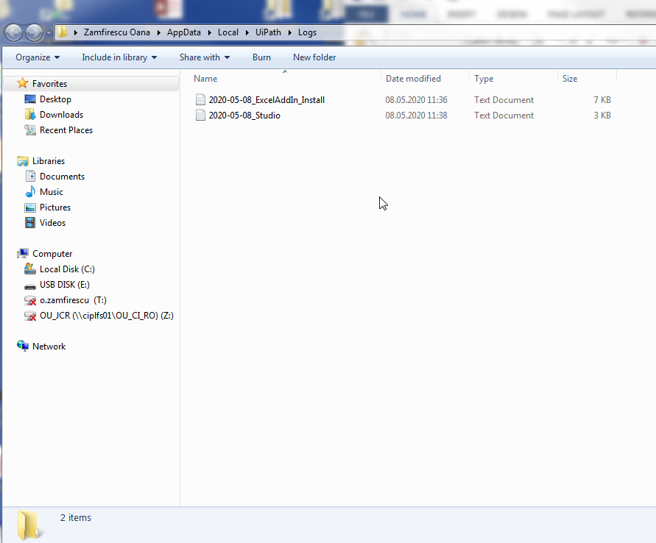

C:\Users\o.zamfirescu\AppData\Local\UiPath\Logs

Copy to clipboard:

20.4.0-beta.1788

Library not registered. (Exception from HRESULT: 0x8002801D (TYPE_E_LIBNOTREGISTERED))
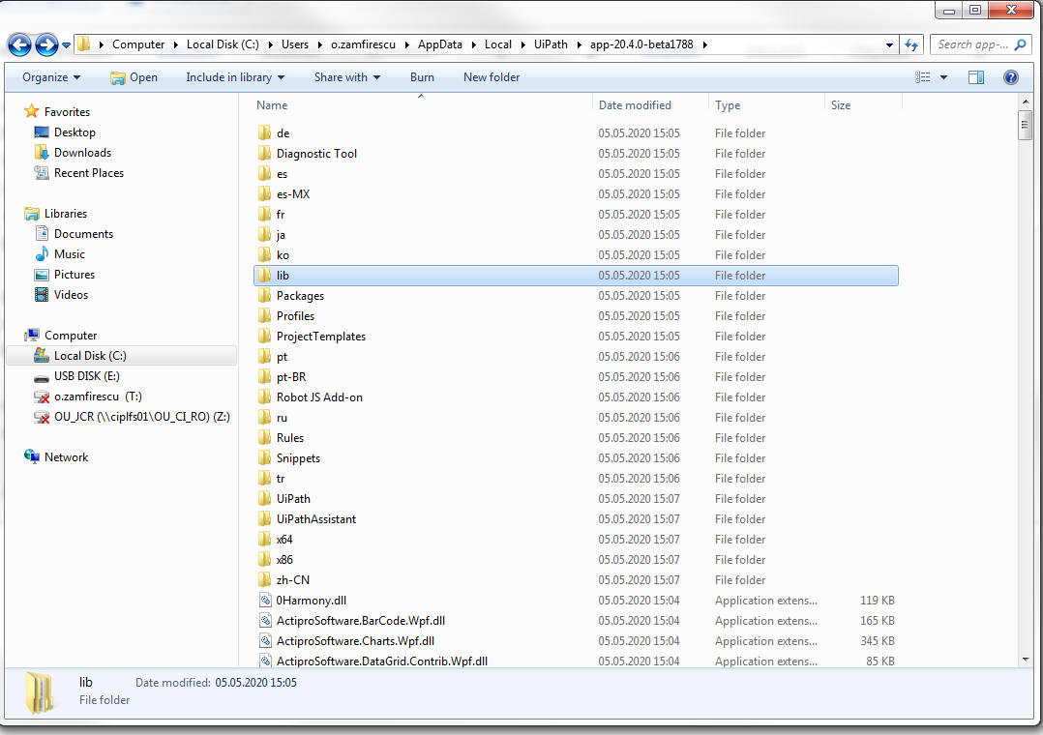

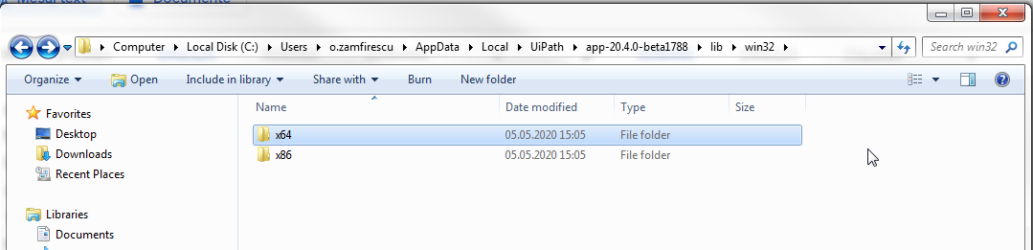

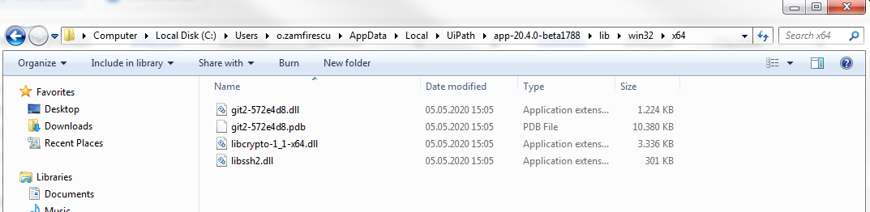

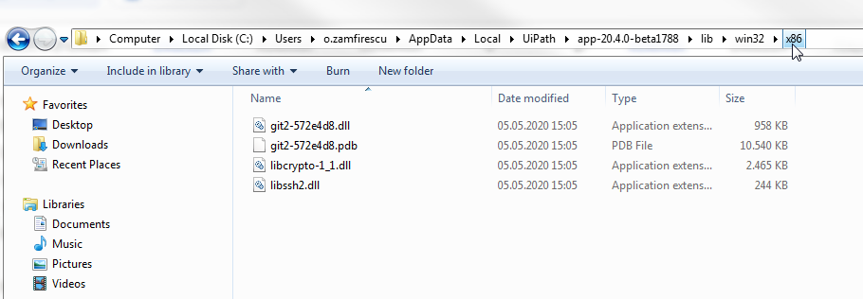
C:\Users\o.zamfirescu\AppData\Local\UiPath\Logs
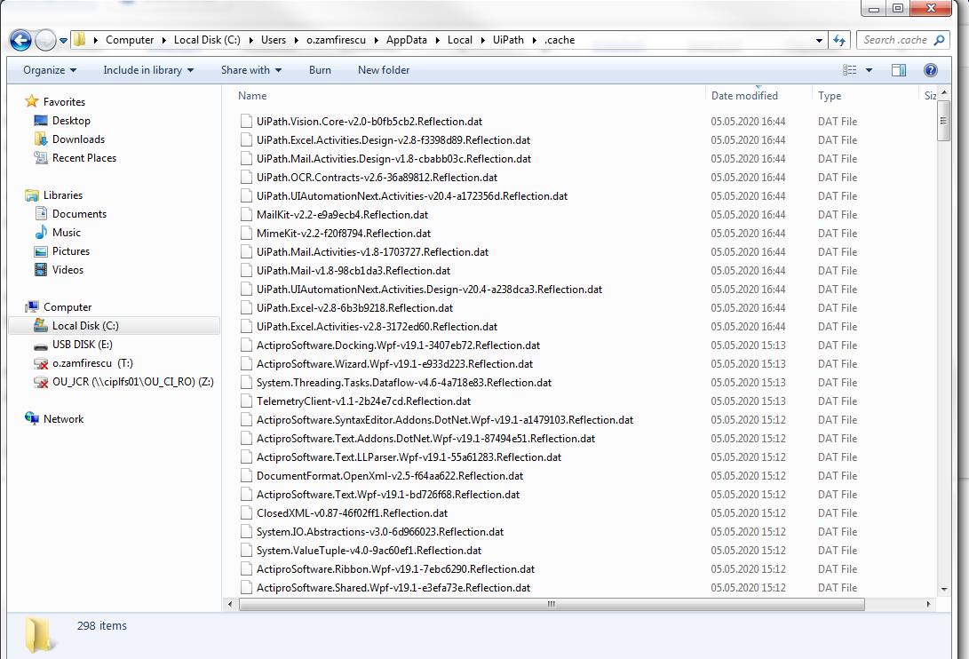
What else should I do?

I can’t get rid off the error:

