Scenario1:
OtpLength:
Default is 6 end users can change based on their requirement.
OtpType:
Otptype default is numeric here we are selecting numeric
OtpCaseType:
Otpcase type is uppercase by default when we are selecting otp type numeric otp case type it will not affect because numeric type doesn’t have uppercase or lowercase.
Result:
Output result return as string
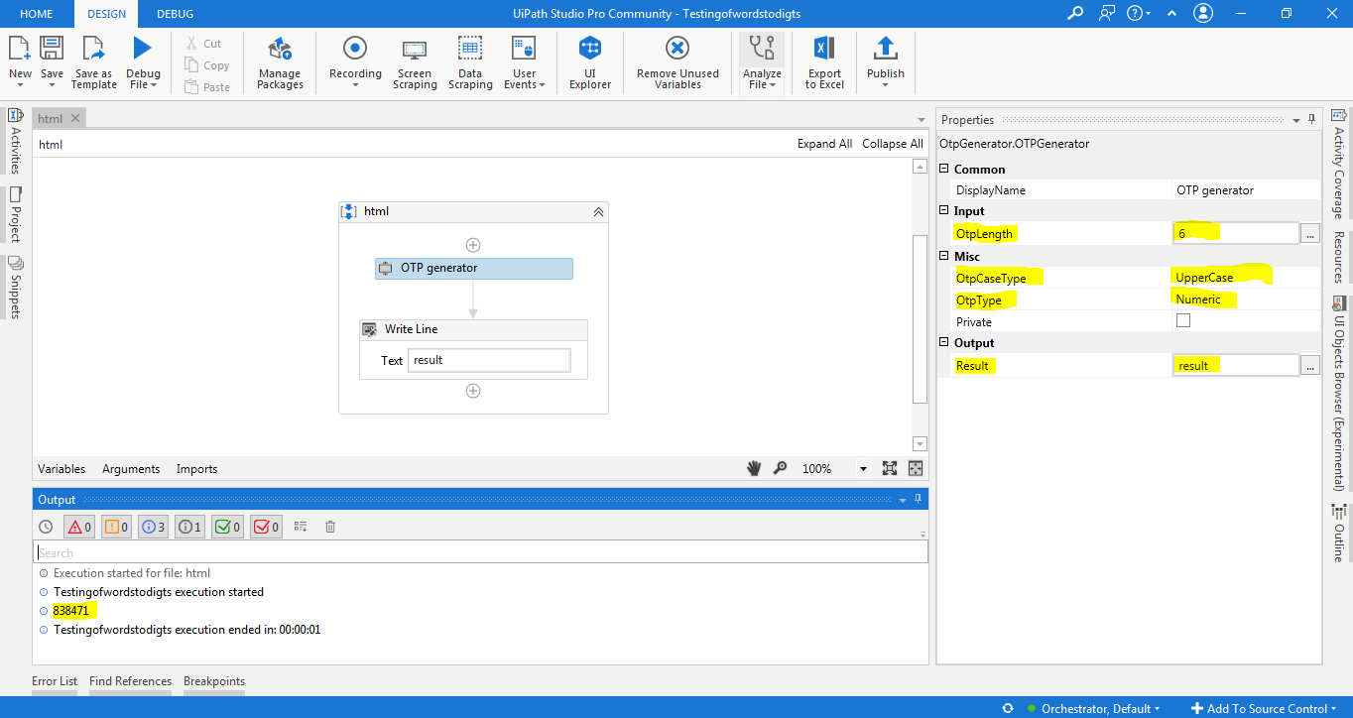
Scenario2:
OtpLength:
Default is 6 end users can change based on their requirement.
OtpType:
Otptype here we are selecting Alphanumeric

OtpCaseType:
Otpcase type here is uppercase the result of the password is uppercase.
Result:
Output result return as string.
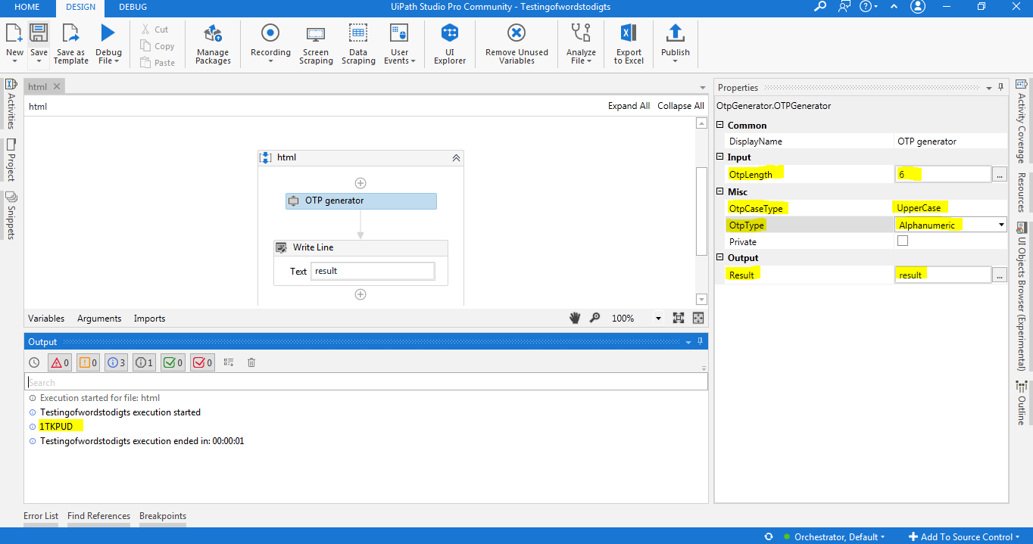

Scenario3:
OtpLength:
Default is 6 end users can change based on their requirement.
OtpType:
Otptype here we are selecting Alphanumeric.
OtpCaseType:
Otpcase type here is Lowercase the result of the password is lowercase.
Result:
Output result return as string

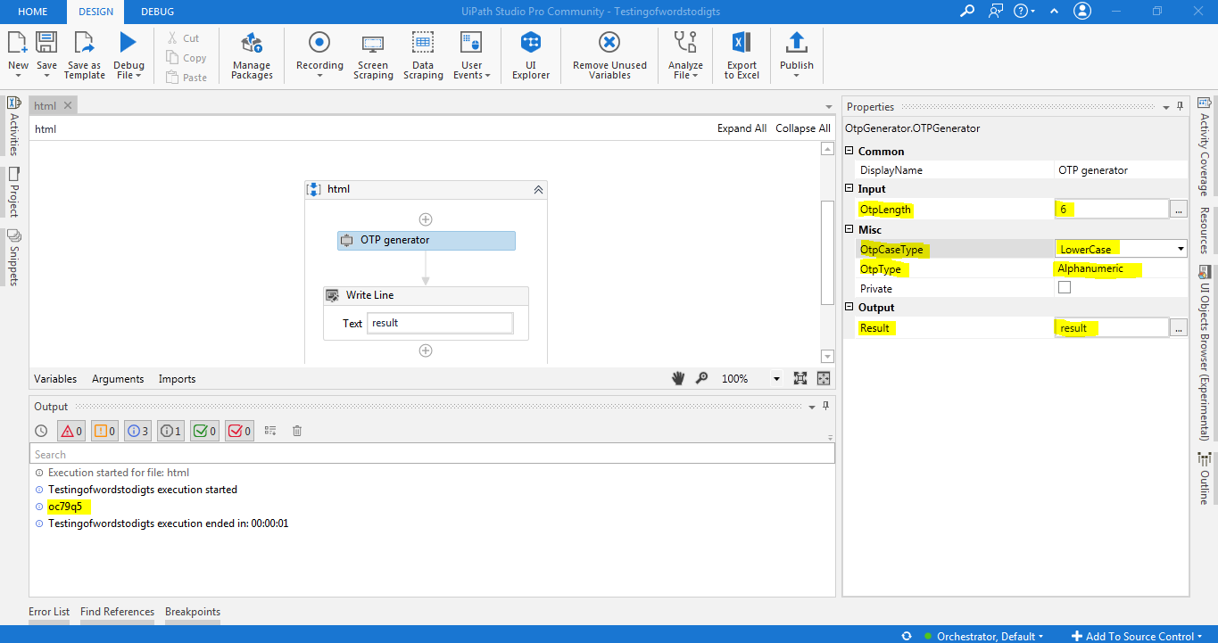

Scenario4:
OtpLength:
Default is 6 end users can change based on their requirement.
OtpType:
Otptype here we are selecting Alphanumeric.

OtpCaseType:
Otpcase type here is UpperAndLower type select the result will show both upper and lower and digit combination.
Result:
Output result return as string
