Senario1:
- DestinationFolderPath : here we need to provide output pdf folder path.
- FontSize : here we need to provide font size of page number default is 10
- FontStyle : here we have 2 options 1 is normal font style. 2 is bold default is 1.
- IsRequiredOnlyDate : this field is empty by default. If user want print only date instead of page number, we need to provide date field as string otherwise it should be empty.
- NumberDisplayStyle : here user can choose different options for page number displaying different ways like 1 is plain number. 2 is text with number. 3 is number by slash default is 1.
- NumberOffsetX : user want add the exact location of the page number these coordinates are responsible to show the location based on user page size and location need to provide coordinates default is 568f.
- NumberOffsetY : user want add the exact location of the page number these coordinates are responsible to show the location based on user page size and location need to provide coordinates default is 15f.
- SourceFolderPath : here we need to provide input pdf folder path.
- File: Indicate if the file is created or not. This field support Boolean variable.
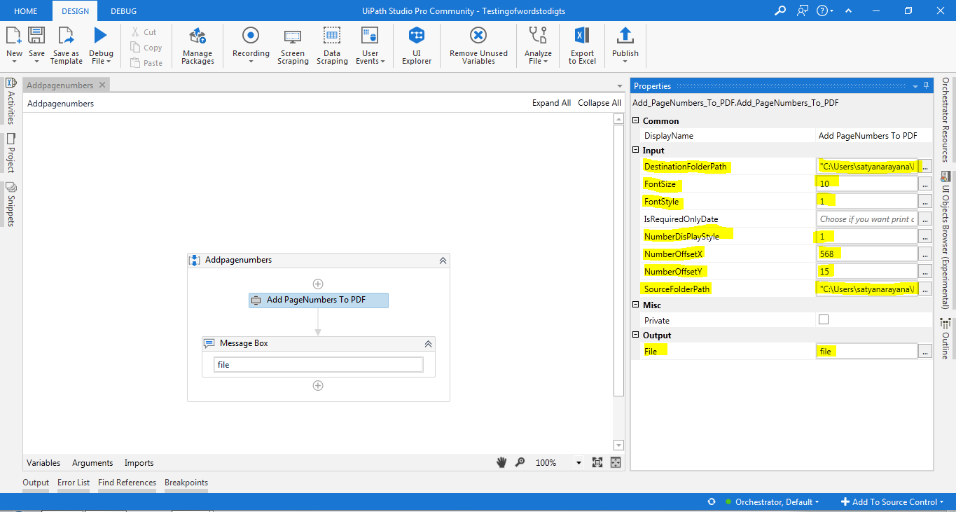

Before Pdf:
After Pdf:
Senario2:
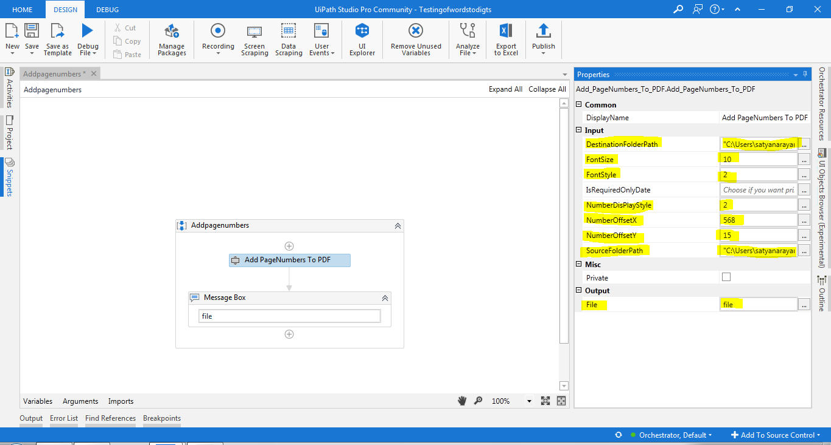
Before Pdf:
After Pdf:

Senario3:
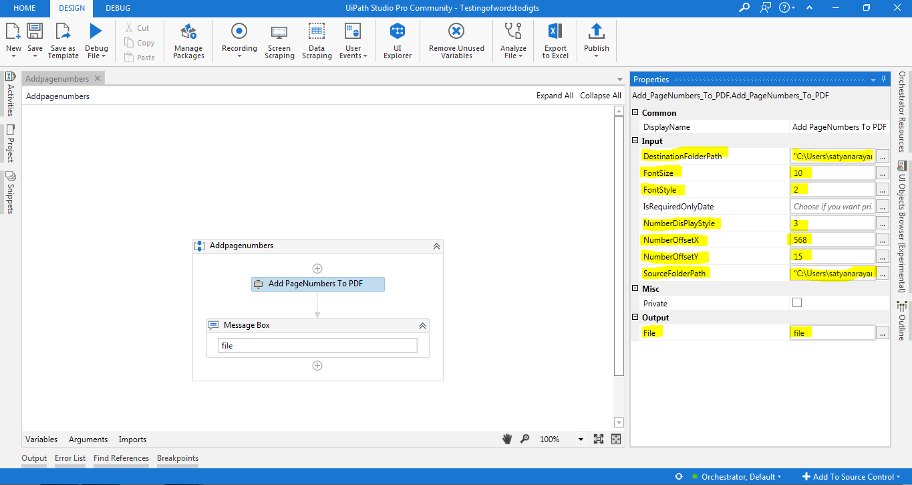
Before Pdf:
After Pdf:

Senario4:
Here is required date only field is providing date as string the output format of date is print only
Format MM-dd-yyyy
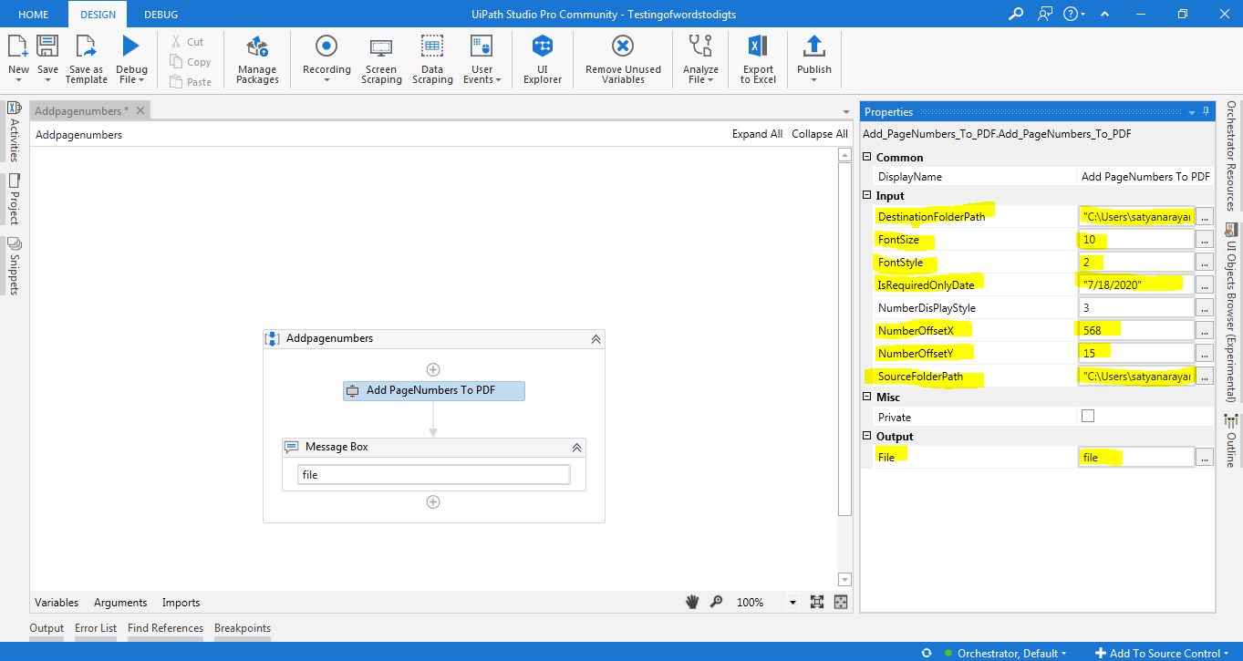
Before Pdf:
After Pdf:

