Getting error while creating Robot in Orchestrator
No more Development robots available. Please update your license! (#1900)
Below is the Licenses screen from my Orchestrator (Community Plan)
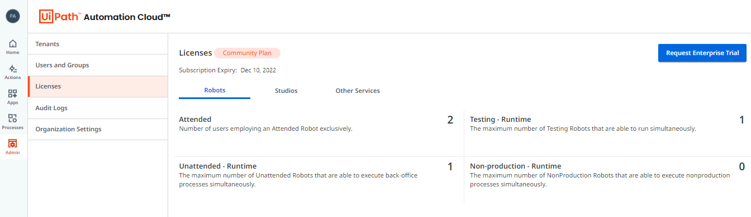

Above error encountered when I was trying to install and configure Studio on my new laptop (Win10).
Because of above error my installation is incomplete and I am stuck.
I am following below steps for Studio Installation.
I am not sure what’s going wrong. Could you please let me know and if possible, or share the step by step installation guide.

- Navigated to https://cloud.uipath.com/portal_/completeSignup and clicked on Login link as I already have the account
- 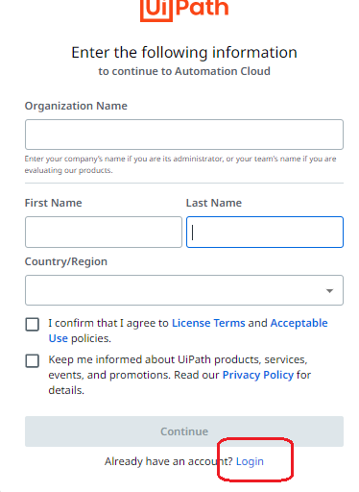
- After login, I get this popup (note, I already tried with different orgnization name since previous not working)
- 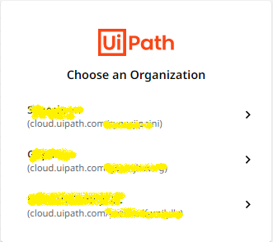
- Selected one of the organization
- Downloaded Uipath Studio from here
- 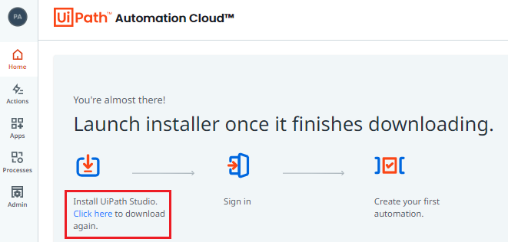
- When I started installation, it populates below screen (when I installed couple of days back in last month, I did not show below screen as I remembered)
- 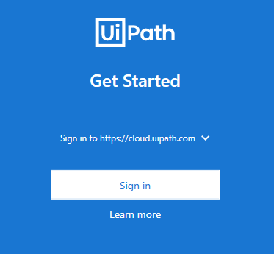
- On click Sign in button, populated below screen
- 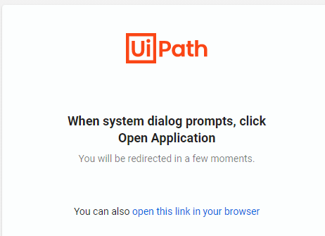
- I clicked on ‘Open this link in your browser’ link. It displayed below popup
- 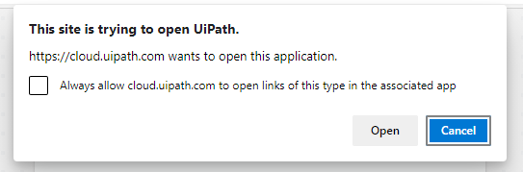
- I clicked on ‘Open’. It displayed with below:
- 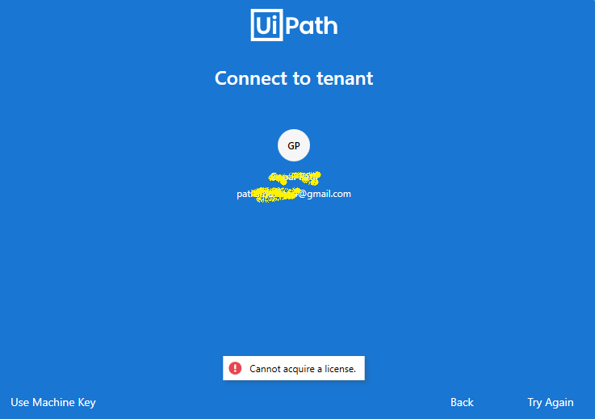
- Now, I clicked on Use Machine Key.
- 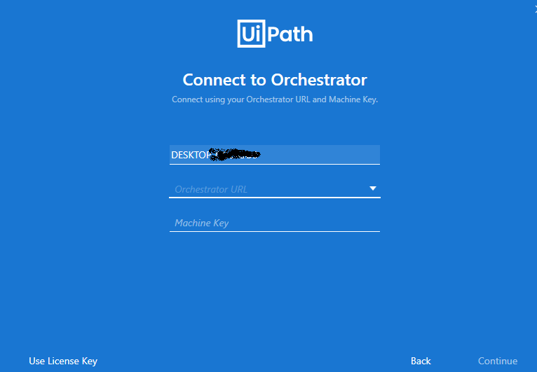
- To get the machine key, I went to the Orchestrator (from where I downloaded Studio). This is what I have:
- 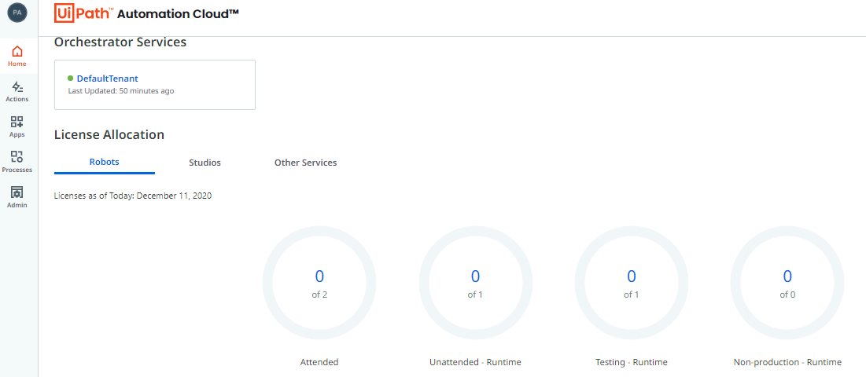
- I clicked on ‘DefaultTenant’
- Then ‘Default’ folder > Robots > Add
- 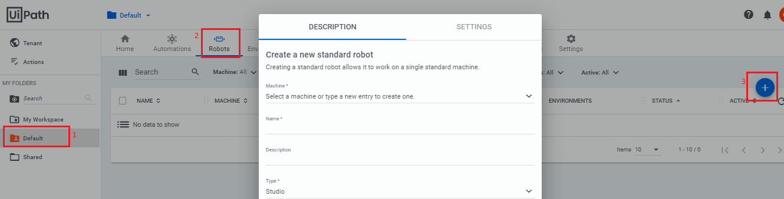
- Entered Machine name (exactly same as my Computer Name)
- Entered Robot’s Name
- Type = Studio
- Entered domain\username (result from cmd c:/>whoami )
- Clicked on Create button. Getting below error:
- 