Stock Trend Price Compassion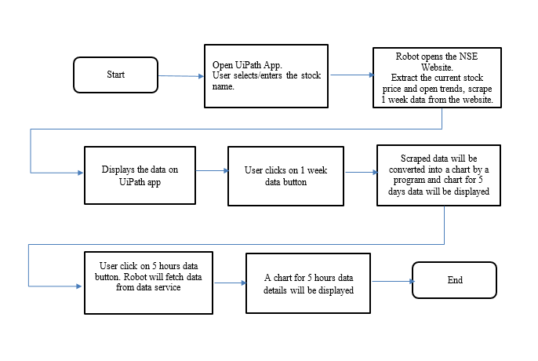
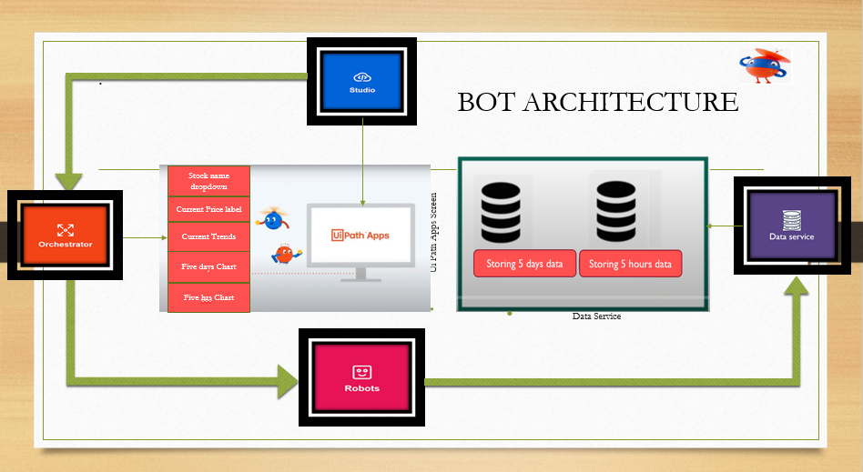

- UIPATH Screen
Step 1: Designed Uipath Apps Screen. Below screenshot for the reference.

- Stock Name: Dropdown
Step 2: Created a process “Process name” which pulls stock names for the dropdown from the config file.
Step 3: Bind uipath app dropdown to the “Process name” .Which triggers on click of the dropdown and pulls the stock names from the config file.

- Creating Data Service 1 “DS name”
Step 4: Create a data service with below fields
Fields name

- Populating Current Price, Open Trends
Step 5: Created a process “Process name” which has multiple states. Once we get input parameter “in_searchstock” from the App, The process will open the browser and does data scrapping for that input (“in_searchstock”). Extracts current price, open trends and 1 week data.

- Storing data in data service “DS name”
Step 6: The 1 week data which is extracted in step 5 will be stored in the data service “DS Name”

- Populating Five days Data:
Step 7: The above process “Process name” will extract data from “DS name” and convert it into chart using excel. On click of the button “Five days data” It will display the chart.

- Creating Data Service 2 “DS name”
Step 8: Create a data service with below fields
Fields name
- Populating Data service 2:
Step 9: Created a process: “Process name” which scrapes NSE website and store data in Data service 2 “DS name”
- Trigger 1: “Trigger name”
Configured a trigger with above process “process name” which runs every hour and stores every hour data in the data service.
- Populating Five Weeks Data:
Step 10: The above process “Process name” will extract data from “DS name” and convert it into chart using excel. On click of the button “Five weeks data” It will display the chart.

- Trigger 2: To Erase oldest data
Step 11: The trigger has been set to erase days every 2 weeks. Trigger is configured with the process “process name” which has code to delete data from the data service base on the todays date.

