These are the two files
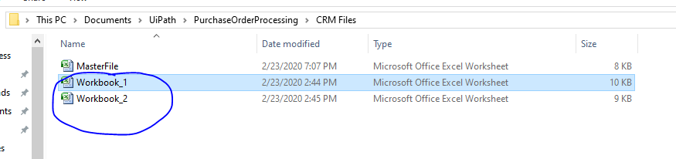
Below is the content of the file Workbook_1
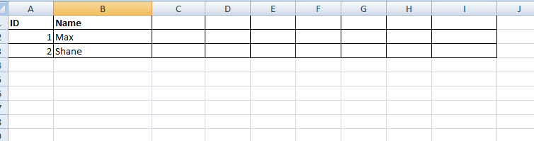
Below is the content of the file Workbook_2
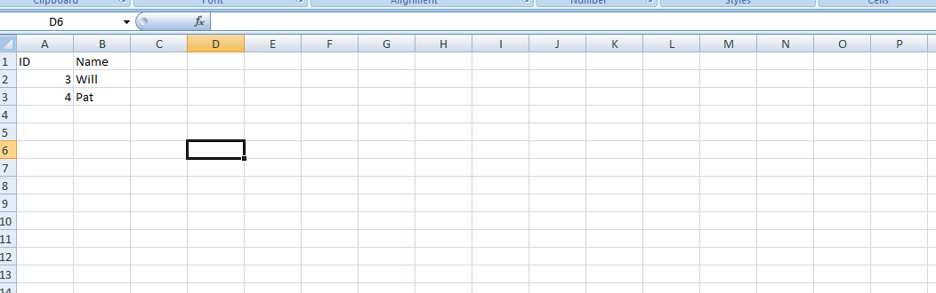
After running the script I am the final sheet like this Master file
