Orchestrator Job Completed.

No messages when ‘View Logs’ in Orchestrator.

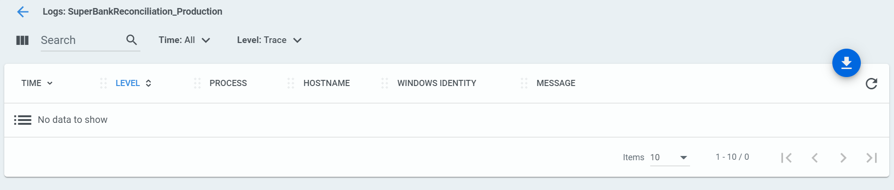

If you open logs on DDHFMWS32 (robot machine) you get all the logging.

