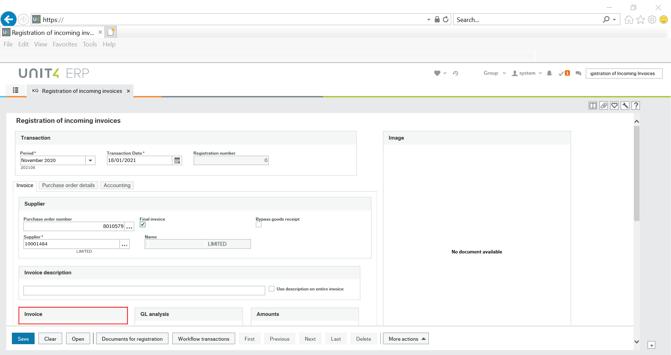
The invoice number field is not immediately visible when the screen is first loaded. This field is shown beneath the highlighted invoice tab.

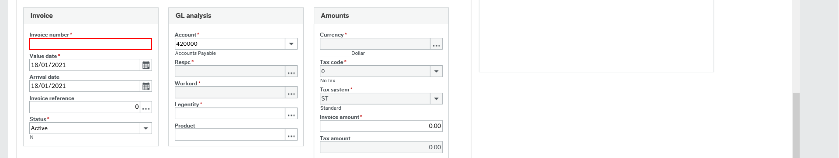
Invoice number is displayed after scrolling down under the invoice tab.

