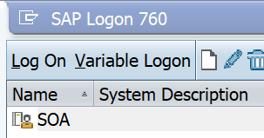

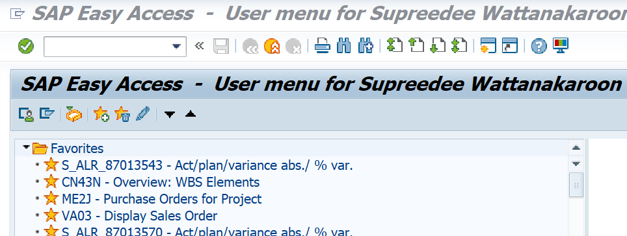

When use Call transaction, it supposed to write T Code such as VA03 or CJE0 but it didn’t show anything and go nowhere.

SAP Configuration on Server side is setting as below.
