First Step
All invoices in Folder ready to be sorted.
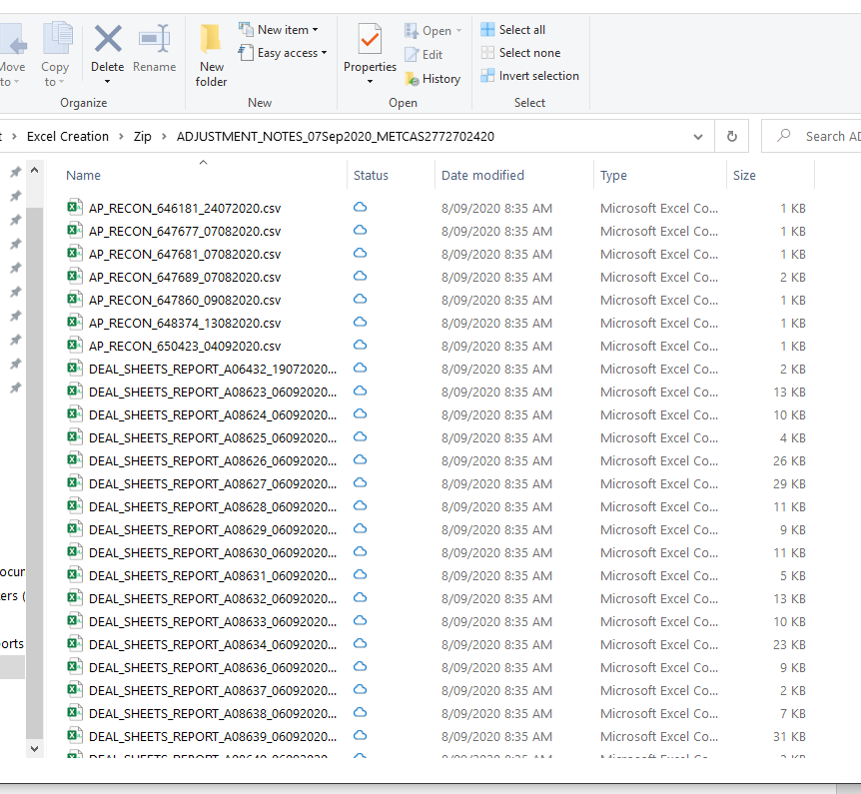

Second Step -
We then use our Excel file to know what type of invoices they are – Column C is the invoice types.

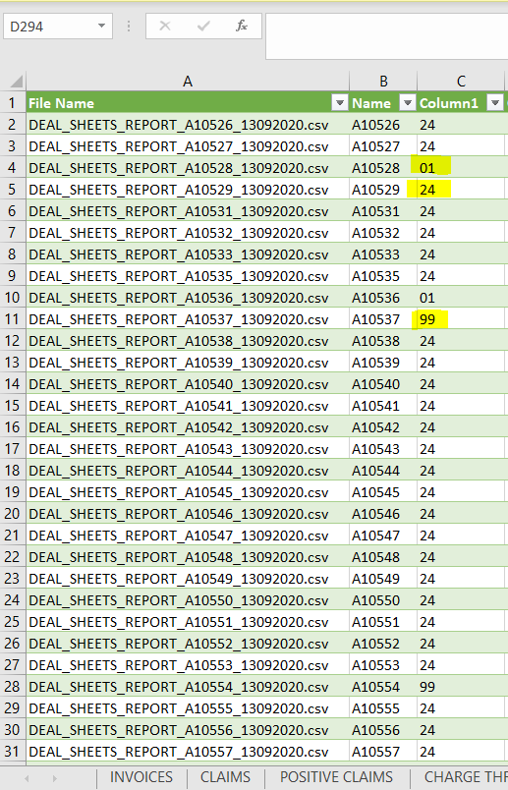

Third Step -
We then need to move the invoices into specific folders
