- Create the form using “Create Form” activity and take the output in a variable.

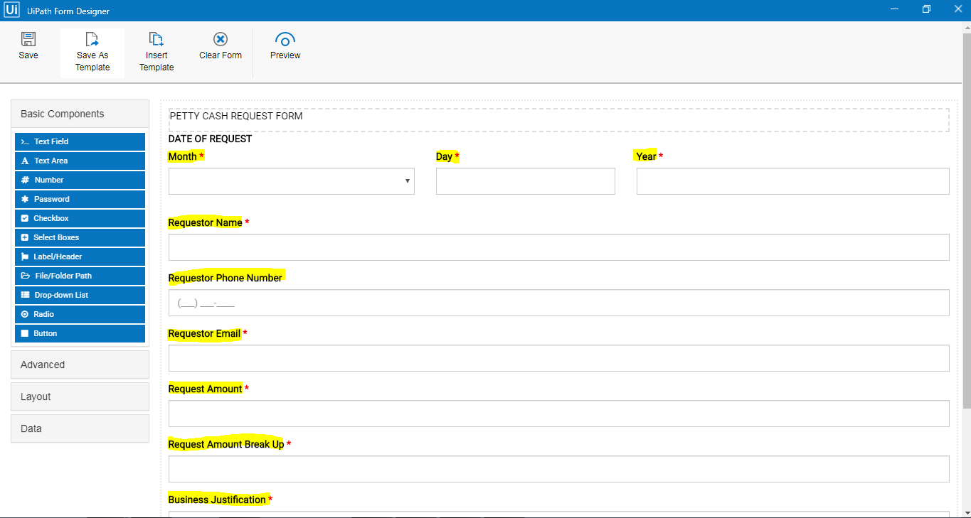
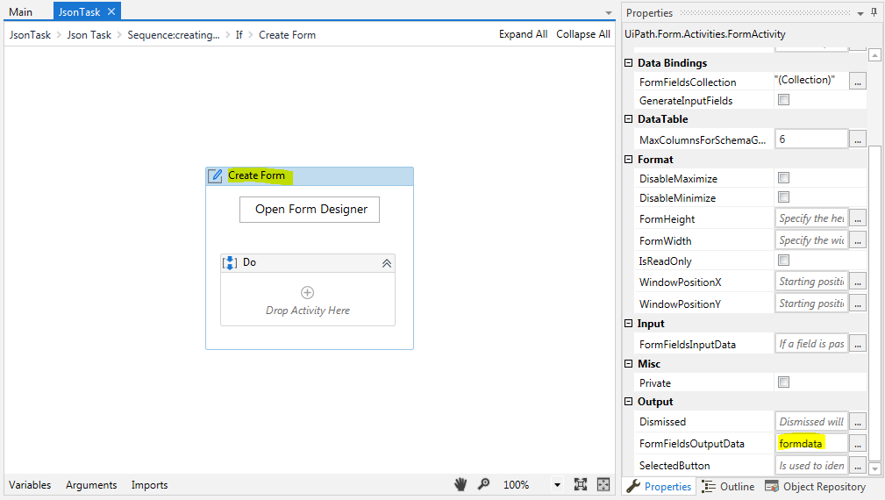

- Use deserialize json activity to extract data from the output variable
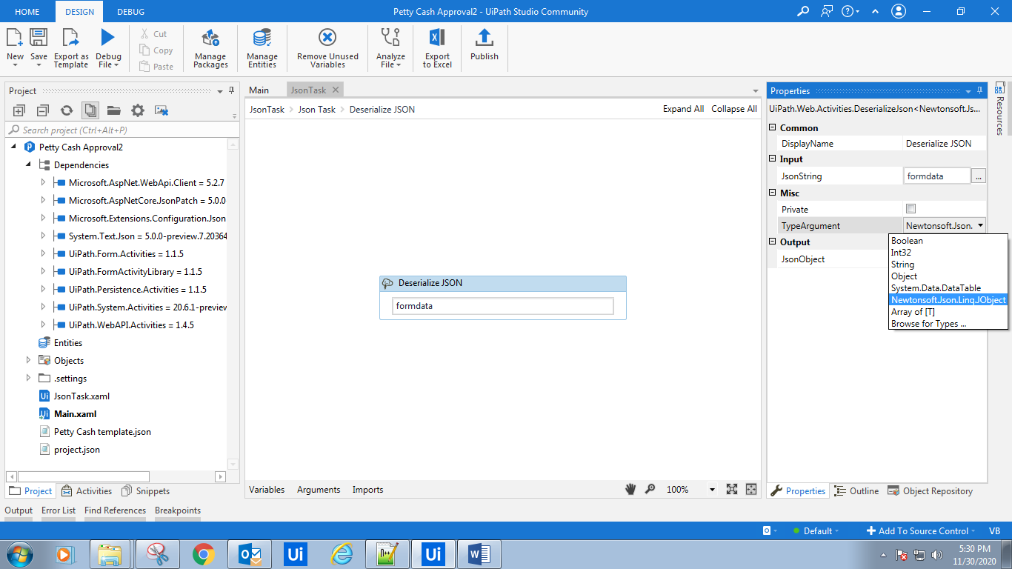
Ensure that the TypeArgument is Newtonsoft.Json.Linq.JObject
Save the output in output json object variable
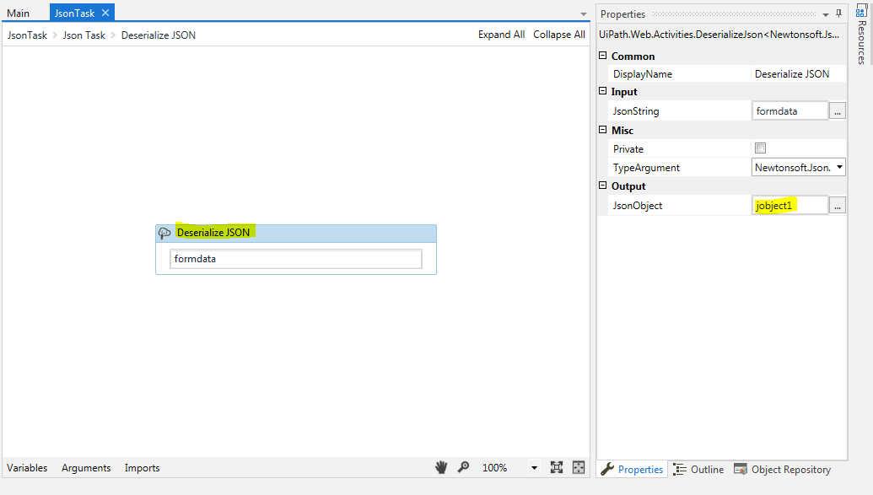
- Now assign relevant variables and put relevant form field values in them :
Assign (variablename)=jsonobjectvariable(“form object column name”). ToString
For eg: jobject1("day").ToString

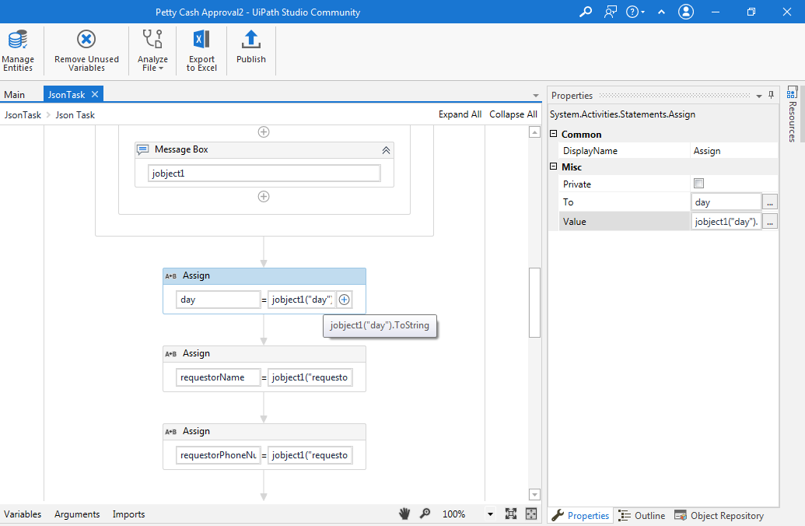
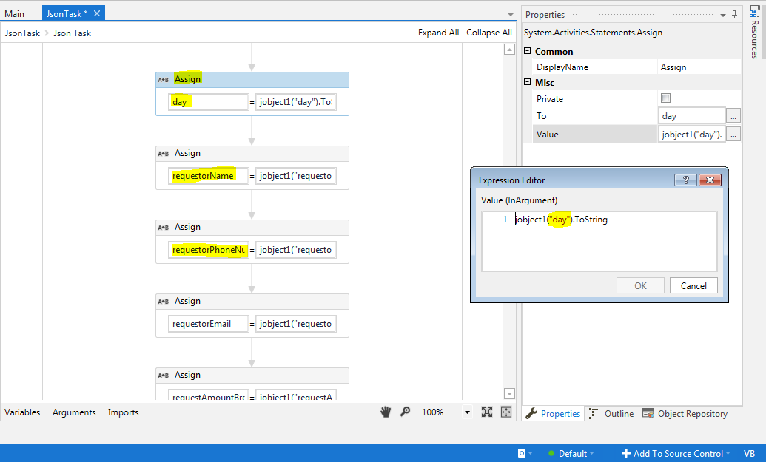

- The values in these variables can now be pasted into any excel sheet or used to build a data table.

