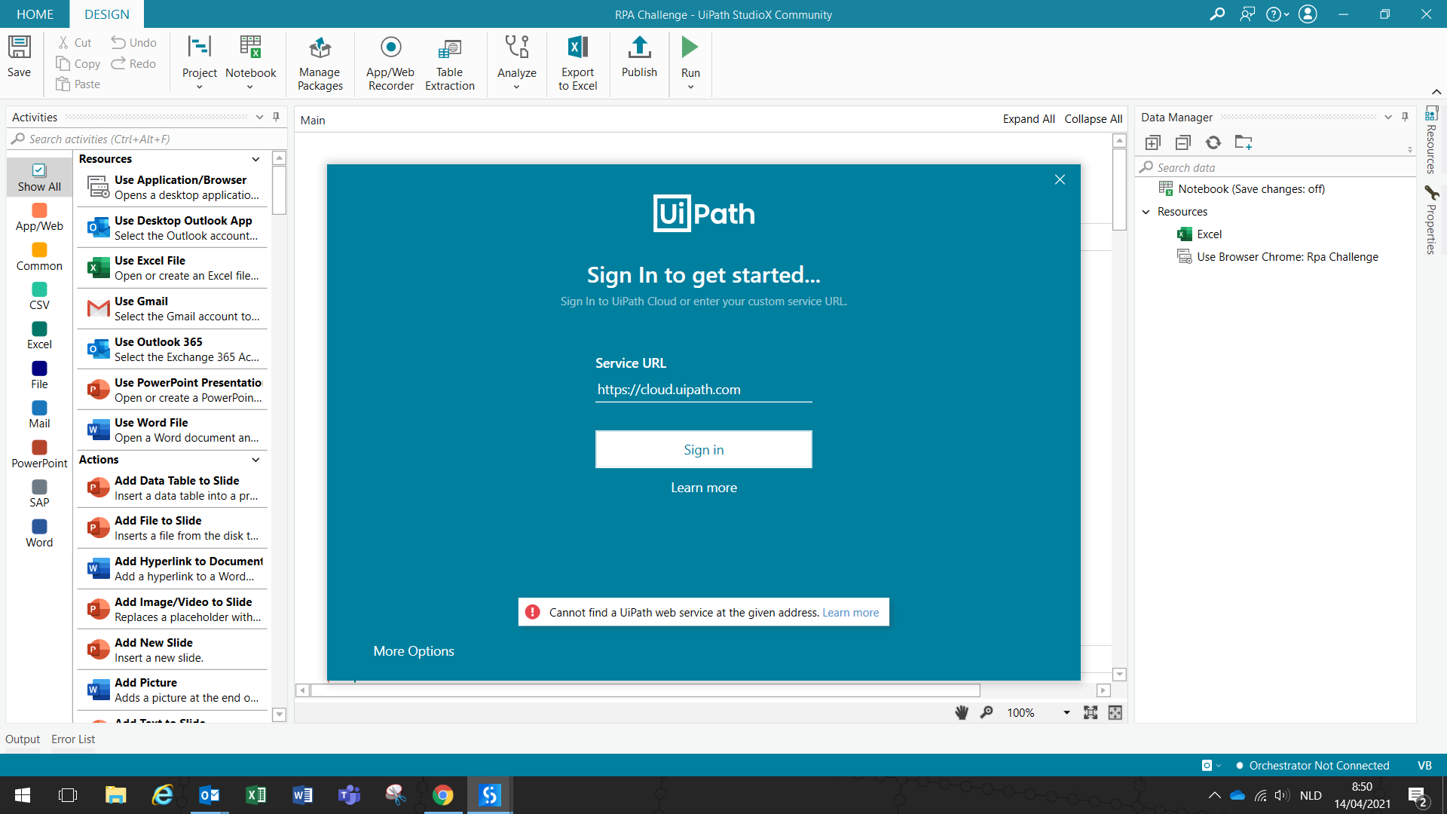

When trying to connect orchestrator via assistant, this screen appears when trying to sign in.

