Step 1: First Drag a container and rename it as Upper container and go to general and in data context assign the dummyvariable entity as shown in below step.
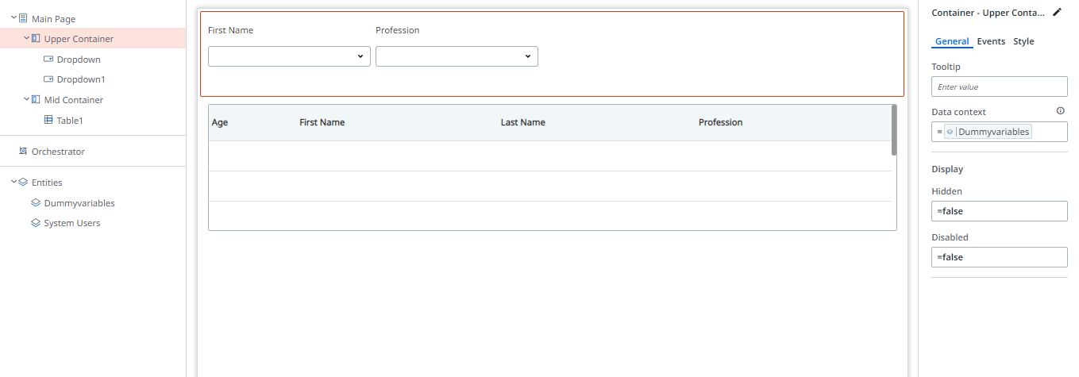

Step 2: Then in upper container drag the dropdown according to your requirements I have assigned first name and profession and these values.Also create a variable i.e var_Main_ResponseKey and assign the variable in selected value binding shown below.Same goes with profession dropdown.
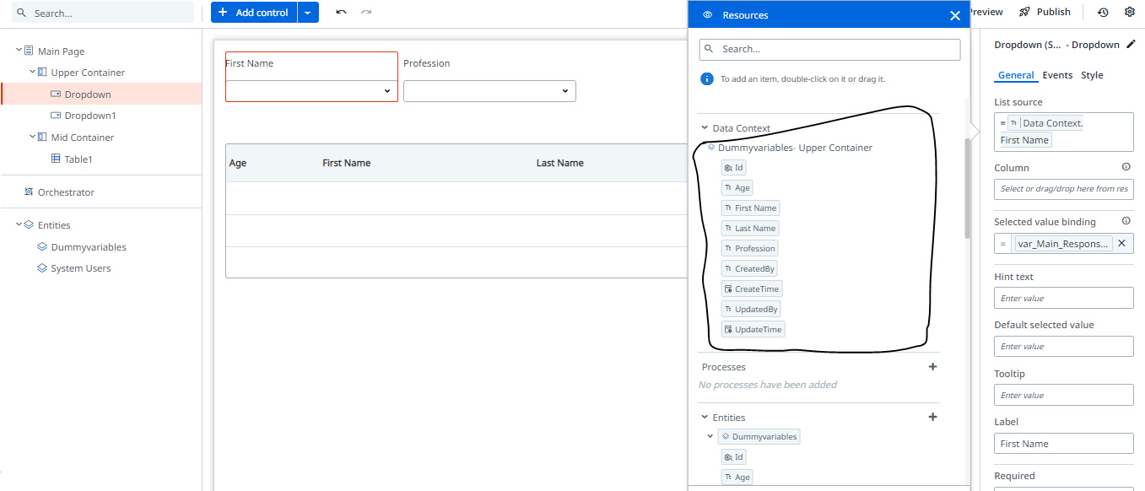

Step 3: Drag the table and assign these expression in data source shown below.
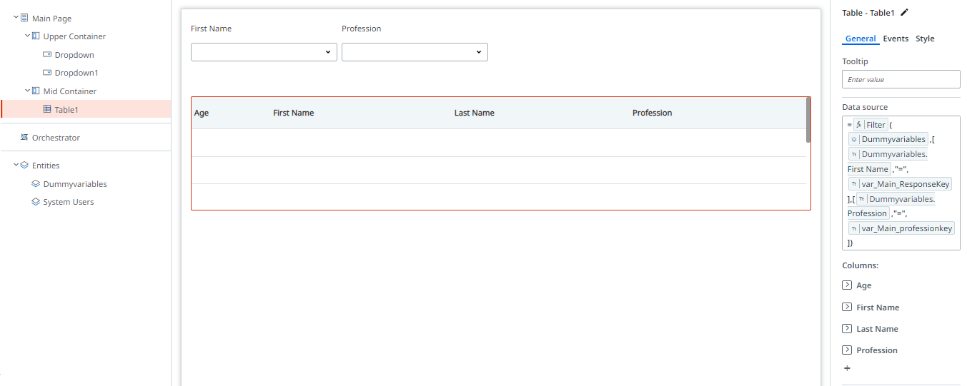

Step 4 : You will get desired output
