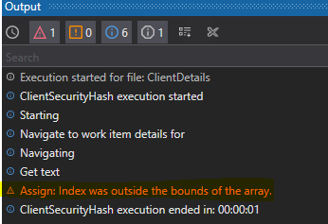
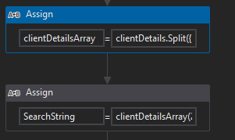
clientDetails.Split({":","Client"},StringSplitOptions.RemoveEmptyEntries)
clientDetailsArray(2).Trim+"-"+clientDetailsArray(4).Trim+"-"+clientDetailsArray(6).Trim

