Dear All,
could you please confirm what is the below error while we are taking the screenshot on VM with Community Edition.
- We are using community Edition.
- run the job via orchestrator with unattended bot.
Please help us.
System.ComponentModel.Win32Exception (0x80004005): The handle is invalid
at System.Drawing.Graphics.CopyFromScreen(Int32 sourceX, Int32 sourceY, Int32 destinationX, Int32 destinationY, Size blockRegionSize, CopyPixelOperation copyPixelOperation)
at System.Drawing.Graphics.CopyFromScreen(Point upperLeftSource, Point upperLeftDestination, Size blockRegionSize, CopyPixelOperation copyPixelOperation)
at UiPath.Vision.UiImage.FromScreenRegion(Rectangle region)
at UiPath.Vision.UiImage…ctor(Rectangle region, Int32 rotationDegree)
at UiPath.Core.Image…ctor(Region screenRegion)

Studio details:-
- Studio 2020.8.0-beta.278 - 8/24/2020
- Community License
- EXE Installer
- License Provider: Internal
- Activation ID: UIP-5d6c55073a
- Update Channel: Stable
- Microsoft Windows 10 Enterprise 64-bit
- .NET Framework Version 4.8

Take Screenshot activity version:-

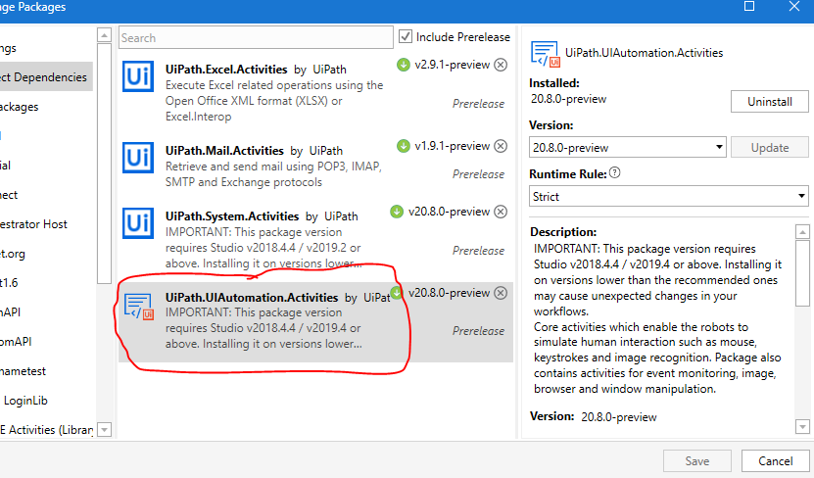

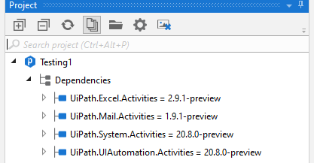

4) Orchestrator version

