How to get the secret key

Google
- Go to the 2-Step Verification page of the specific account https://myaccount.google.com/signinoptions/two-step-verification for Google
- Go to Authenticator app > Set Up
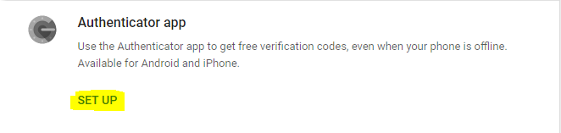
- Select whichever type of phone, this is not important, then press NEXT
- Select CAN'T SCAN IT
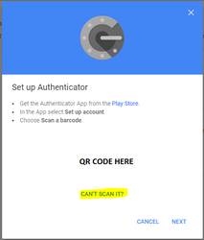
- On the next page a 32 character string, separated into groups of 4, this is the Secret Key that you will need to use in the activity
