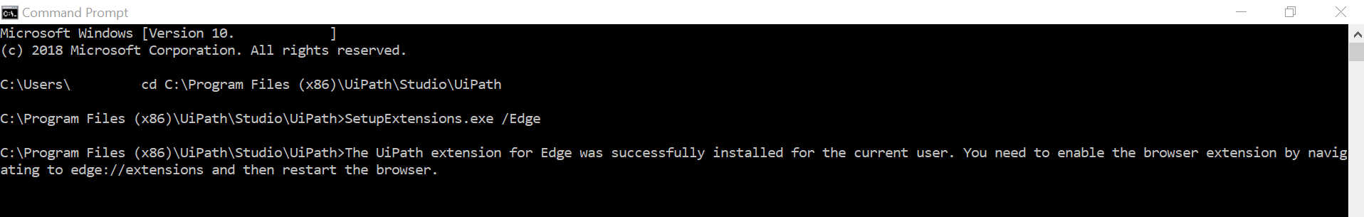
Installed the Microsoft Edge extension manually.

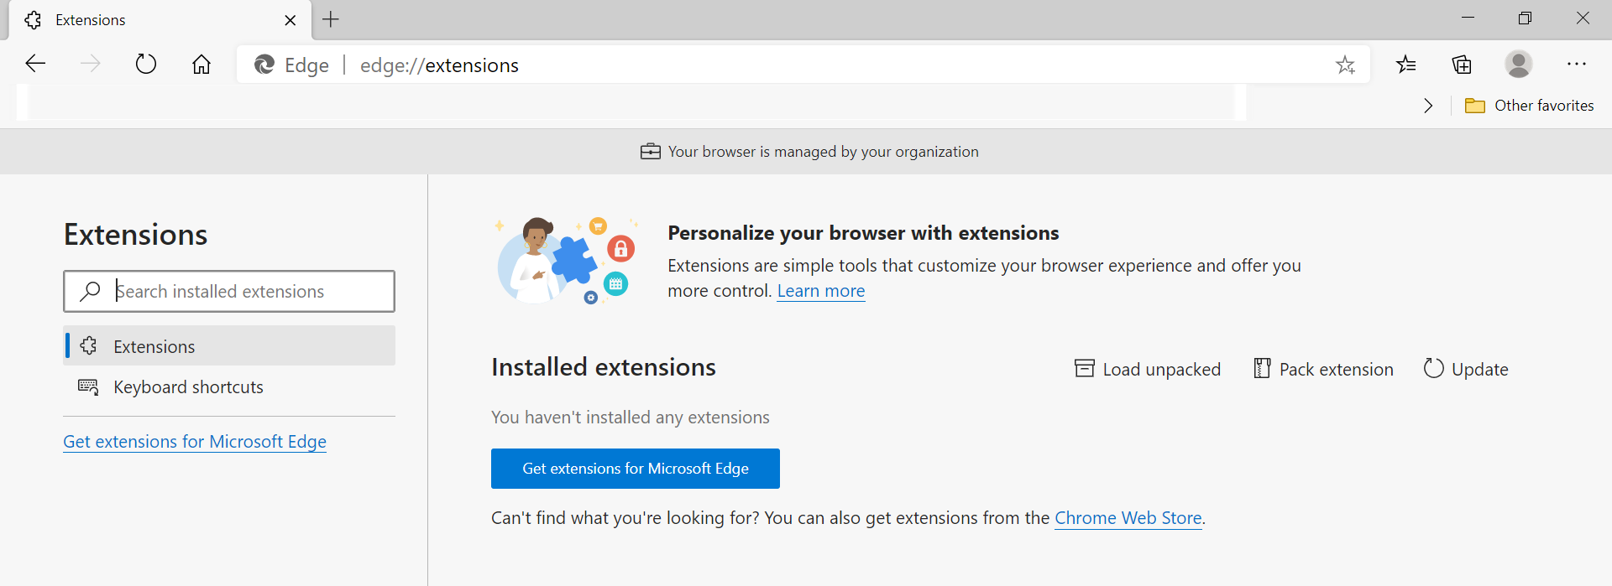
Navigated to edge://extensions to enable the extension but no extension has been installed.

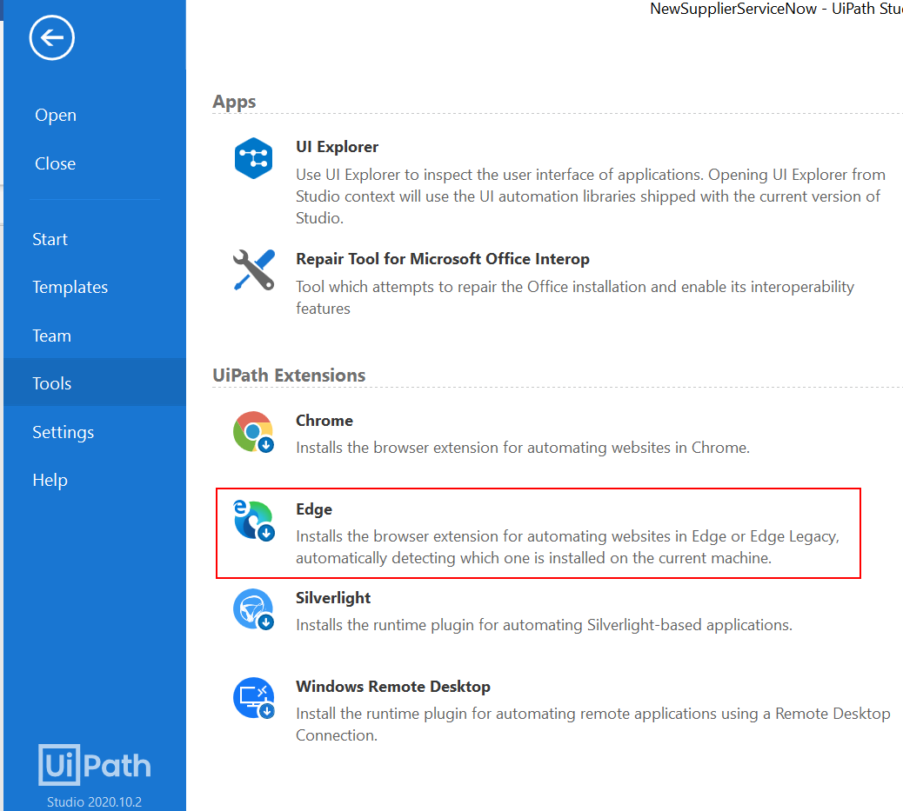
I’ve also tried installing the extension in the UiPath application.

