The Matches activity is set to look for that text in pdf file, the text is there but it doesn’t populate the variable ValidDate with the text.
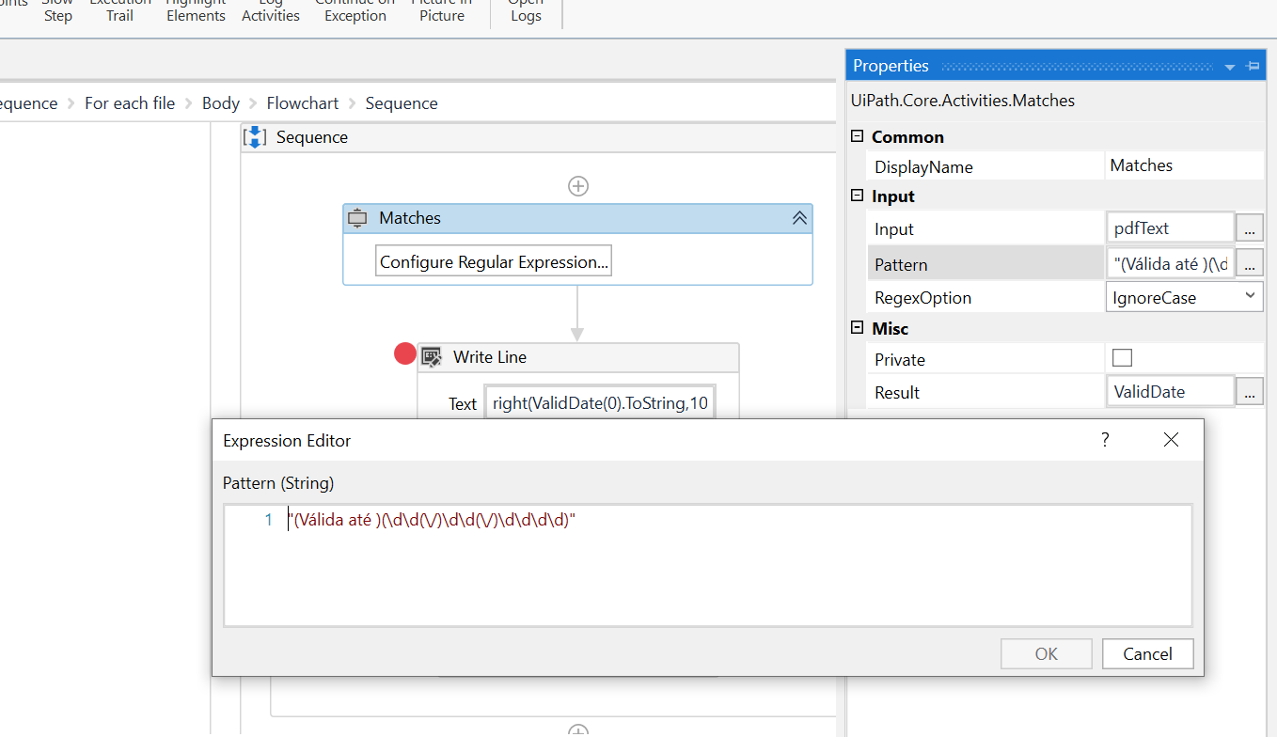

After passing through match activity the write line fails.
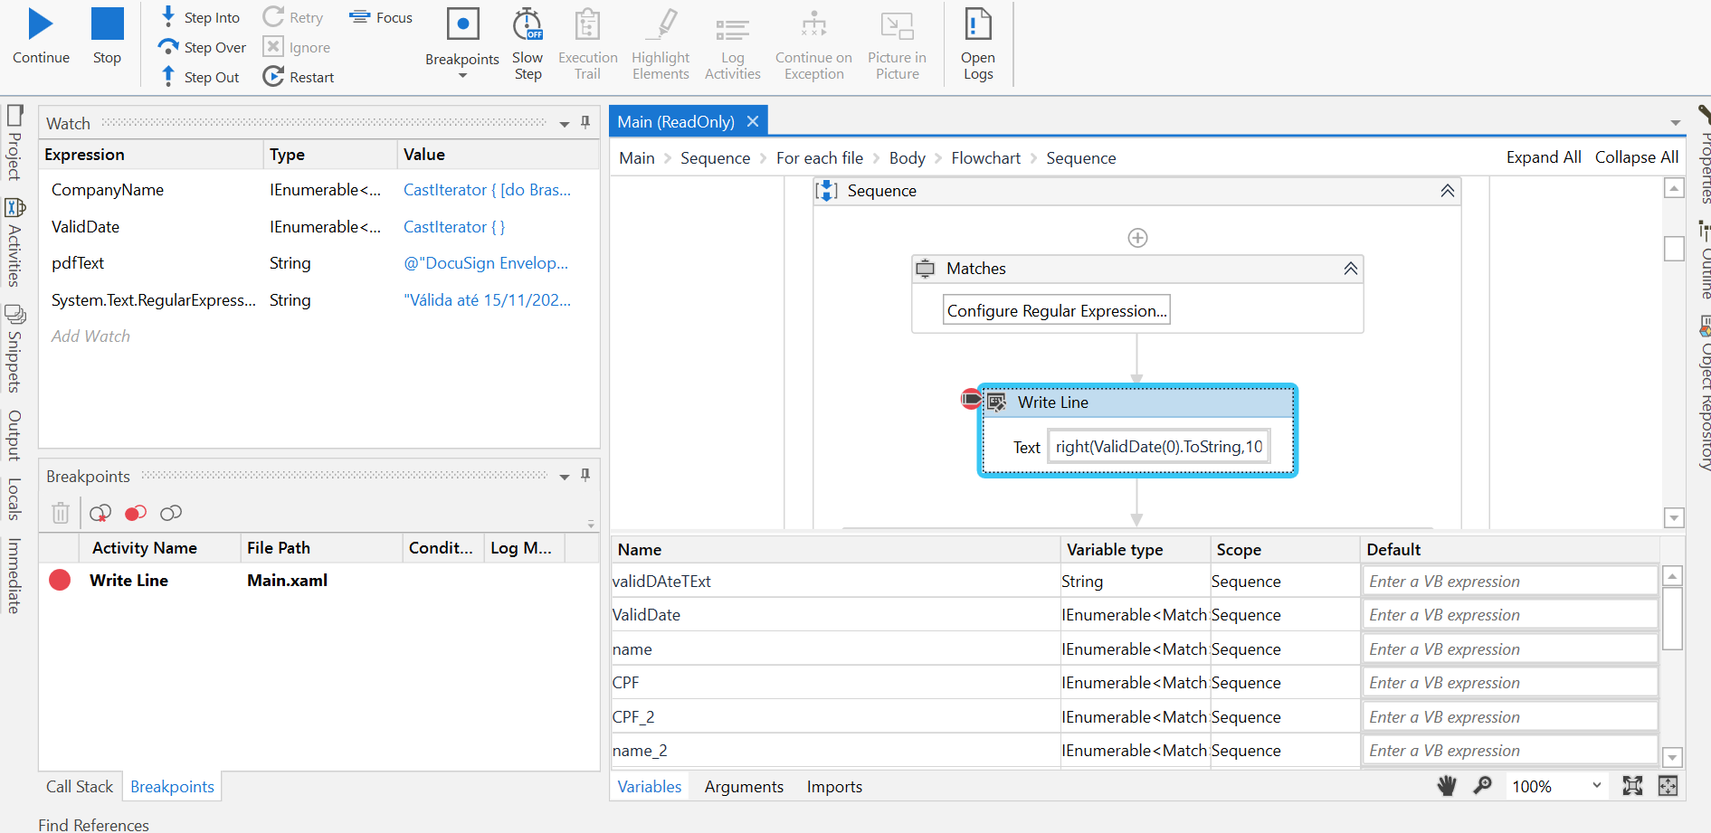

Write line code
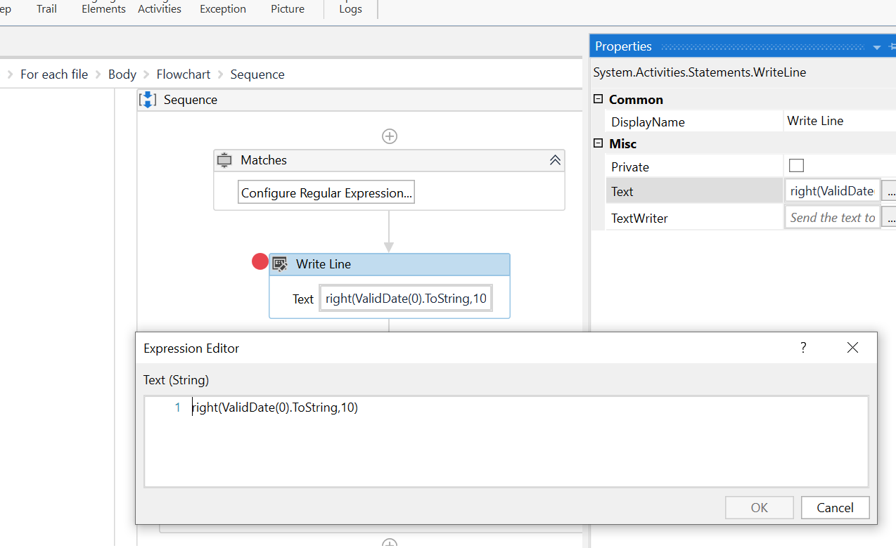
PDF file contains personal identifiable data
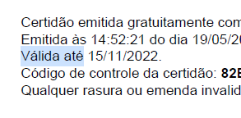
Emitida às 14:52:21 do dia 19/05/2022 <hora e data de Brasília>.
Válida até 15/11/2022.
Código de controle da certidão: 82B...

