1. Goal of the Bot
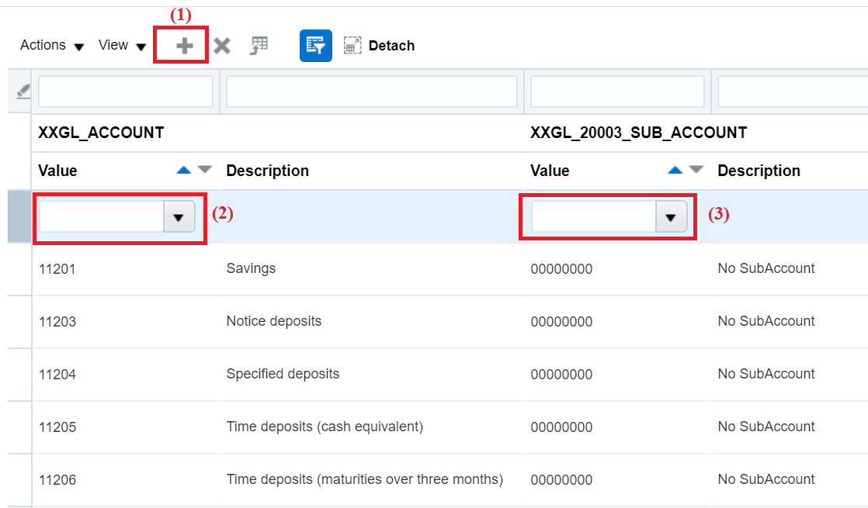
The bot reads 2 columns of data from a spreadsheet and uses them to populate the above Web page. For each row of data in the spreadsheet, it performs the above actions:
- Clicks the “+” sign to insert a new row (which always goes to the top of the grid)
- Populates the “Account” field
- Populates the “Subaccount” field
Please note that the two columns are not always in the same place (e.g. instead of being in columns 1 and 3, for another environment, they might be in columns 1 and 4 respectively), hence the column numbers to be used are also stored as parameters in the same spreadsheet. This is my motivation for trying to use dynamic electors.
(Note: I realize that there is now a “delivered” way to use dynamic selectors directly in UIPath. However, I believe our company has an older version of the product, and this feature is not yet available.)

2. Steps the Bot Takes

2.01. Read the Columns of Data from Spreadsheet into DataTable
Steps omitted for brevity.

2.02. Populate AccountColnum and SubaccountColnum from Spreadsheet
Steps omitted for brevity.

2.03. Assign account_selector variable
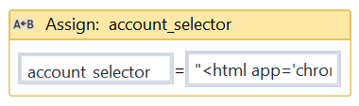
"<html app='chrome.exe' htmlwindowname='11byatxuhg' title='Manage Chart of Accounts Value Sets - Setup and Maintenance - Or*' />" + "<webctrl tableCol='" + AccountColnum.ToString + "' tag='INPUT' tableRow='1' />"

2.04. Assign subaccount_selector variable
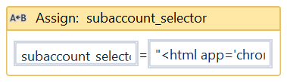
"<html app='chrome.exe' htmlwindowname='11byatxuhg' title='Manage Chart of Accounts Value Sets - Setup and Maintenance - Or*' />" + "<webctrl tableCol='" + SubaccountColnum.ToString + "' tag='INPUT' tableRow='1' />"

2.05. For Each Row

2.05.01. Click “+” Sign
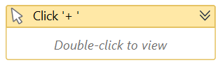

2.05.02. Check For Some Possible Error Conditions
Steps omitted for brevity.

2.05.03. Type Into Account
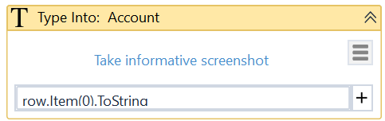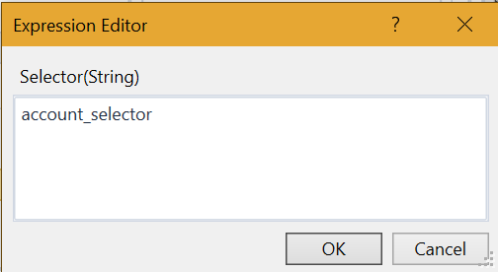

2.05.04. Type Into Subaccount
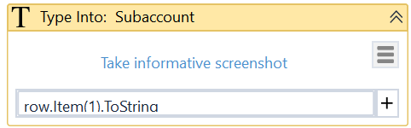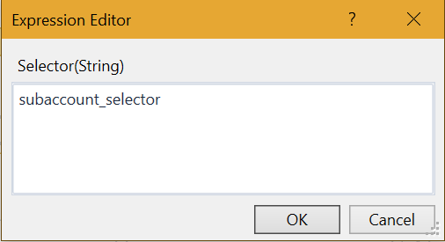

3. Execution Result
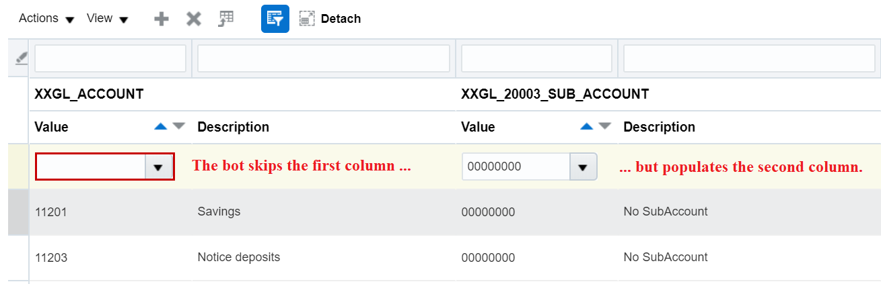
The bot successfully inserts a row, but then it skips the first column and populates the second column.

4. Attempts to Solve the Problem

4.01. Tried Changing the Order
I tried populating the Subaccount column first, followed by the Account column. However, it still populated the Subaccount and ignored the Account.

4.02. Tried Adding an Extra ‘Type Into’ Activity for Account

4.02.01. Extra ‘Type Into’ activity for Account, added for testing purpose
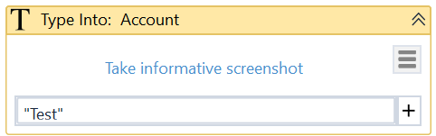
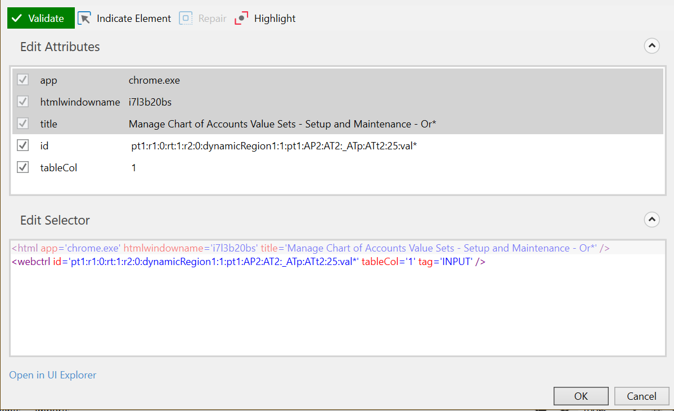

4.02.02. Followed by the original ‘Type Into’ activity for Account
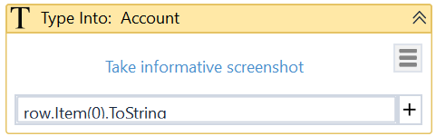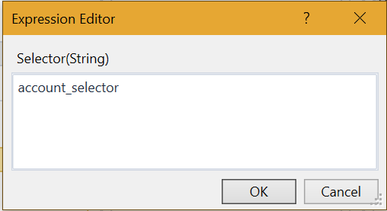

4.02.03. Followed by the original ‘Type Into’ activity for Subaccount

4.02.04. Result
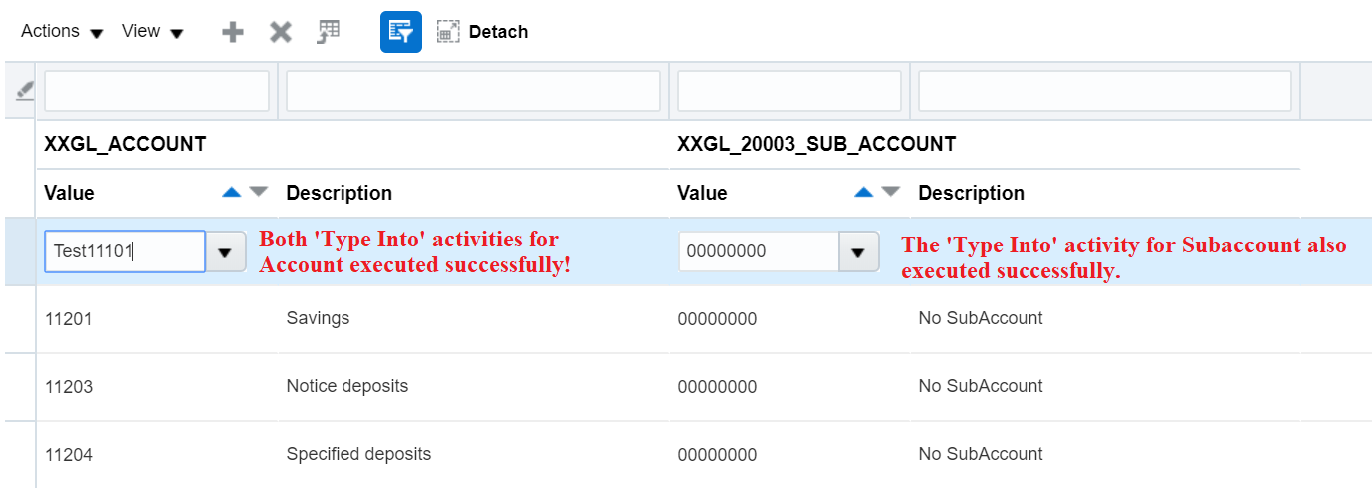

5. Additional Information from UI Explorer
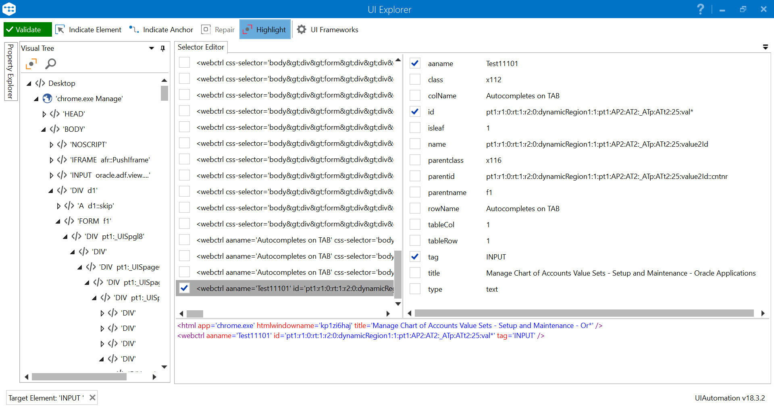
When I ‘Indicate Element’ for the Account field, I get the above by default. Please note that the ‘id’ tag changes as additional rows are inserted. For example, if I insert another row and repeat the above steps, the ‘id’ ends in ‘26’ rather than ’25, i.e.:
<html app='chrome.exe' htmlwindowname='kp1zi6haj' title='Manage Chart of Accounts Value Sets - Setup and Maintenance - Or*' />
<webctrl id='pt1:r1:0:rt:1:r2:0:dynamicRegion1:1:pt1:AP2:AT2:_ATp:ATt2:26:val*' tableCol='1' tag='INPUT' />
Hence, for my dynamic selector, I used the ‘tableRow’ tag instead of ‘id’:
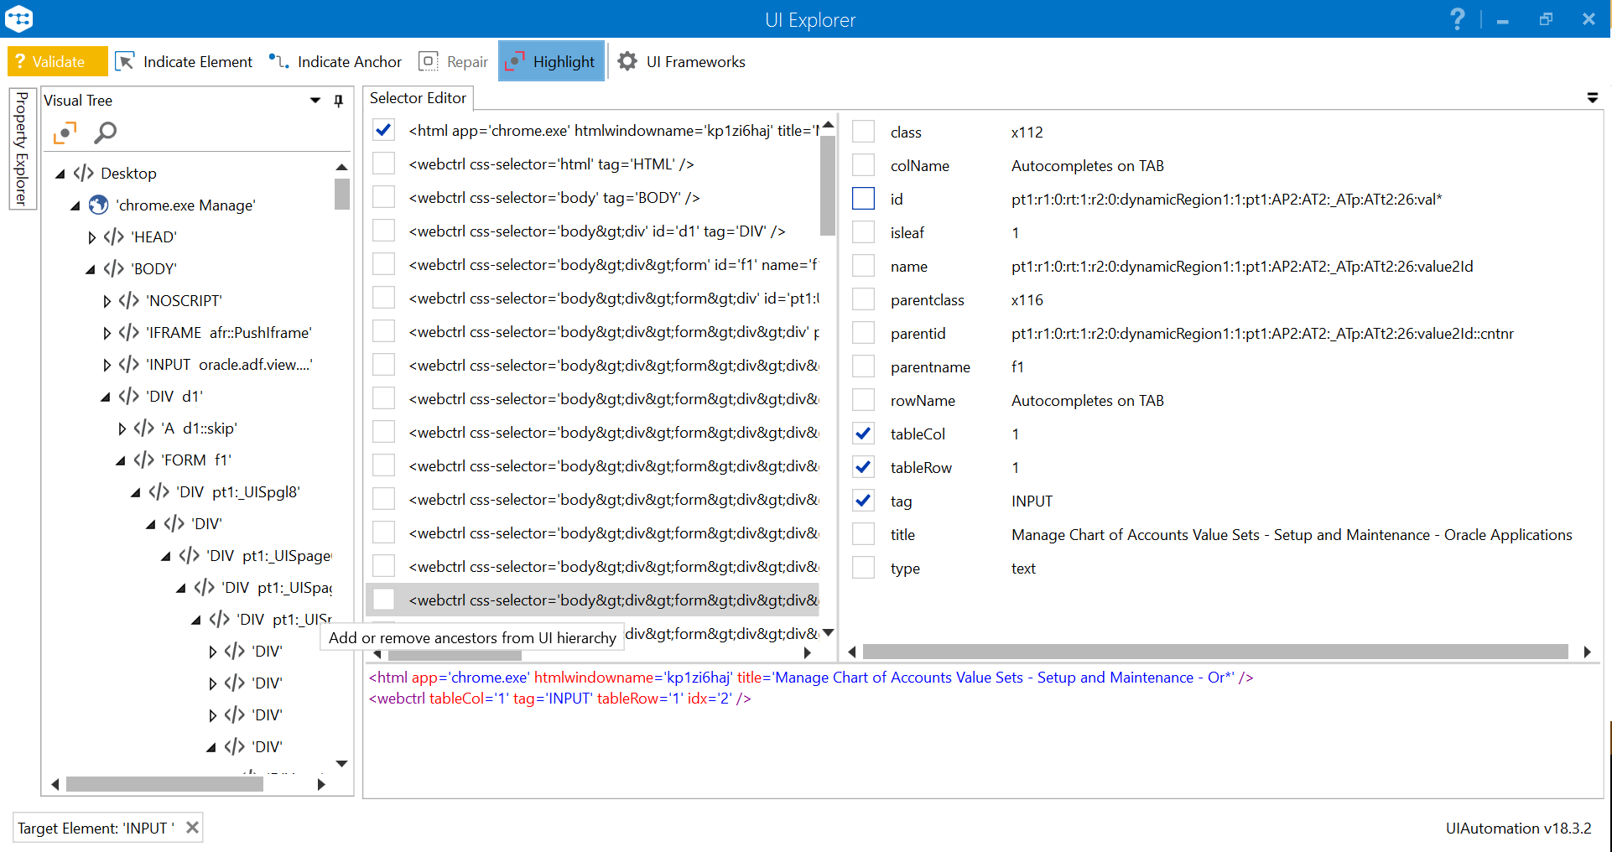
I tested this approach by using ‘Highlight’, and confirmed that it does indeed highlight the Account field on the Web page.

